PRODUCT INVENTORY MANAGEMENT SYSTEM
REST API DOCUMENTATION
Version: 1.0
Project Repository: https://github.com/ervg0203/product-inventory-management
Technology Stack: Java 21, Spring Boot, Spring Data MongoDB, MongoDB, Gradle
Base URL: http://localhost:8080
API Version Prefix: /api/v1
Request Format: application/json
Prepared By: Vaibhav Kumar

1. INTRODUCTION
The Product Inventory Management System provides REST APIs for managing product information, warehouse details, and stock quantities maintained at individual warehouses.
The application supports:
- Product creation, retrieval, updating, and deletion.
- Warehouse creation, retrieval, updating, and deletion.
- Single and bulk operations.
- Paginated product and warehouse listings.
- Advanced search and query-parameter-based search.
- Excel import for products and warehouses.
- Inventory creation and retrieval.
- Setting, increasing, and decreasing stock quantities.
- Total product stock calculation across warehouses.
- Low-stock queries with optional warehouse filtering.
- Validation and standardized API responses.
This document describes the actual controller routes, request DTOs, response DTOs, processing flows, and error-handling behaviour identified in the supplied source code.
2. COMMON API RESPONSE STRUCTURE
Most successful API responses use the following response wrapper:
{
"success": true,
"message": "Operation completed successfully",
"data": {}
}
The fields are:
- success: Indicates whether the operation succeeded.
- message: Describes the result of the operation.
- data: Contains the requested resource, list, paginated result, import result, or null.
For example, creating a product returns an envelope similar to:
{
"success": true,
"message": "Product created successfully",
"data": {
"id": "PRODUCT_ID",
"sku": "SKU-1001",
"title": "Wireless Mouse"
}
}
The example is abbreviated. Actual product responses contain the fields defined in ProductResponseDTO.
Inventory deletion is an exception: the controller returns HTTP 204 No Content without a response body.
3. API ENDPOINT SUMMARY
3.1 Product APIs
Method | Endpoint | Description
GET | /api/v1/products | Get paginated products
POST | /api/v1/products/advance-search | Advanced product search
GET | /api/v1/products/search | Search products using query parameters
GET | /api/v1/products/{id} | Get product by ID
POST | /api/v1/products/create | Create one product
POST | /api/v1/products/create-multi | Create multiple products
PUT | /api/v1/products/update | Update one product
PUT | /api/v1/products/update-multi | Update multiple products
POST | /api/v1/products/import | Import products from Excel
DELETE | /api/v1/products/delete-all | Delete all products
DELETE | /api/v1/products/delete-by-filters | Delete products matching search filters
DELETE | /api/v1/products/{id} | Delete one product
3.2 Warehouse APIs
Method | Endpoint | Description
GET | /api/v1/warehouses | Get paginated warehouses
POST | /api/v1/warehouses/advance-search | Advanced warehouse search
GET | /api/v1/warehouses/search | Search warehouses using query parameters
GET | /api/v1/warehouses/{id} | Get warehouse by ID
POST | /api/v1/warehouses/create | Create one warehouse
POST | /api/v1/warehouses/create-multi | Create multiple warehouses
PUT | /api/v1/warehouses/update | Update one warehouse
PUT | /api/v1/warehouses/update-multi | Update multiple warehouses
POST | /api/v1/warehouses/import | Import warehouses from Excel
DELETE | /api/v1/warehouses/delete-all | Delete all warehouses
DELETE | /api/v1/warehouses/delete-by-filters | Delete warehouses matching filters
DELETE | /api/v1/warehouses/{id} | Delete one warehouse
3.3 Inventory APIs
Method | Endpoint | Description
POST | /api/v1/inventory/create | Create one inventory record
POST | /api/v1/inventory/create-multi | Create multiple inventory records
PUT | /api/v1/inventory/update-multi | Update multiple inventory records
GET | /api/v1/inventory/{inventoryId} | Get inventory by ID
GET | /api/v1/inventory/products/{productId} | Get product stock across warehouses
GET | /api/v1/inventory/warehouses/{warehouseId} | Get inventory for a warehouse
PUT | /api/v1/inventory/{inventoryId}/stock | Set exact stock quantity
PATCH | /api/v1/inventory/{inventoryId}/stock/increase | Increase stock
PATCH | /api/v1/inventory/{inventoryId}/stock/decrease | Decrease stock
GET | /api/v1/inventory/low-stock?threshold={threshold} | Get low-stock records
DELETE | /api/v1/inventory/{inventoryId} | Delete one inventory record
4. PRODUCT API DOCUMENTATION
4.1 Get All Products
HTTP Method: GET
Endpoint: /api/v1/products
Success Status: 200 OK
Query Parameters
Parameter | Required | Description
page | No | Zero-based page number; default 0
size | No | Number of records per page; configured default 20, maximum 100
Example Request
GET /api/v1/products?page=0&size=10
Example Response
{
"success": true,
"message": "Products fetched successfully",
"data": {
"content": [
{
"id": "prod001",
"sku": "SKU-1001",
"title": "Wireless Mouse",
"description": "Wireless optical mouse",
"category": "Electronics",
"price": 799.00,
"discountPercentage": 10.00,
"rating": 4.50,
"brand": "ExampleBrand",
"returnPolicy": "30 days",
"createdAt": "2026-10-20T10:00:00",
"updatedAt": "2026-10-20T10:00:00",
"errors": [],
"valid": true
}
],
"totalRecords": 1,
"page": 0,
"pageSize": 10,
"totalPages": 1,
"first": true,
"last": true
}
}
Processing Flow
- The controller reads the optional page and size parameters.
- Missing values use the configured pagination defaults.
- The service retrieves the requested page of products.
- The response is mapped to ProductResponseDTO objects.
- The controller returns the paginated data inside ApiResponseDTO.
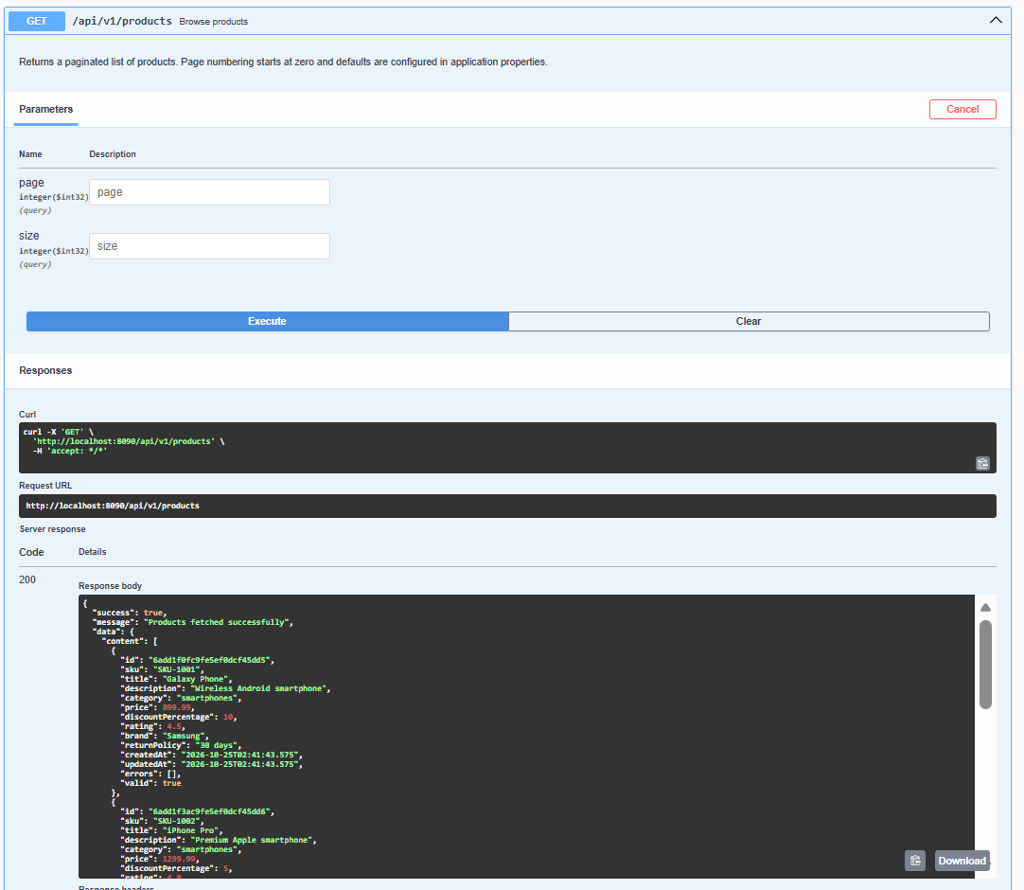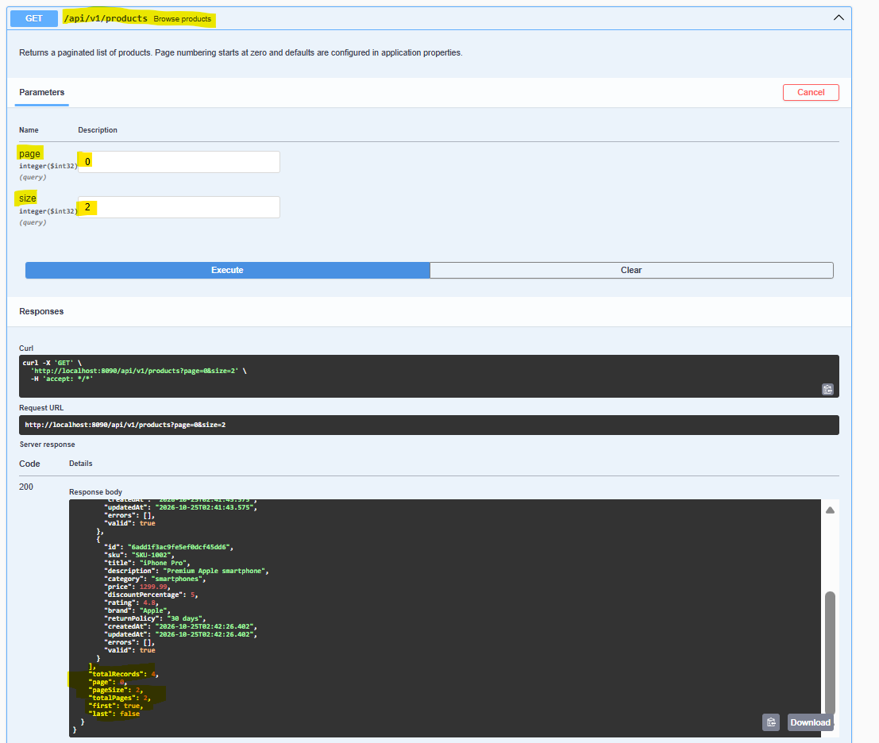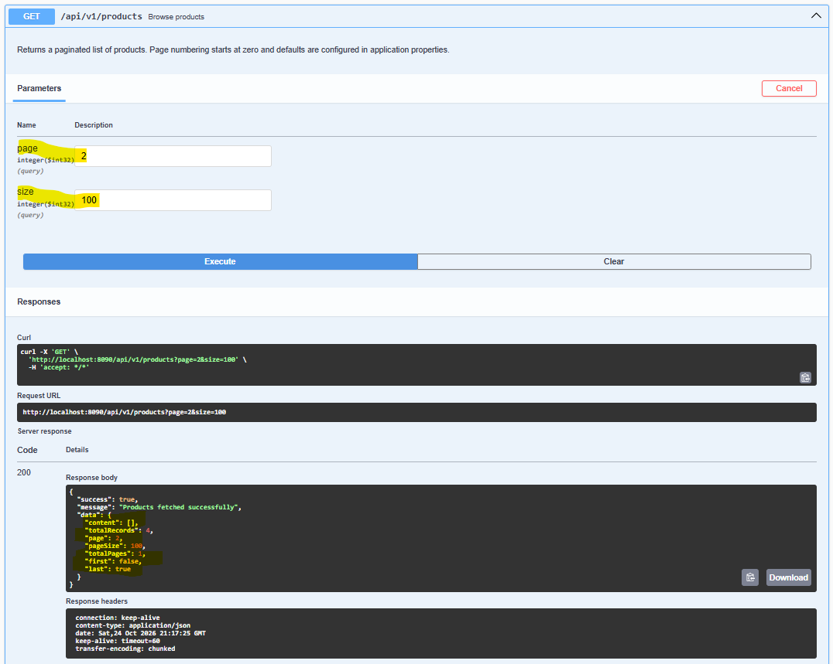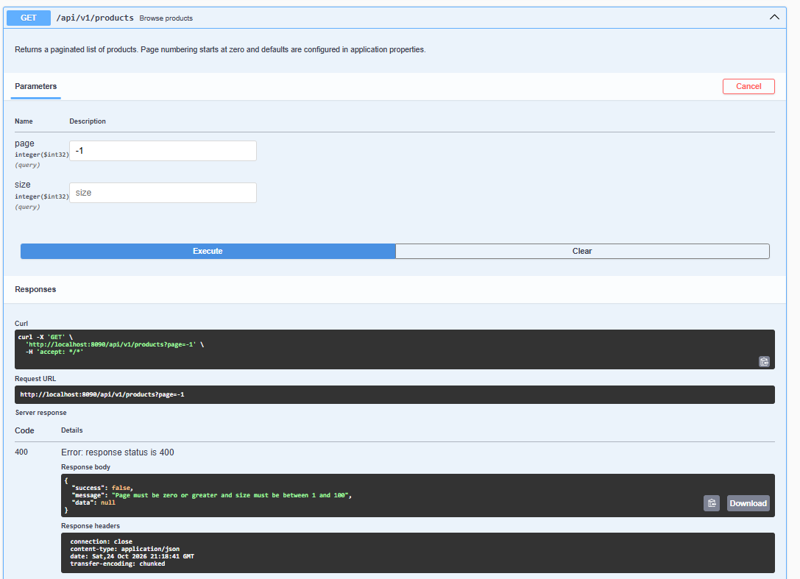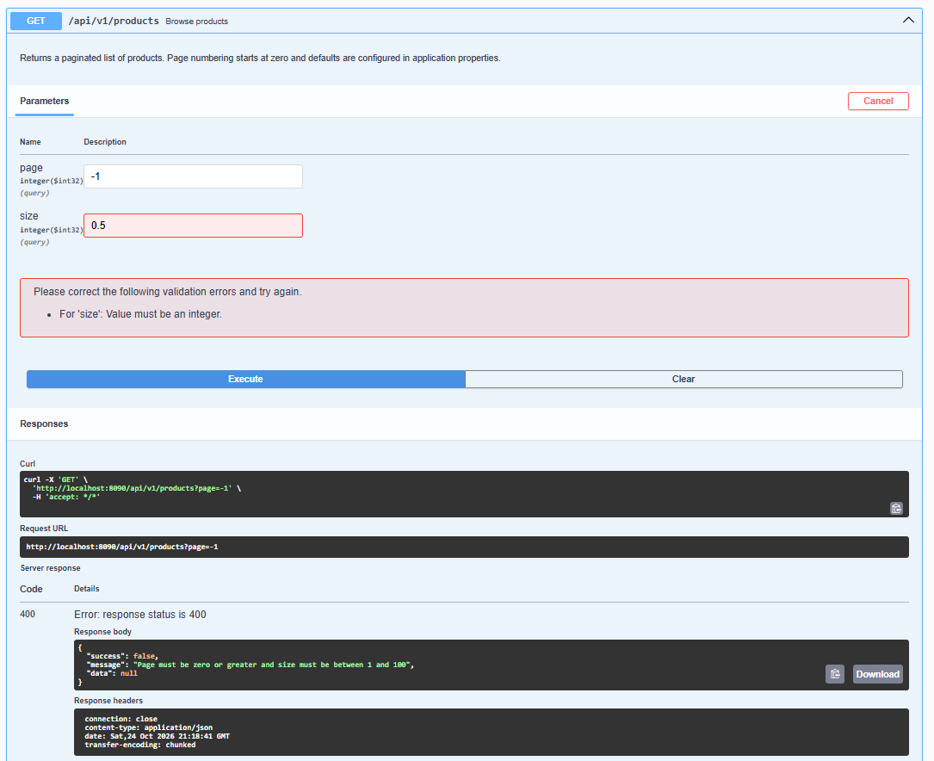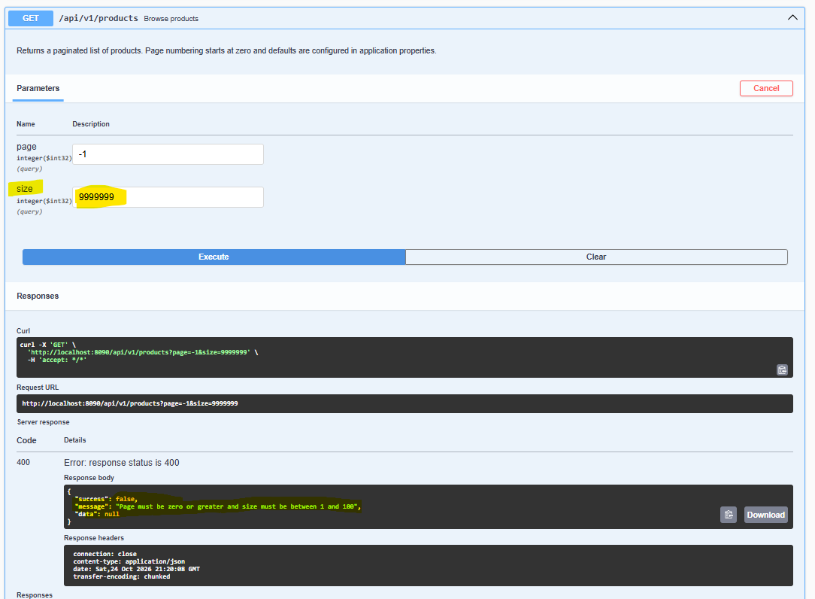
4.2 Create Product
HTTP Method: POST
Endpoint: /api/v1/products/create
Success Status: 201 Created
Request DTO: ProductRequestDTO
The request fields are:
- id
- sku
- title
- description
- category
- price
- discountPercentage
- rating
- brand
- returnPolicy
The request DTO also defines errors and isValid fields used by validation logic. They are normally managed by the application rather than supplied by API clients.
Example Request
{
"sku": "SKU-1001",
"title": "Wireless Mouse",
"description": "Wireless optical mouse",
"category": "Electronics",
"price": 799.00,
"discountPercentage": 10.00,
"rating": 4.50,
"brand": "ExampleBrand",
"returnPolicy": "30 days"
}
Validation Rules
The ProductValidator checks that:
- SKU is required and no longer than 50 characters.
- Title is required and no longer than 150 characters.
- Description is required and no longer than 2,000 characters.
- Category is required and no longer than 100 characters.
- Brand is required and no longer than 100 characters.
- Return policy is required and no longer than 150 characters.
- Price is required and greater than zero.
- Discount percentage is required and between 0 and 100 inclusive.
- Rating is required and between 0 and 5 inclusive.
- Decimal values must have no more than two fractional digits and must satisfy the configured precision constraints.
Example Response
{
"success": true,
"message": "Product created successfully",
"data": {
"id": "prod001",
"sku": "SKU-1001",
"title": "Wireless Mouse",
"description": "Wireless optical mouse",
"category": "Electronics",
"price": 799.00,
"discountPercentage": 10.00,
"rating": 4.50,
"brand": "ExampleBrand",
"returnPolicy": "30 days",
"createdAt": "2026-10-20T10:00:00",
"updatedAt": "2026-10-20T10:00:00",
"errors": [],
"valid": true
}
}
The ID and timestamps are illustrative. MongoDB generates the actual ID, and the application manages timestamps.
Processing Flow
Client → ProductController → ProductService → Product validation → ProductRepository → MongoDB → ApiResponseDTO → Client.
Error Responses
- 400 Bad Request: Malformed request or invalid JSON.
- 409 Conflict: Duplicate key, such as an existing SKU where uniqueness is enforced.
- 422 Unprocessable Entity: Product validation failed.
- 503 Service Unavailable: Database access failure.
- 500 Internal Server Error: Unexpected application failure.
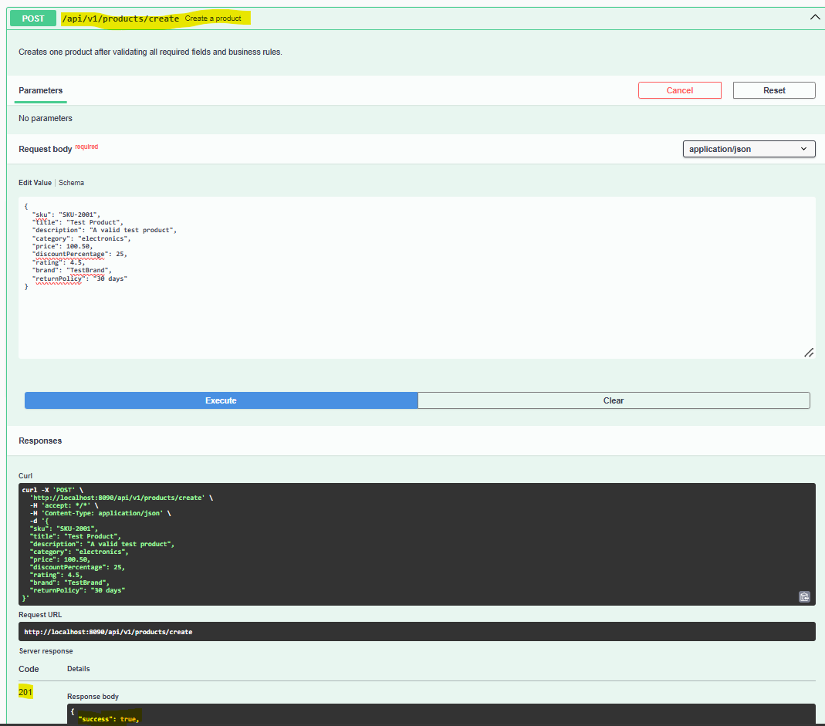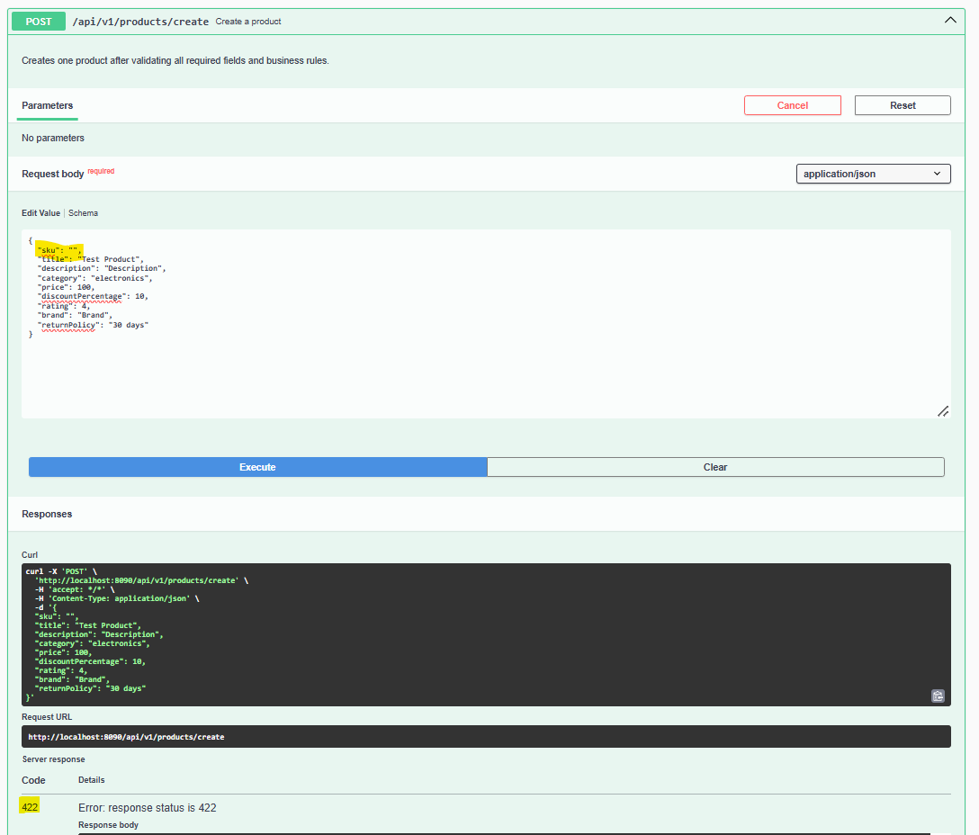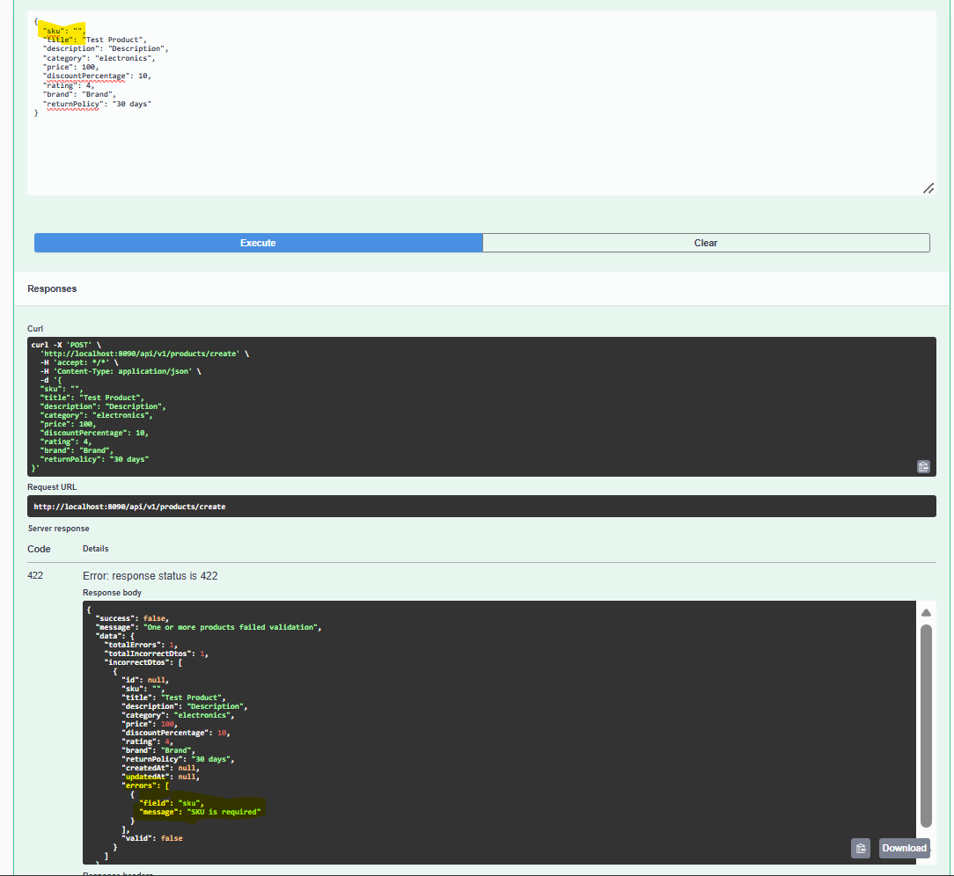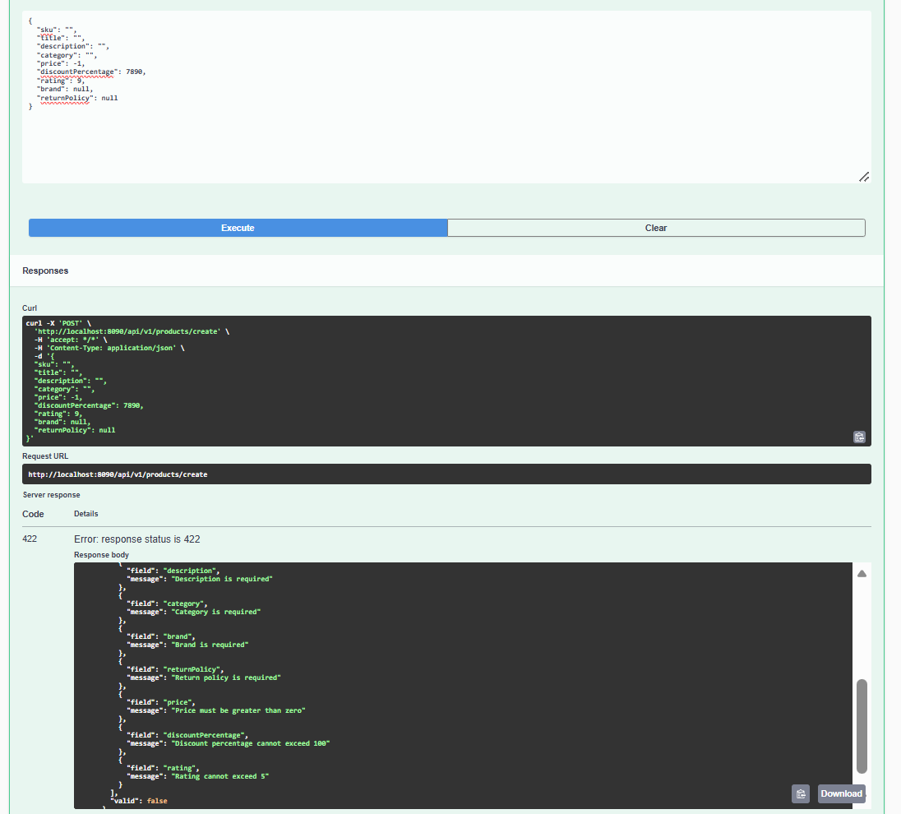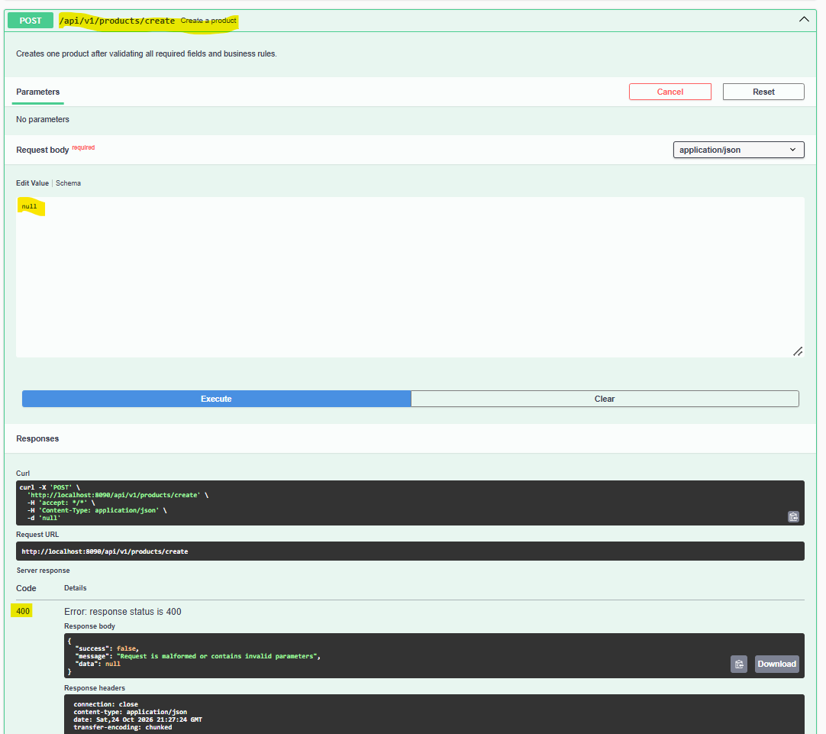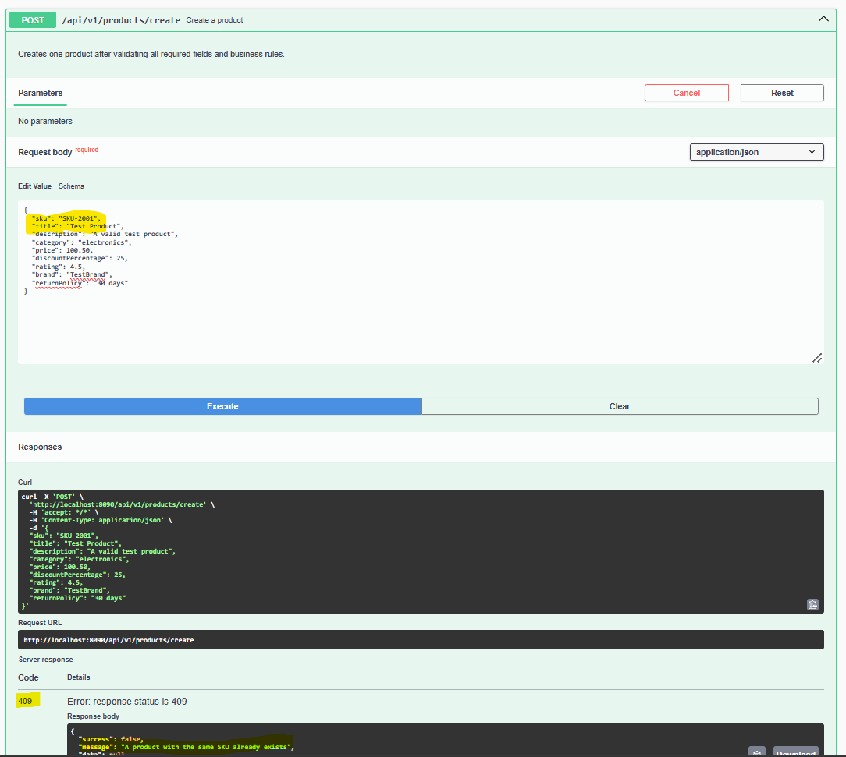
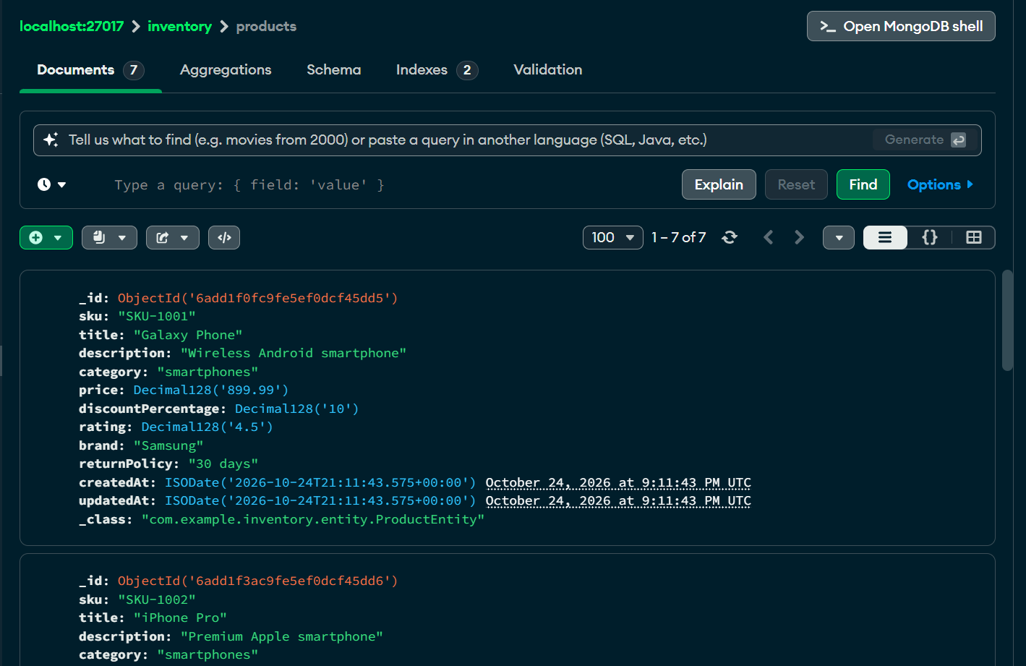
4.3 Get Product by ID
HTTP Method: GET
Endpoint: /api/v1/products/{id}
Success Status: 200 OK
Example Request
GET /api/v1/products/prod001
Example Response
{
"success": true,
"message": "Product fetched successfully",
"data": {
"id": "prod001",
"sku": "SKU-1001",
"title": "Wireless Mouse",
"description": "Wireless optical mouse",
"category": "Electronics",
"price": 799.00,
"discountPercentage": 10.00,
"rating": 4.50,
"brand": "ExampleBrand",
"returnPolicy": "30 days",
"createdAt": "2026-10-20T10:00:00",
"updatedAt": "2026-10-20T10:00:00",
"errors": [],
"valid": true
}
}
Error Response
HTTP Status: 404 Not Found
{
"success": false,
"message": "Product not found for the supplied ID",
"data": null
}
The exact message is determined by the exception thrown by the service.
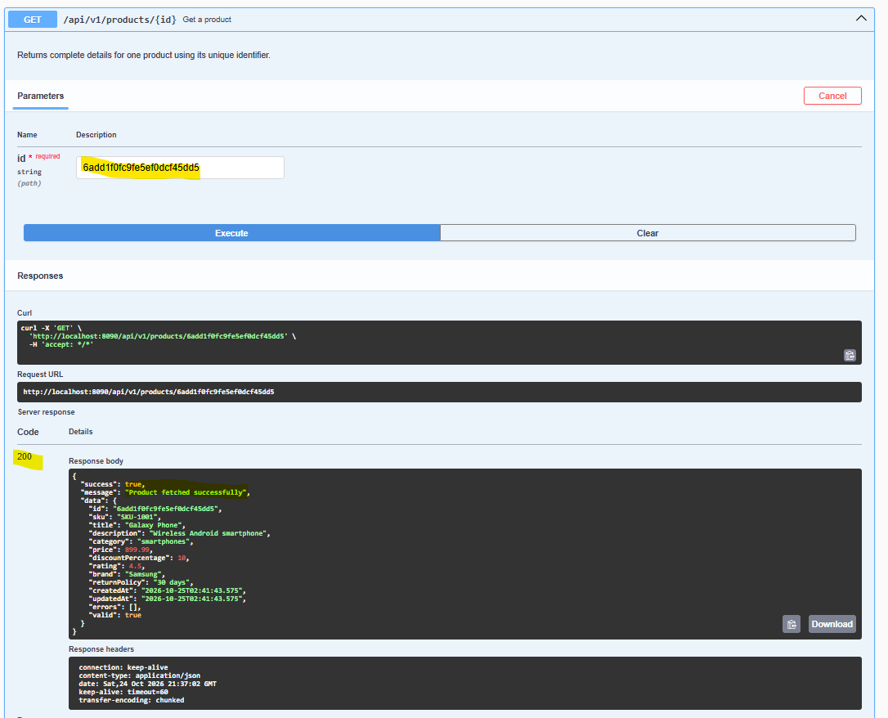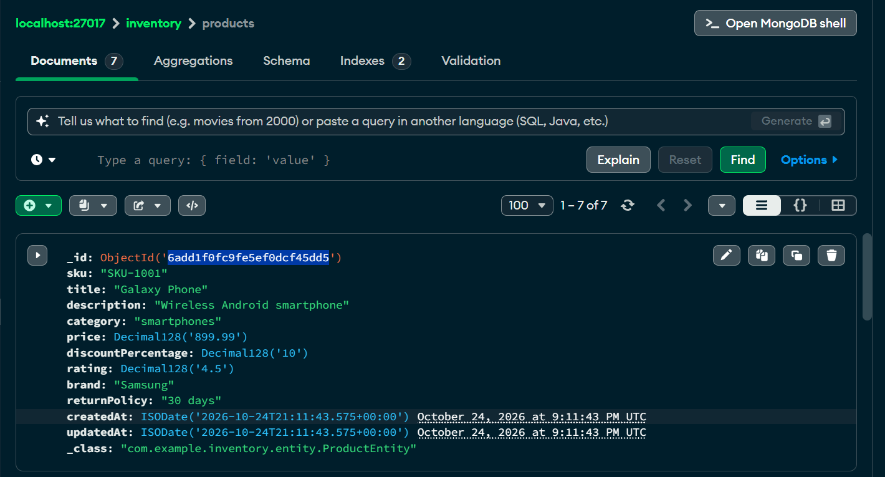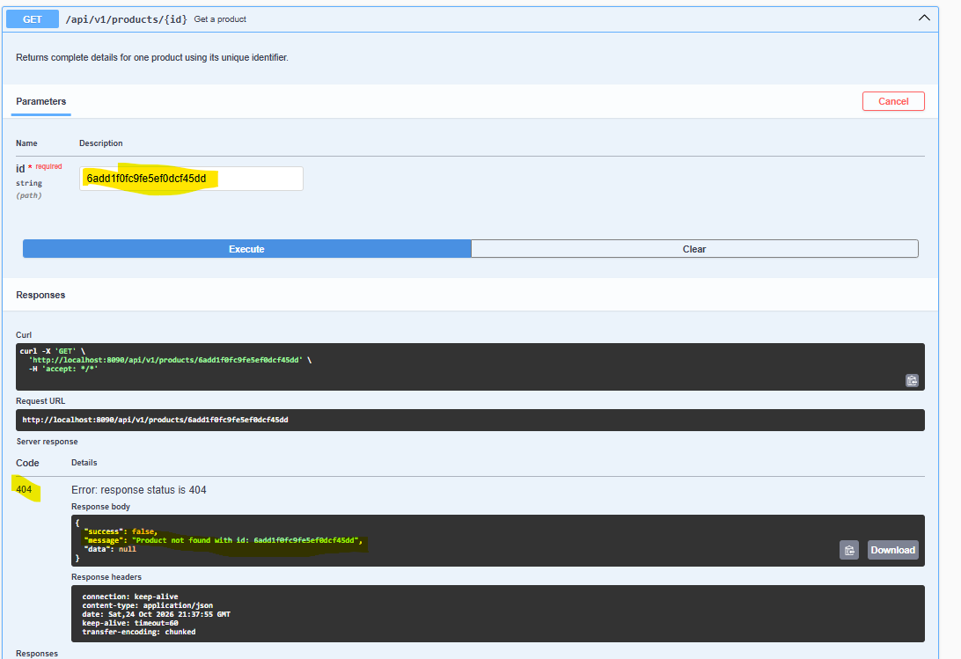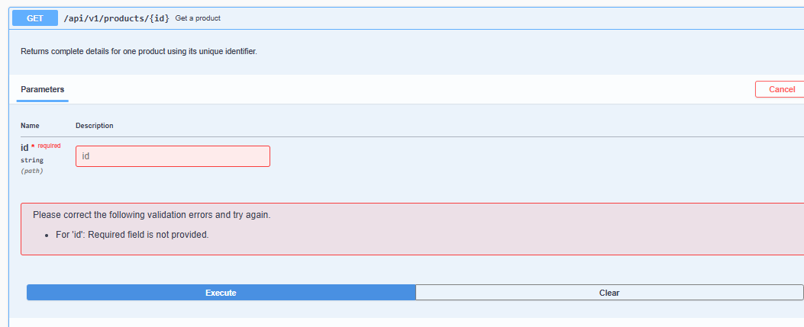
4.4 Update Product
HTTP Method: PUT
Endpoint: /api/v1/products/update
Success Status: 200 OK
The product ID is supplied in the request body, not as a path variable.
Example Request
{
"id": "prod001",
"sku": "SKU-1001",
"title": "Wireless Mouse Pro",
"description": "Updated wireless optical mouse",
"category": "Electronics",
"price": 899.00,
"discountPercentage": 5.00,
"rating": 4.60,
"brand": "ExampleBrand",
"returnPolicy": "30 days"
}
Example Response
{
"success": true,
"message": "Product updated successfully",
"data": {
"id": "prod001",
"sku": "SKU-1001",
"title": "Wireless Mouse Pro",
"description": "Updated wireless optical mouse",
"category": "Electronics",
"price": 899.00,
"discountPercentage": 5.00,
"rating": 4.60,
"brand": "ExampleBrand",
"returnPolicy": "30 days",
"createdAt": "2026-10-20T10:00:00",
"updatedAt": "2026-10-23T10:00:00",
"errors": [],
"valid": true
}
}
Important Update Behavior
The implementation validates the product SKU against existing SKUs during update. Confirm the exact SKU update rules in ProductServiceImpl before changing the SKU value in an update request.
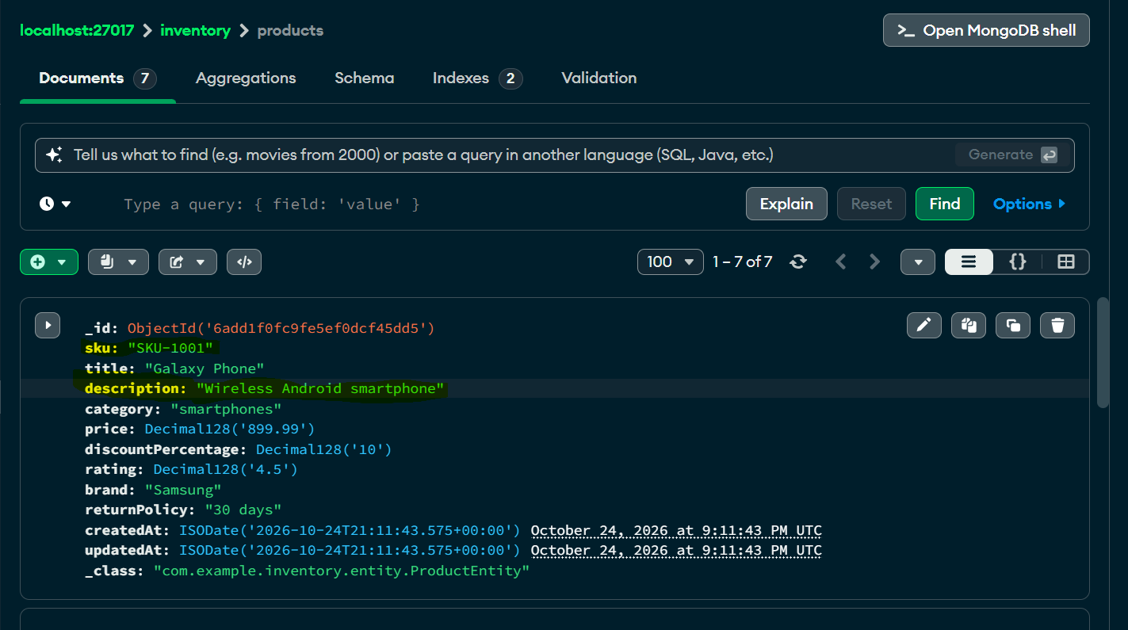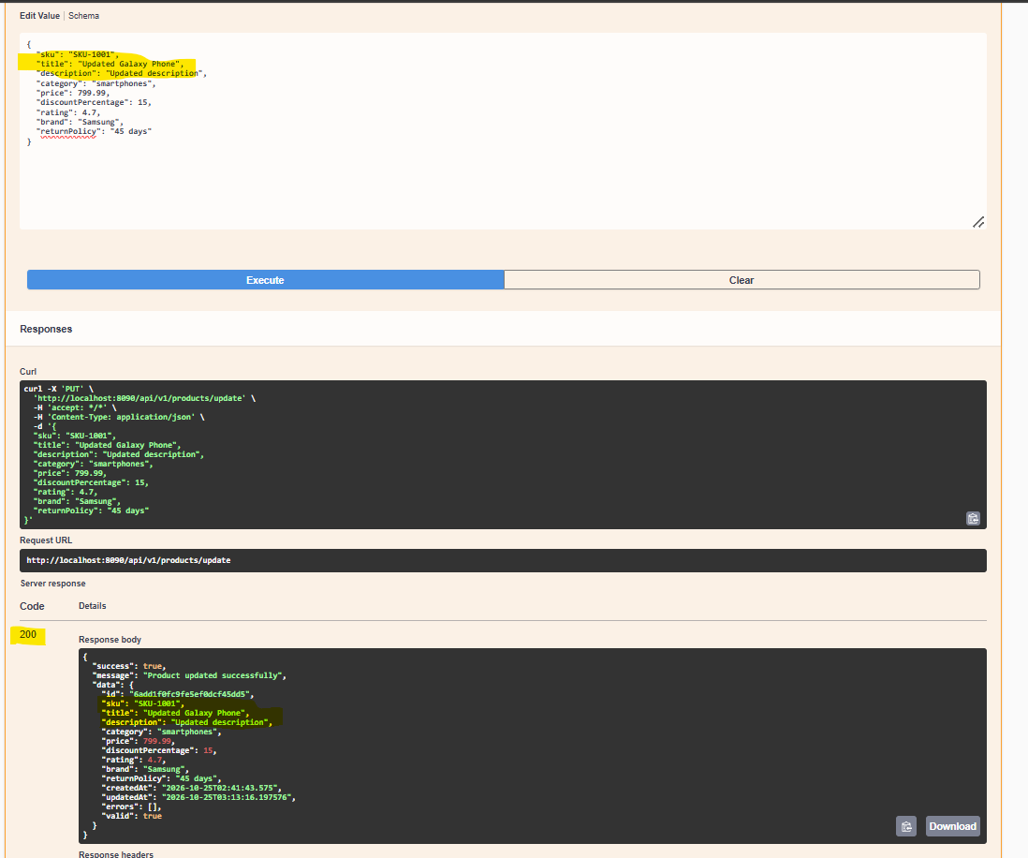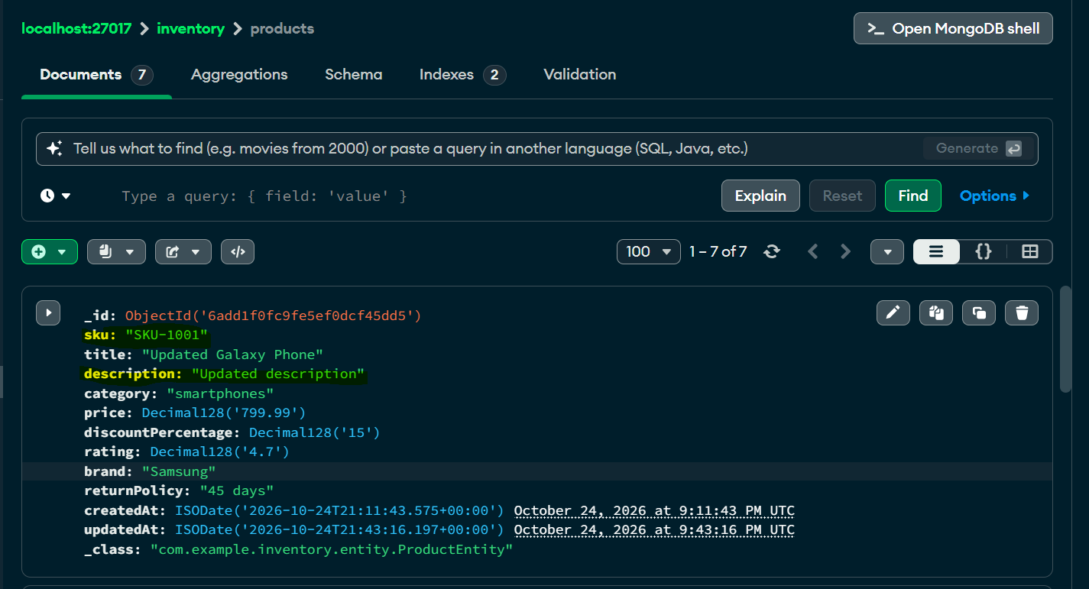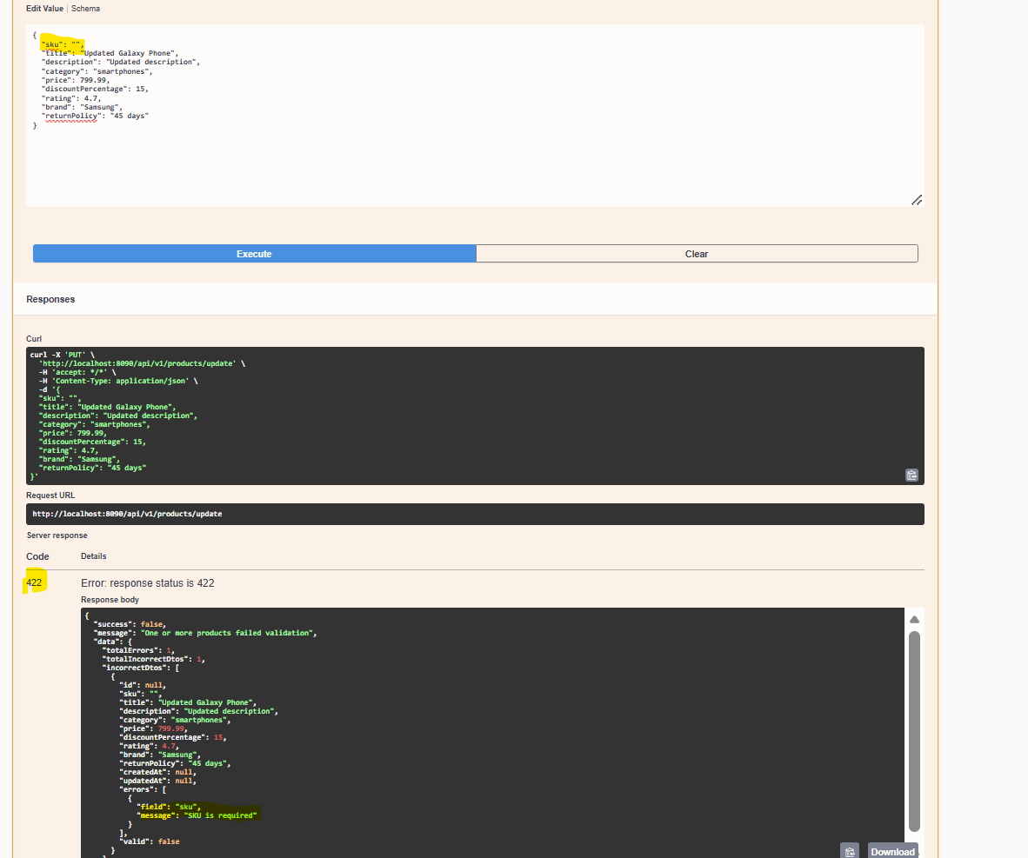

4.5 Create Multiple Products
HTTP Method: POST
Endpoint: /api/v1/products/create-multi
Success Status: 201 Created
Example Request
[
{
"sku": "SKU-1001",
"title": "Wireless Mouse",
"description": "Wireless optical mouse",
"category": "Electronics",
"price": 799.00,
"discountPercentage": 10.00,
"rating": 4.50,
"brand": "ExampleBrand",
"returnPolicy": "30 days"
},
{
"sku": "SKU-1002",
"title": "USB Keyboard",
"description": "USB keyboard",
"category": "Electronics",
"price": 1299.00,
"discountPercentage": 5.00,
"rating": 4.20,
"brand": "ExampleBrand",
"returnPolicy": "30 days"
}
]
Example Response
{
"success": true,
"message": "Products created successfully",
"data": [
{
"id": "prod001",
"sku": "SKU-1001",
"title": "Wireless Mouse",
"description": "Wireless optical mouse",
"category": "Electronics",
"price": 799.00,
"discountPercentage": 10.00,
"rating": 4.50,
"brand": "ExampleBrand",
"returnPolicy": "30 days",
"createdAt": "2026-10-20T10:00:00",
"updatedAt": "2026-10-20T10:00:00",
"errors": [],
"valid": true
}
]
}
The response above is abbreviated to one item for readability. The actual data contains the products returned by the service.

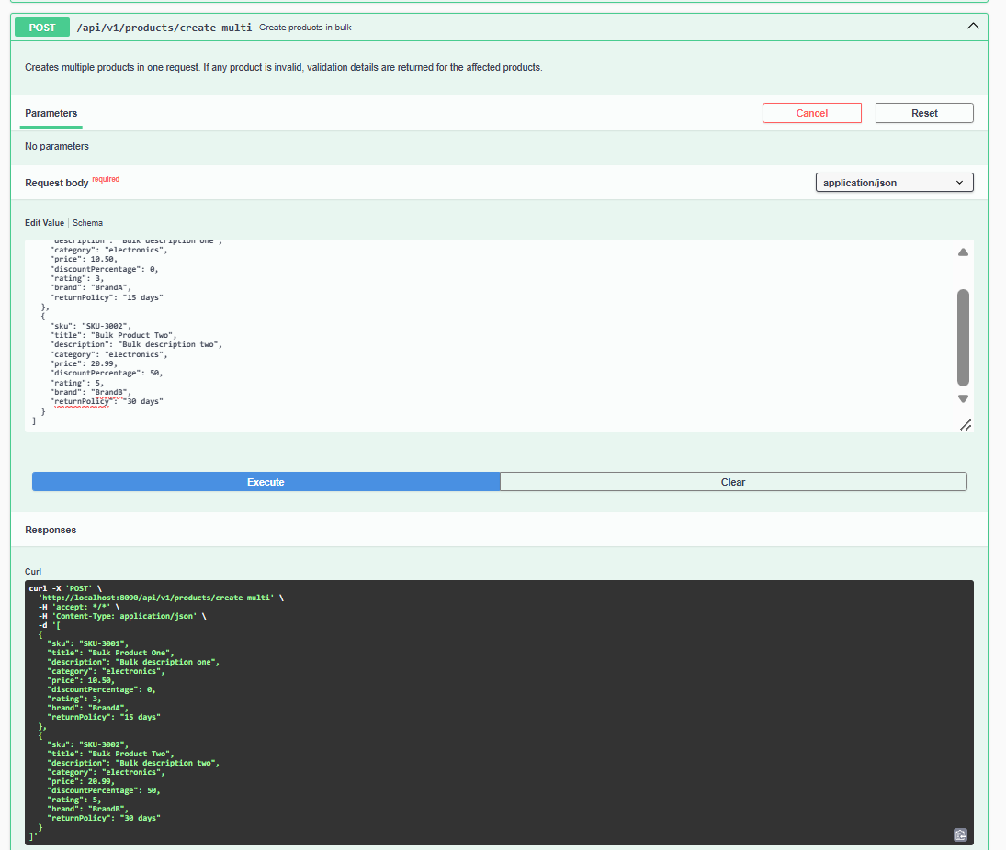
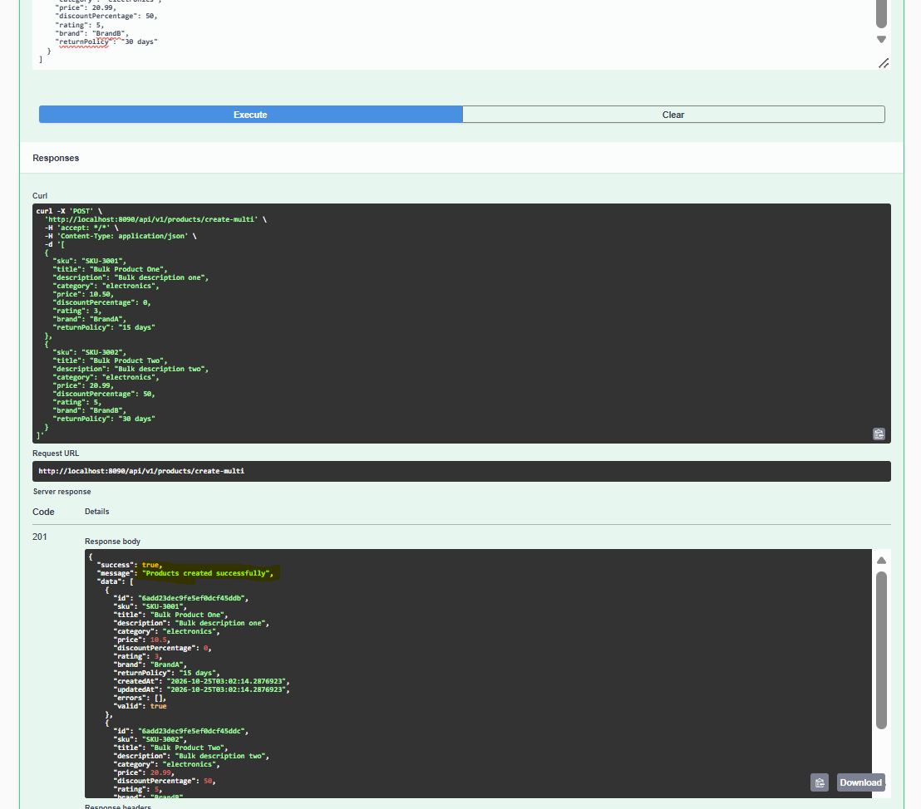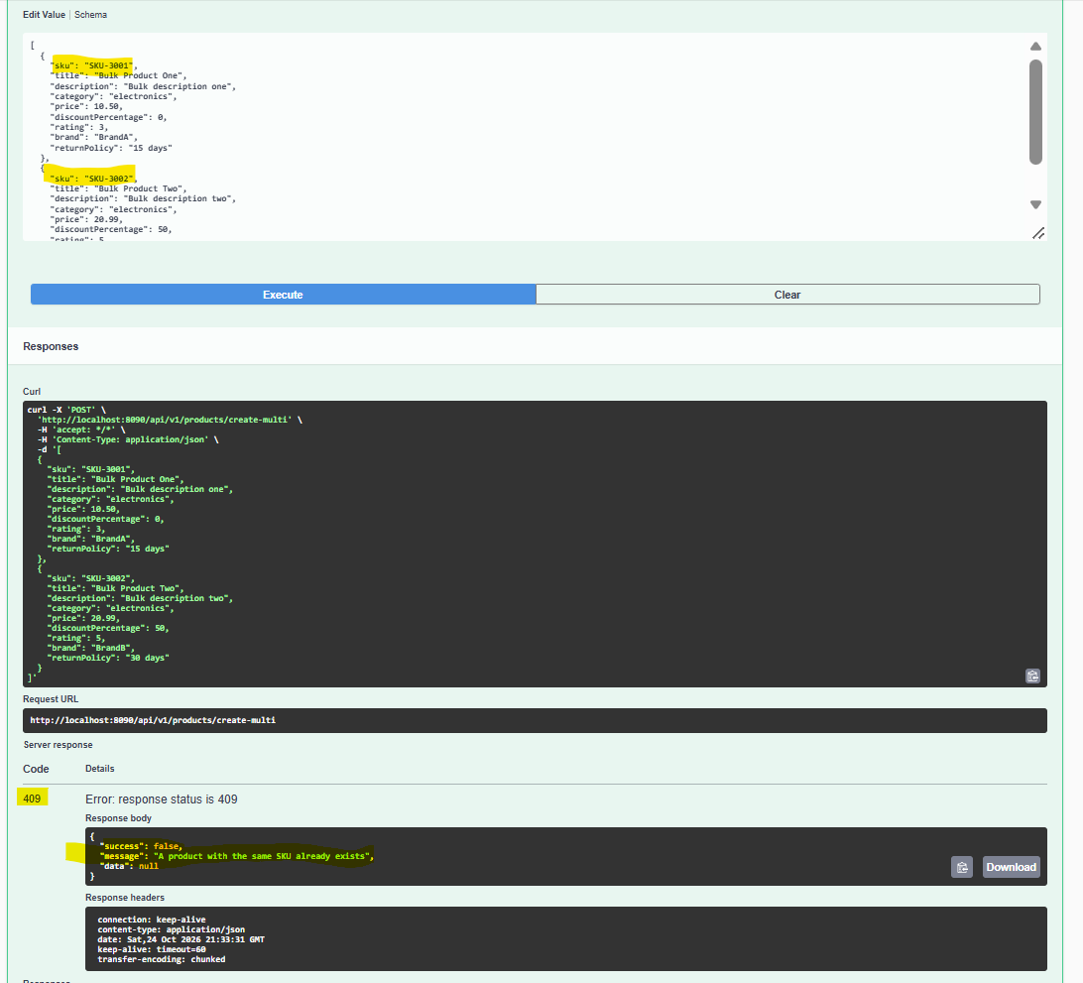

4.6 Update Multiple Products
HTTP Method: PUT
Endpoint: /api/v1/products/update-multi
Success Status: 200 OK
Request Body
An array of ProductRequestDTO objects. Each product must include the identifier and fields required by the update logic.
Response Message
"Products updated successfully"
The response data is a list of ProductResponseDTO objects

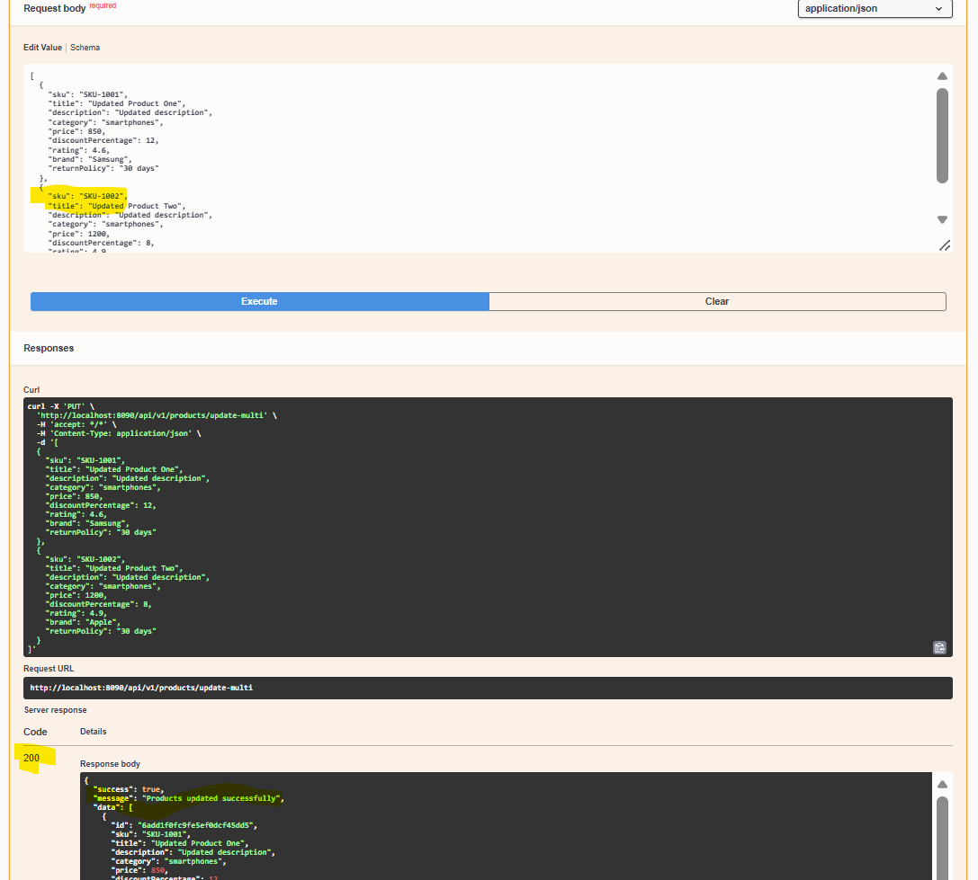.
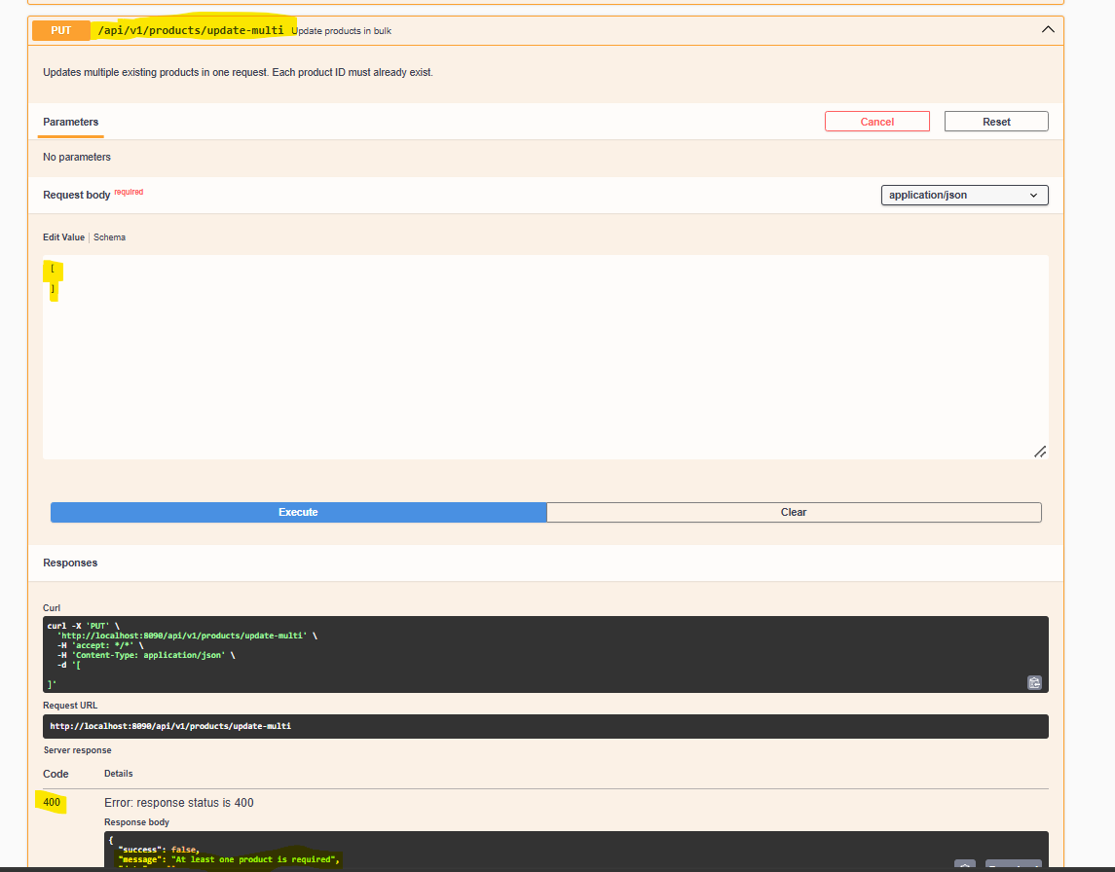
4.7 Delete Product by ID
HTTP Method: DELETE
Endpoint: /api/v1/products/{id}
Success Status: 200 OK
Example Request
DELETE /api/v1/products/prod001
Example Response
{
"success": true,
"message": "Product deleted successfully",
"data": null
}
The product service also removes related inventory records according to its deletion logic.
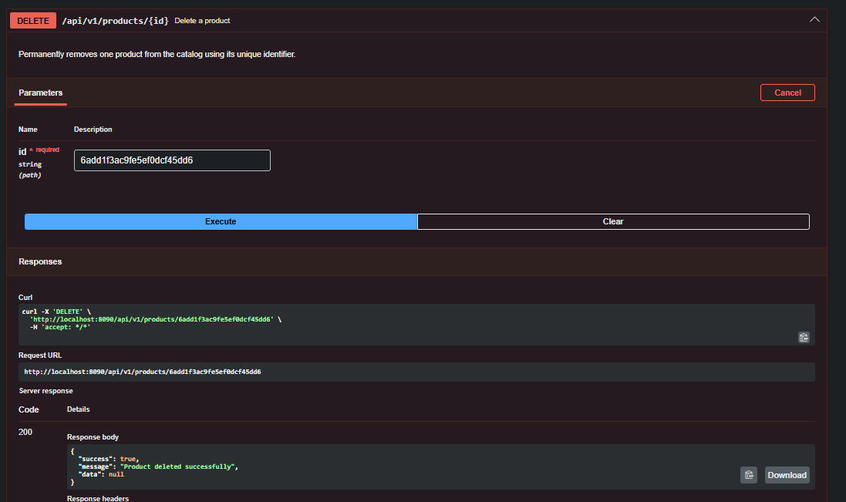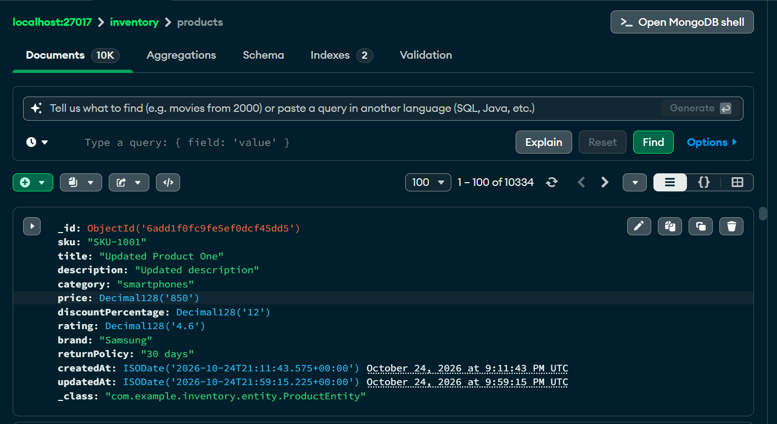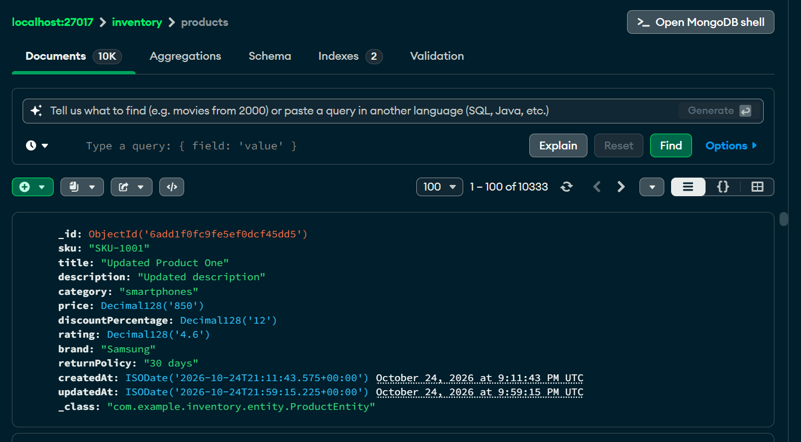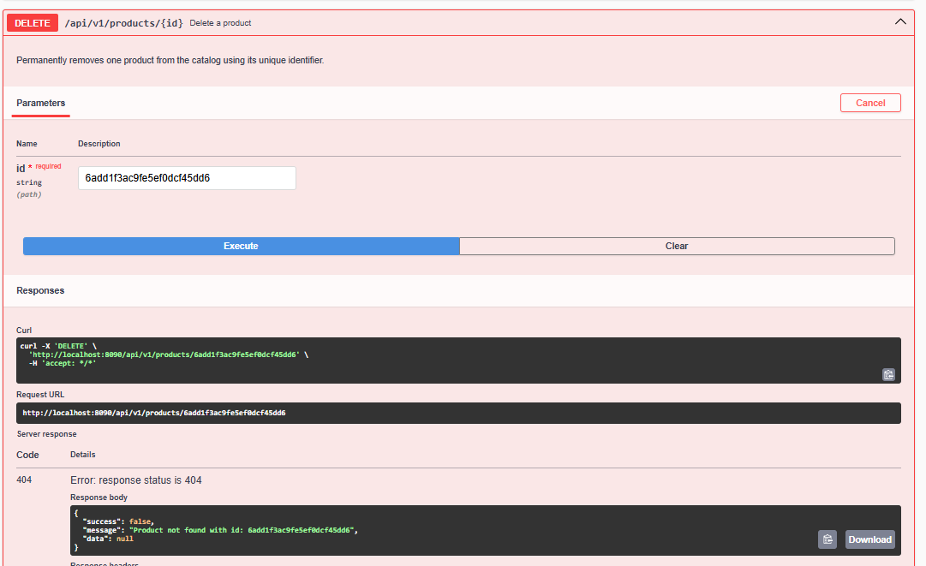
4.8 Delete All Products
HTTP Method: DELETE
Endpoint: /api/v1/products/delete-all
Success Status: 200 OK
Example Response
{
"success": true,
"message": "All products deleted successfully",
"data": null
}
This operation is destructive and should be used carefully.

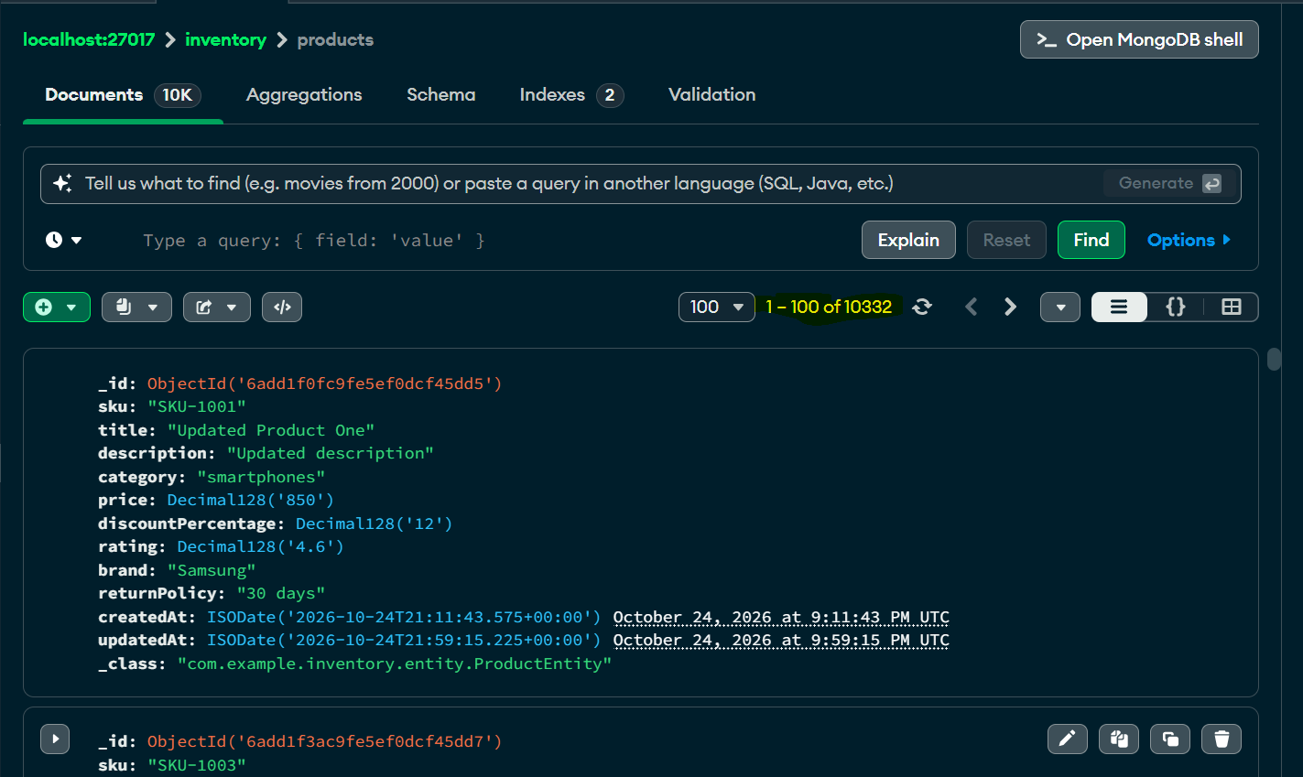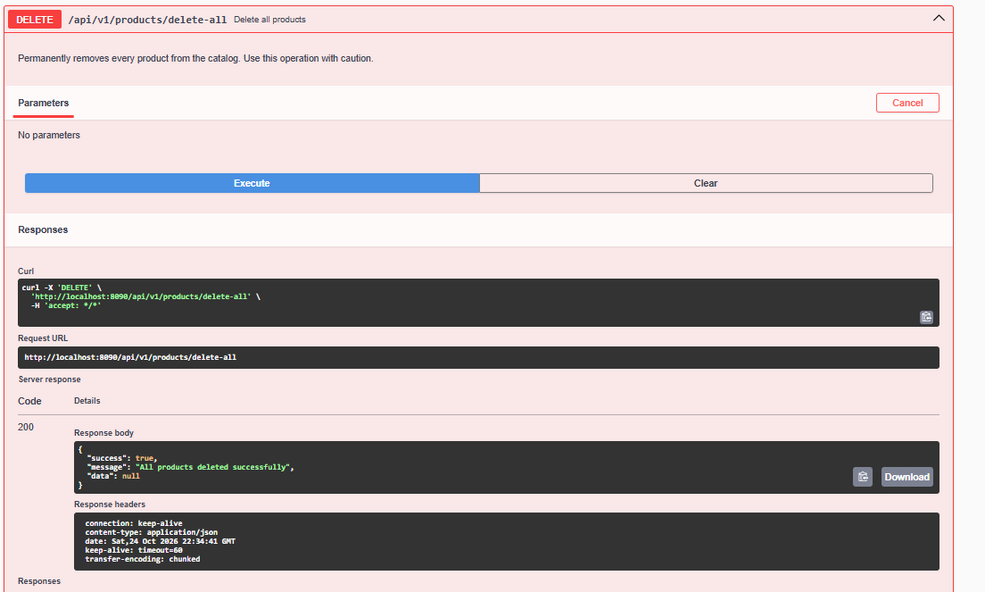
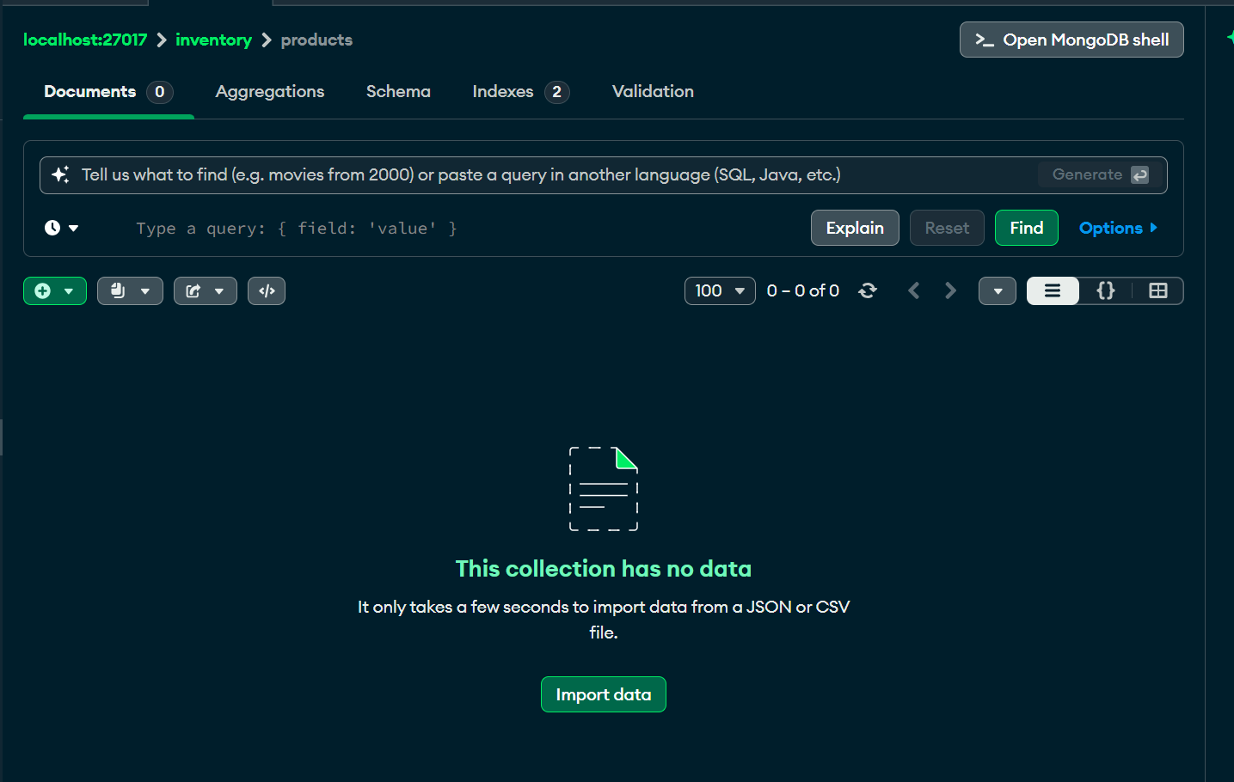
4.9 Delete Products by Filters
HTTP Method: DELETE
Endpoint: /api/v1/products/delete-by-filters
Success Status: 200 OK
Request Body
Uses SearchRequestDTO<ProductField>.
Example:
{
"filters": [
{
"field": "category",
"operator": "EQUALS",
"value": "Electronics"
}
],
"page": 0,
"size": 20,
"sortBy": "title",
"sortDirection": "ASC"
}
Example Response
{
"success": true,
"message": "Products matching filters deleted successfully",
"data": null
}
The implementation deletes products matching the supplied filters and their related inventory records.
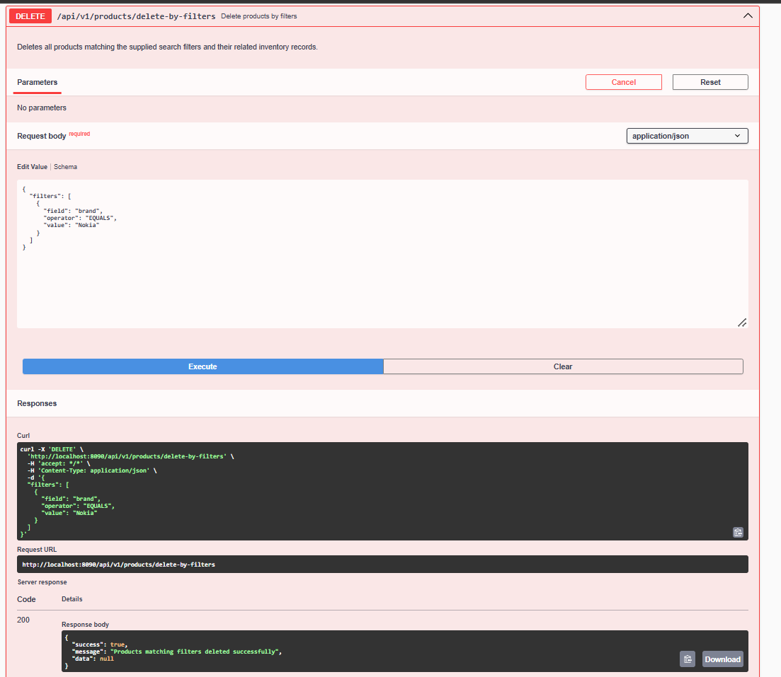
4.10 Import Products from Excel
HTTP Method: POST
Endpoint: /api/v1/products/import
Content-Type: multipart/form-data
Form Field: file
Success Status: 200 OK
Request
Upload an .xlsx file using a multipart form field named file.
Processing Flow
- The controller receives the uploaded file.
- ProductExcelParser reads and parses the spreadsheet.
- Rows containing an ID are treated as updates.
- Rows without an ID are treated as creations.
- The service validates all rows before persistence.
- The response separates created and updated products.
Example Response
{
"success": true,
"message": "Products imported successfully",
"data": {
"created": [
{
"id": "prod101",
"sku": "SKU-101",
"title": "New Product",
"description": "Imported product",
"category": "Electronics",
"price": 500.00,
"discountPercentage": 0.00,
"rating": 4.00,
"brand": "ExampleBrand",
"returnPolicy": "30 days",
"createdAt": "2026-10-23T10:00:00",
"updatedAt": "2026-10-23T10:00:00",
"errors": [],
"valid": true
}
],
"updated": []
}
}
This example illustrates the ImportResponseDTO structure. The actual imported records depend on the uploaded file.
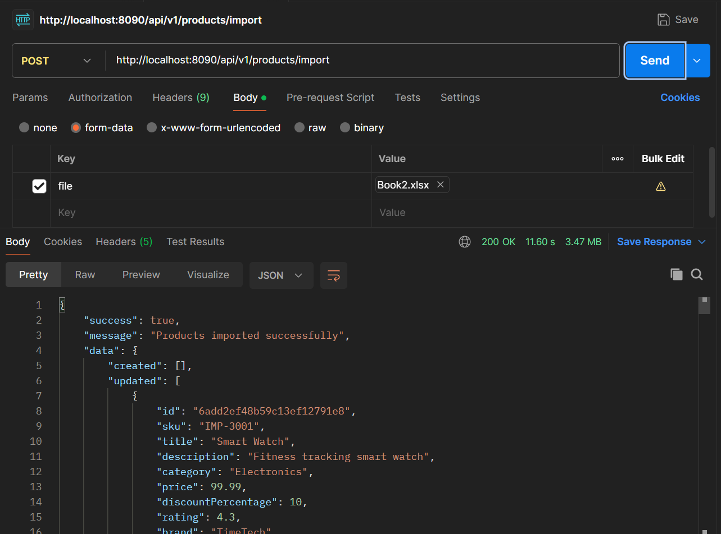
5. PRODUCT SEARCH APIs
5.1 Advanced Product Search
HTTP Method: POST
Endpoint: /api/v1/products/advance-search
Success Status: 200 OK
Request Structure
The endpoint accepts SearchRequestDTO<ProductField>.
Fields:
- filters: List of filter objects.
- page: Zero-based page number.
- size: Page size, limited to 100.
- sortBy: Field used for sorting.
- sortDirection: ASC or DESC.
Each filter contains:
- field
- operator
- value
Supported Product Fields
ID, SKU, TITLE, DESCRIPTION, CATEGORY, PRICE, DISCOUNT_PERCENTAGE, RATING, BRAND, RETURN_POLICY, CREATED_AT, UPDATED_AT.
The JSON parser accepts enum names or their configured field values, case-insensitively.
Supported Operators
EQUALS, NOT_EQUALS, CONTAINS, STARTS_WITH, ENDS_WITH, GREATER_THAN, GREATER_THAN_OR_EQUAL, LESS_THAN, LESS_THAN_OR_EQUAL, IN, BETWEEN.
Example Request
{
"filters": [
{
"field": "category",
"operator": "EQUALS",
"value": "Electronics"
},
{
"field": "price",
"operator": "LESS_THAN_OR_EQUAL",
"value": 1000
}
],
"page": 0,
"size": 10,
"sortBy": "price",
"sortDirection": "ASC"
}
Filter Behavior
Multiple filters use AND semantics. A product must satisfy all supplied filters.
Example Response
{
"success": true,
"message": "Products searched successfully",
"data": {
"content": [],
"totalRecords": 0,
"page": 0,
"pageSize": 10,
"totalPages": 0,
"first": true,
"last": true
}
}
The empty result is an illustrative example; actual records depend on the database and filters. 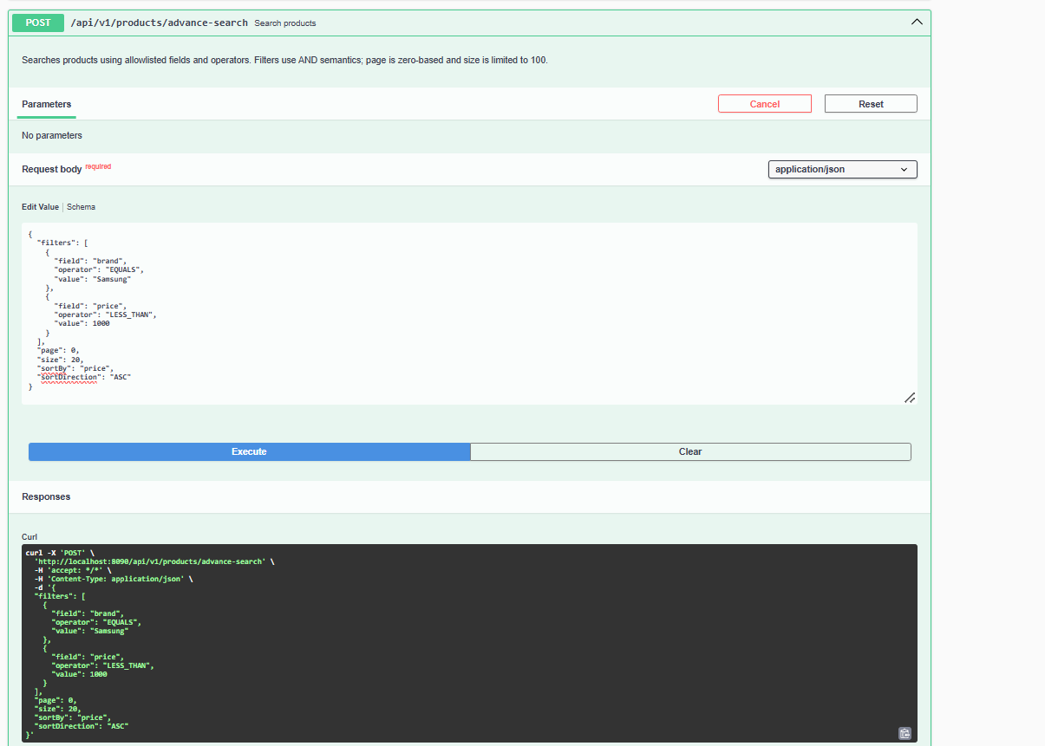
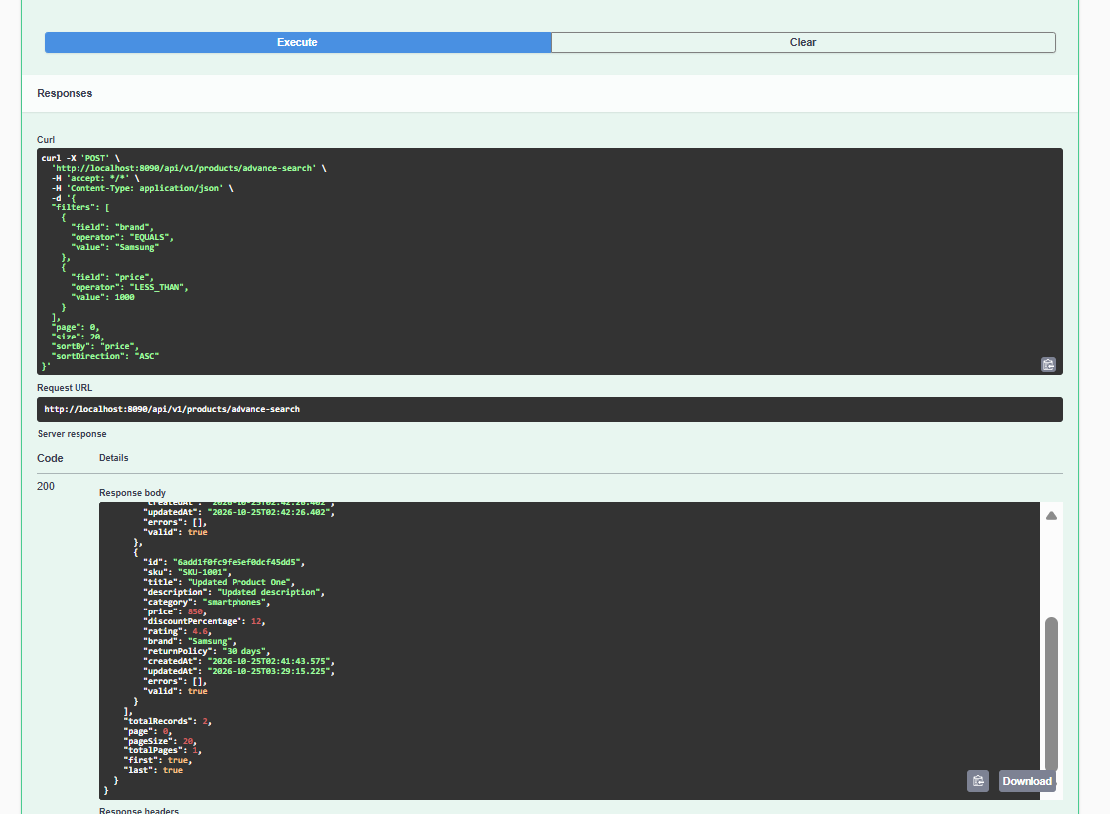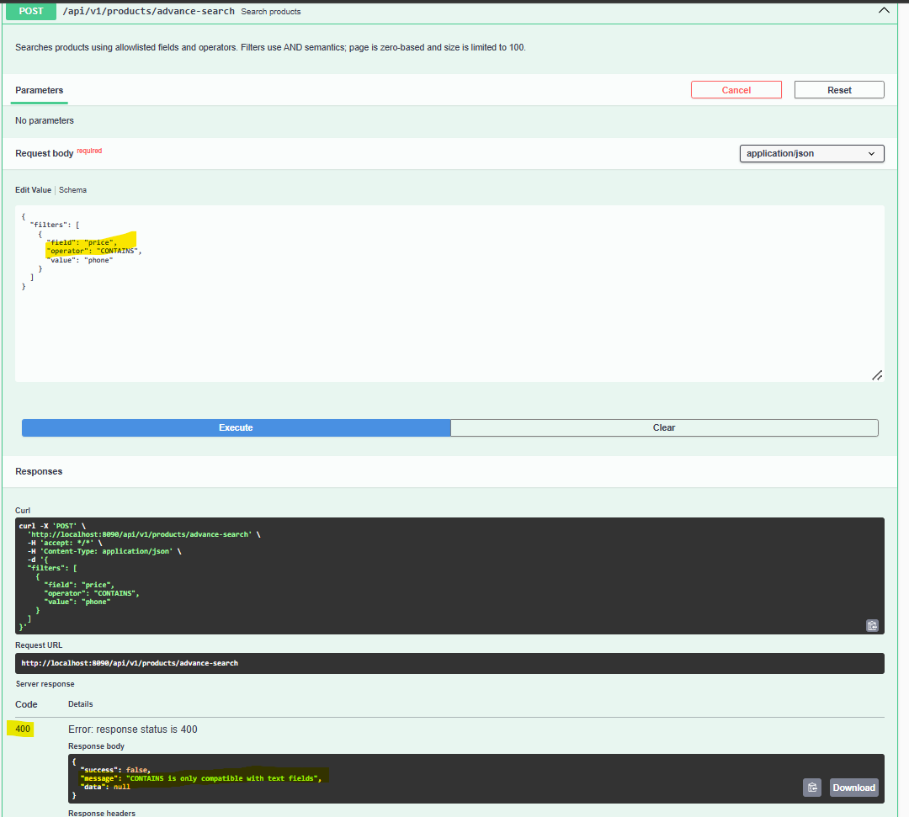
5.2 Query-Parameter Product Search
HTTP Method: GET
Endpoint: /api/v1/products/search
Success Status: 200 OK
Supported Query Parameters
Text parameters:
- query
- title
- description
- sku
- brand
- category
- returnPolicy
Numeric ranges:
- minPrice
- maxPrice
- minRating
- maxRating
- minDiscountPercentage
- maxDiscountPercentage
Numeric comparisons:
- priceOperator
- priceValue
- ratingOperator
- ratingValue
- discountOperator
- discountValue
Multiple-value parameters:
- brands
- categories
Range parameters:
- priceBetween
- ratingBetween
Pagination and sorting:
- page
- size
- sortBy
- sortDirection
Example Request
GET /api/v1/products/search?query=phone&category=Electronics&minPrice=500&maxPrice=2000&page=0&size=10&sortBy=price&sortDirection=ASC
Search Behavior
- The query parameter searches across title, description, SKU, brand, and category.
- Supplied filters use AND semantics.
- The query keyword searches across the supported text fields using OR semantics.
- If no filters are supplied, the endpoint returns a paginated product listing.
- Numeric ranges and explicit comparison filters for the same numeric field cannot be combined.
- Page numbering starts at zero.
- Page size is limited to 100.
Example Response
The response uses ApiResponseDTO<PageResponseDTO<ProductResponseDTO>> with the message "Products searched successfully".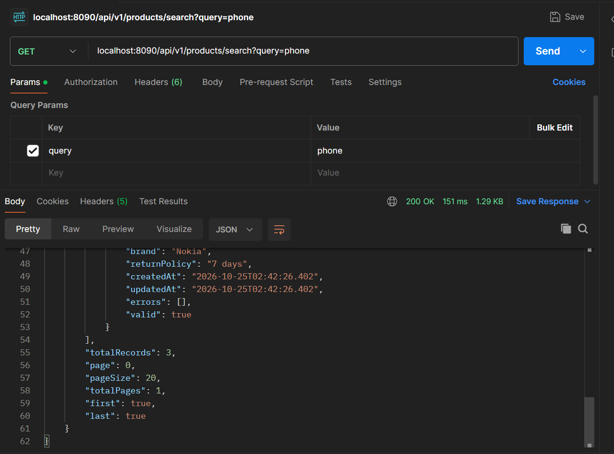

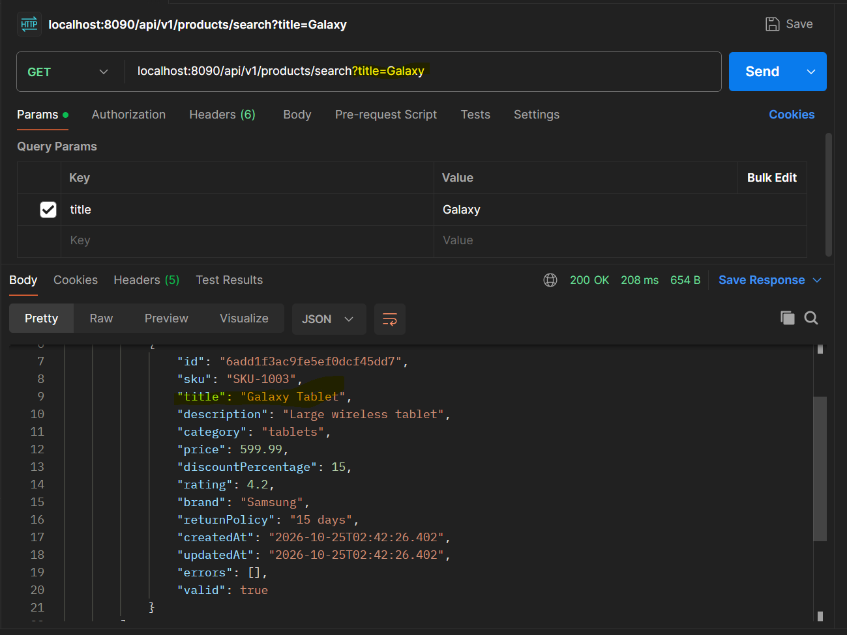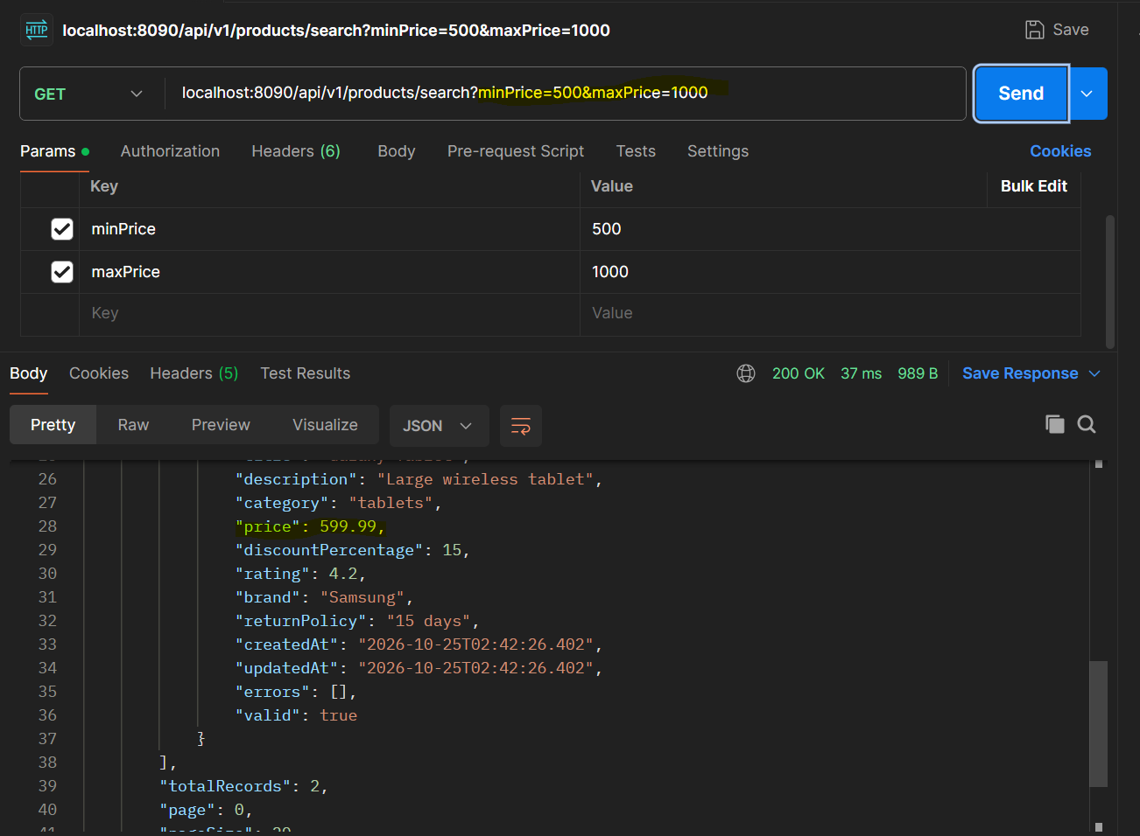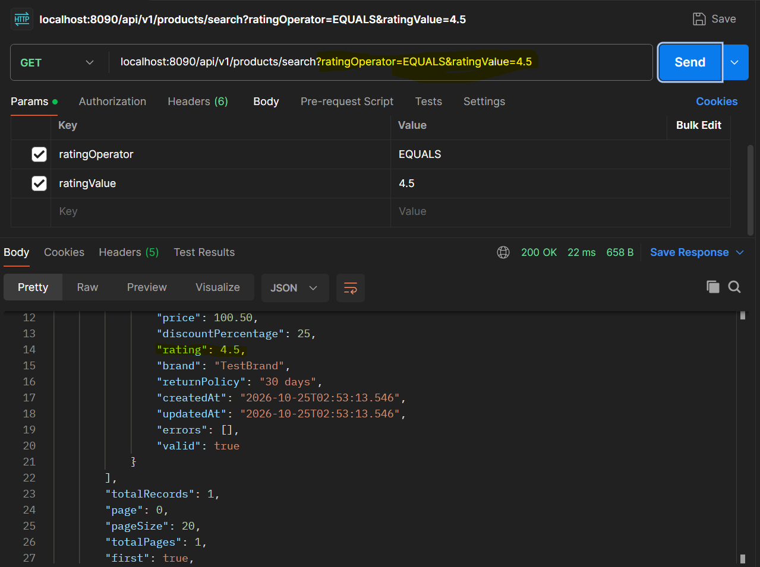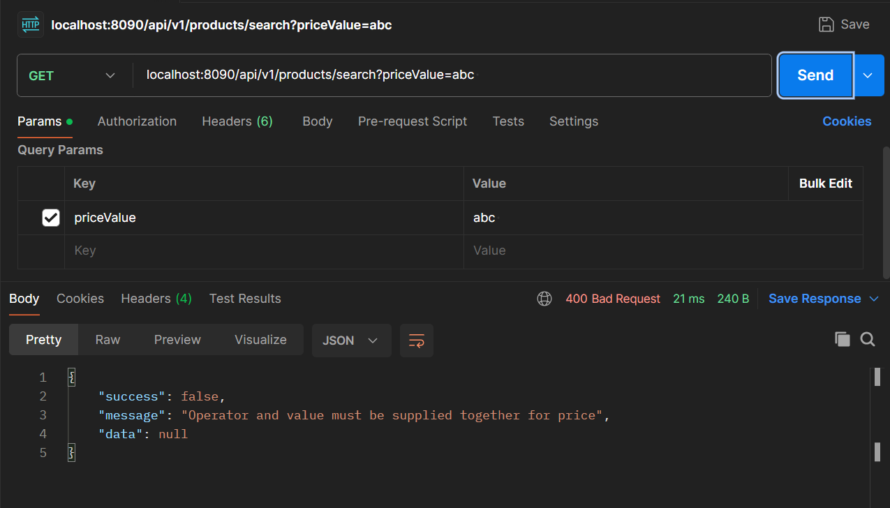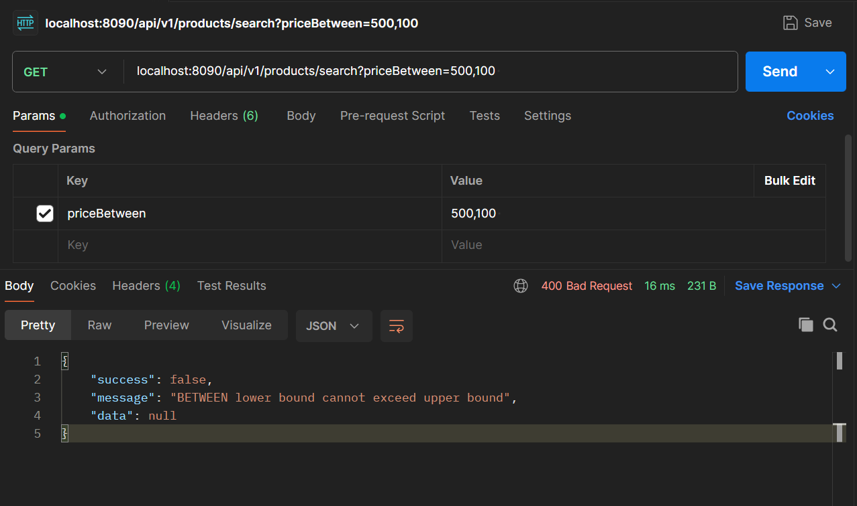
6. WAREHOUSE API DOCUMENTATION
6.1 Create Warehouse
HTTP Method: POST
Endpoint: /api/v1/warehouses/create
Success Status: 201 Created
Request Fields
WarehouseRequestDTO contains:
- id
- code
- name
- address
- city
- state
- postalCode
- active
The errors and isValid fields are used by the validation logic.
Validation Rules
The WarehouseValidator checks:
- Code is required and no longer than 50 characters.
- Name is required and no longer than 150 characters.
- Address is required and no longer than 250 characters.
- City is required and no longer than 100 characters.
- State is required and no longer than 100 characters.
- Postal code is required and no longer than 20 characters.
Example Request
{
"code": "WH-001",
"name": "Central Warehouse",
"address": "100 Main Street",
"city": "Bengaluru",
"state": "Karnataka",
"postalCode": "560001",
"active": true
}
Example Response
{
"success": true,
"message": "Warehouse created successfully",
"data": {
"id": "wh001",
"code": "WH-001",
"name": "Central Warehouse",
"address": "100 Main Street",
"city": "Bengaluru",
"state": "Karnataka",
"postalCode": "560001",
"active": true,
"createdAt": "2026-10-23T10:00:00",
"updatedAt": "2026-10-23T10:00:00",
"errors": [],
"valid": true
}
}
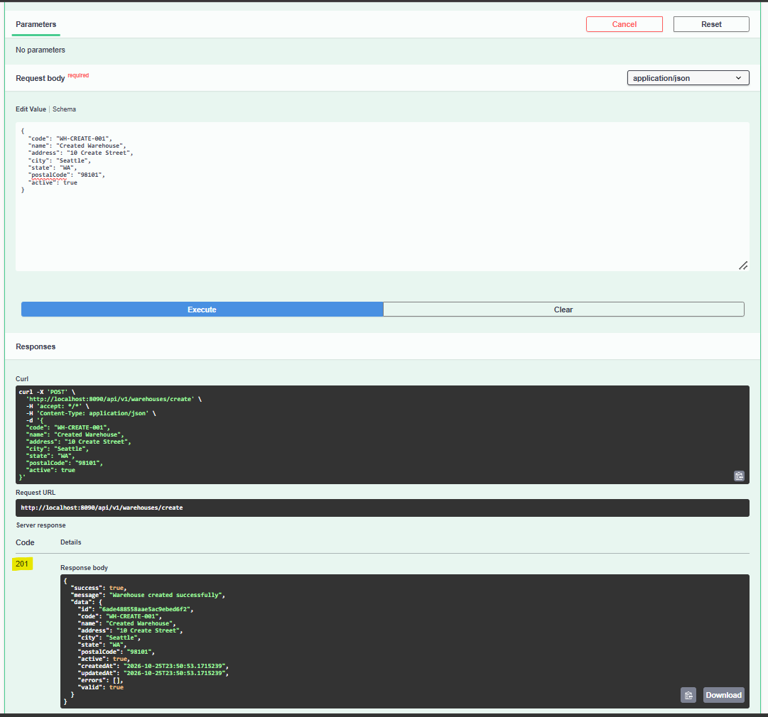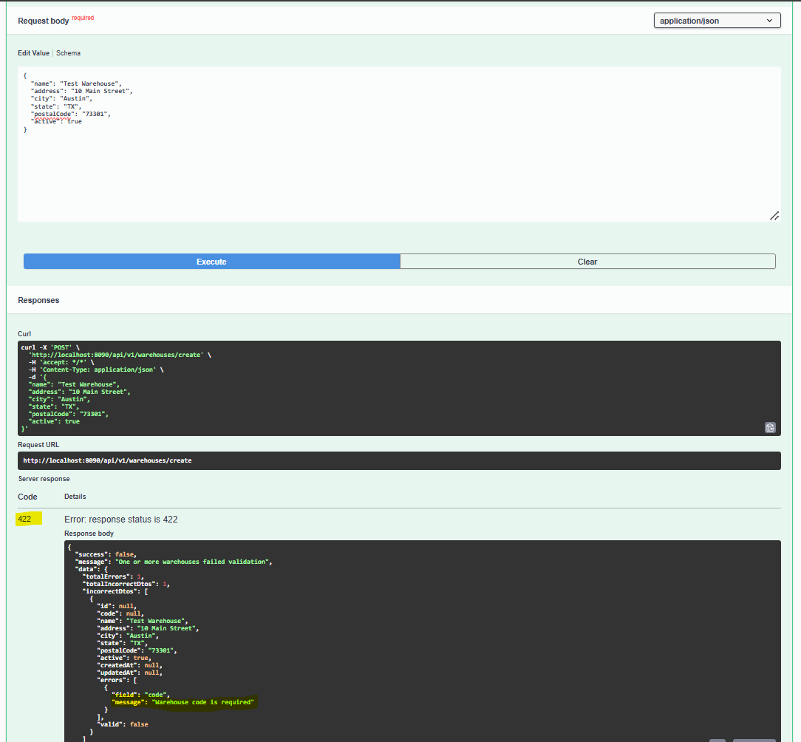
6.2 Get All Warehouses
HTTP Method: GET
Endpoint: /api/v1/warehouses
Success Status: 200 OK
Query Parameters
- page: Zero-based page number; default 0.
- size: Page size; configured default 20 and maximum 100.
Example Request
GET /api/v1/warehouses?page=0&size=10
Response Structure
The response is ApiResponseDTO<PageResponseDTO<WarehouseResponseDTO>>.
The data object contains:
- content
- totalRecords
- page
- pageSize
- totalPages
- first
- last
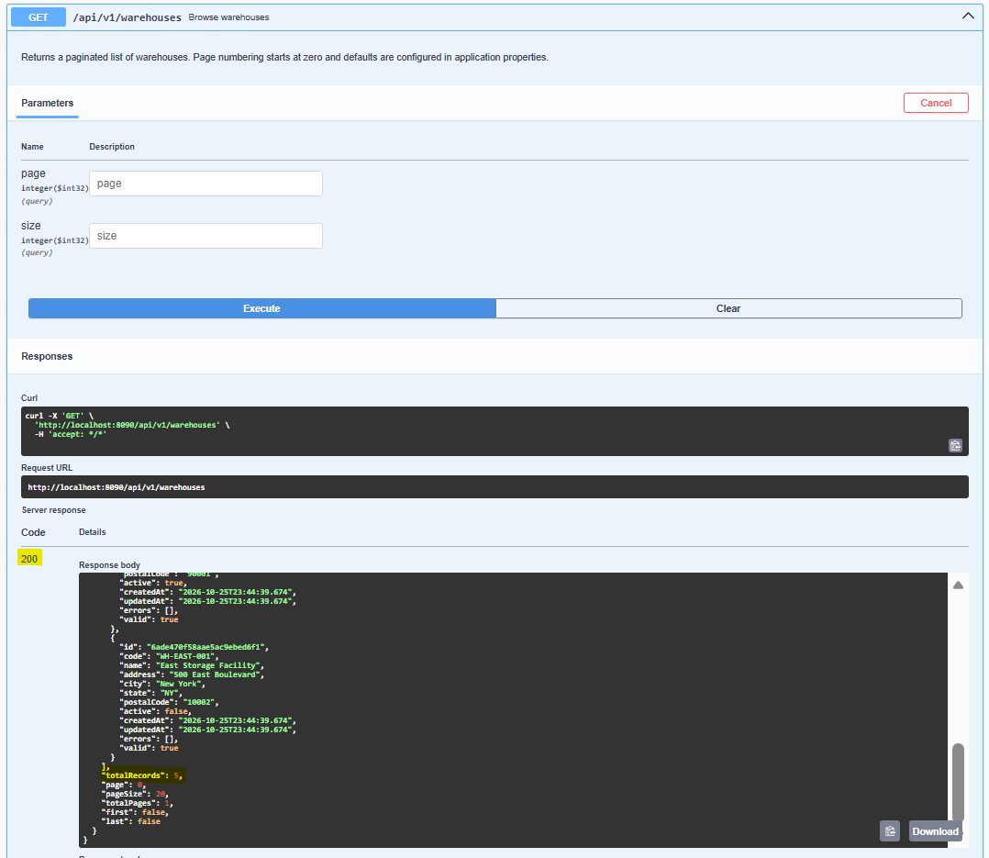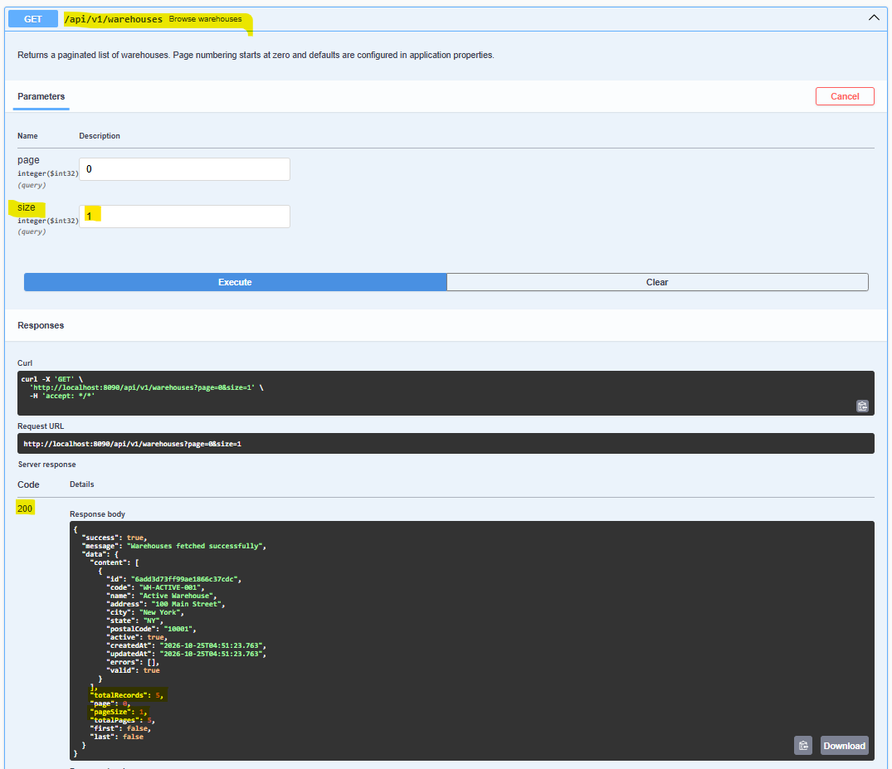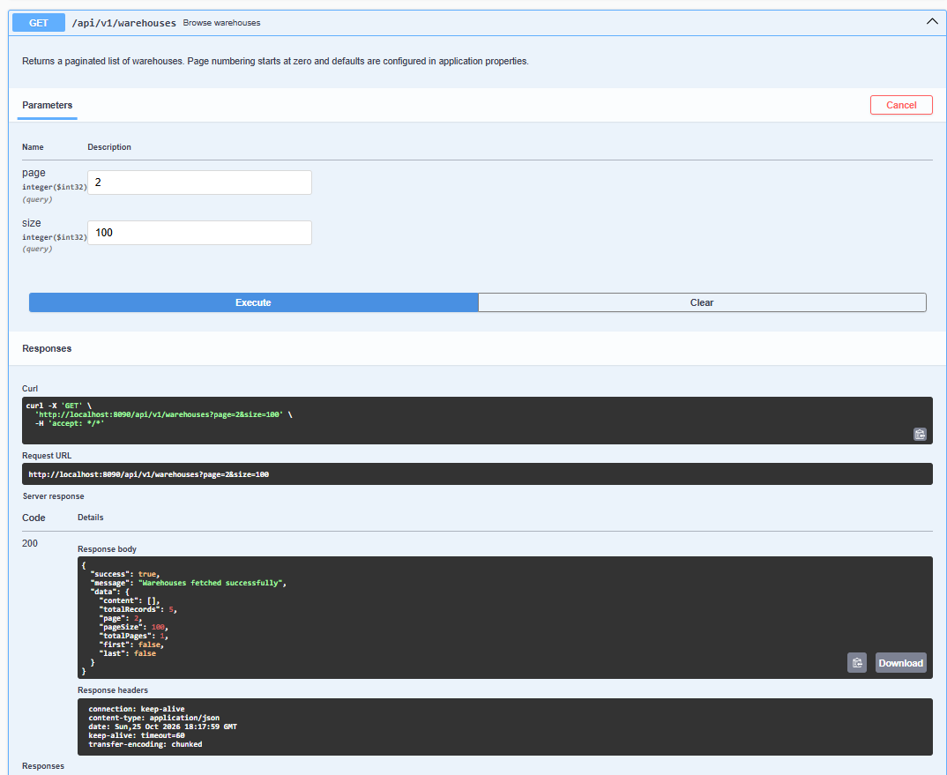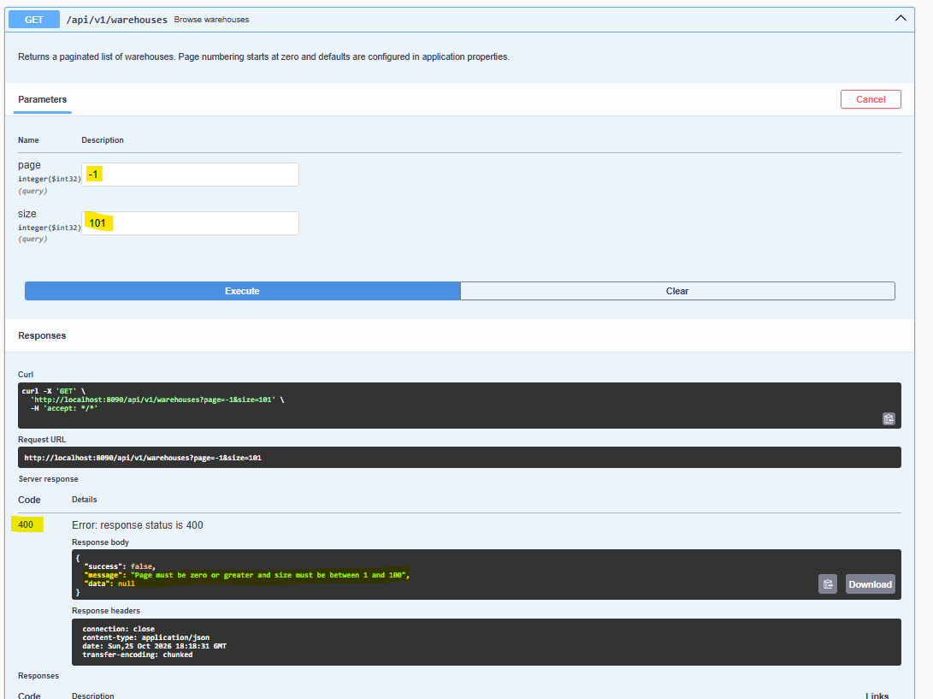
6.3 Get Warehouse by ID
HTTP Method: GET
Endpoint: /api/v1/warehouses/{id}
Success Status: 200 OK
Example:
GET /api/v1/warehouses/wh001
The response uses the standard envelope with message "Warehouse fetched successfully" and a WarehouseResponseDTO in data.
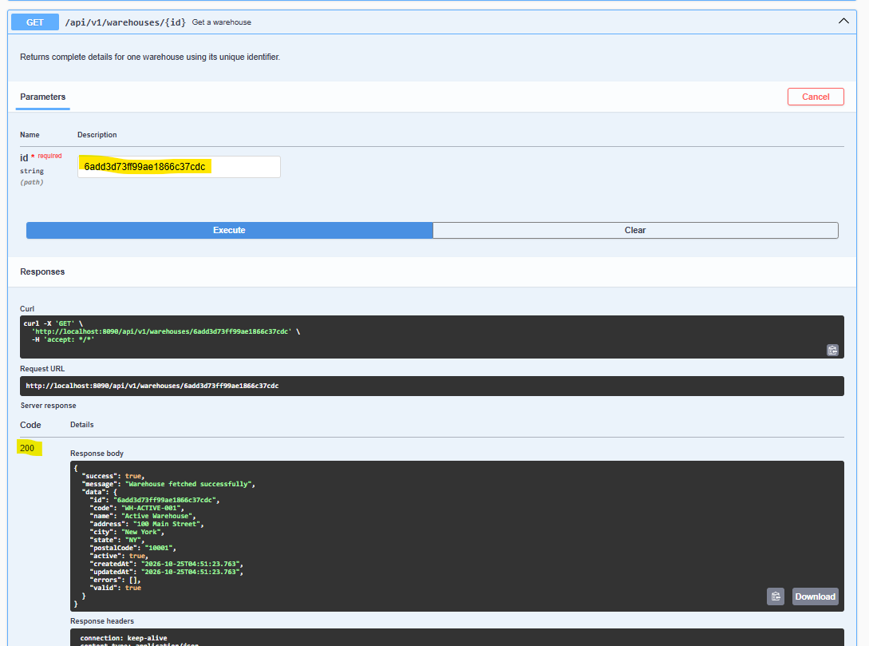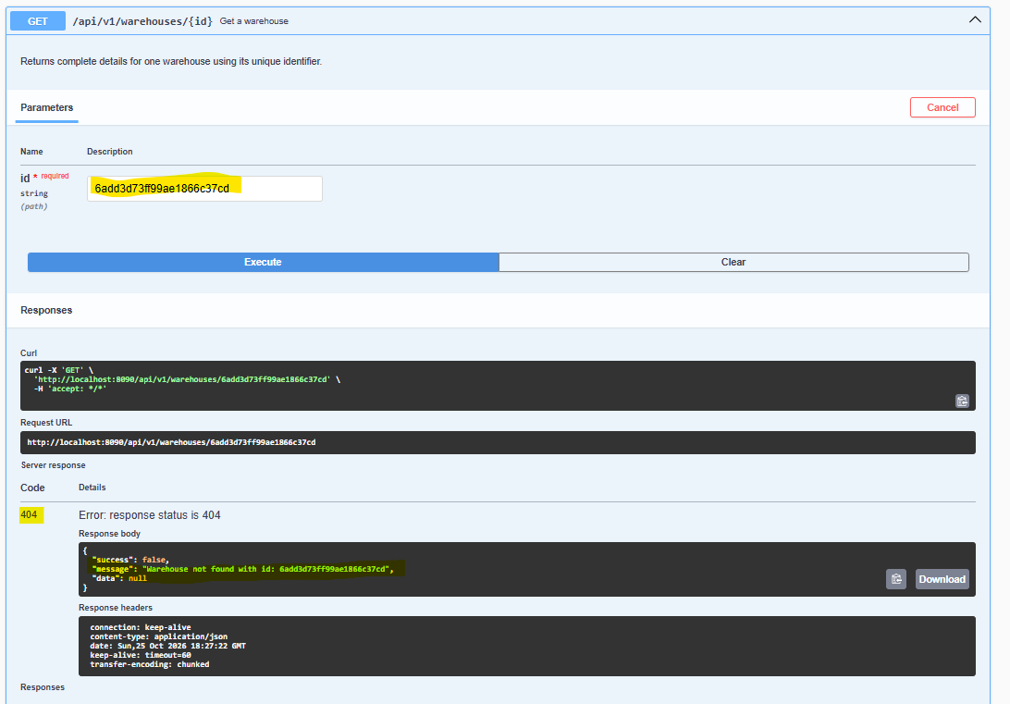

6.4 Update Warehouse
HTTP Method: PUT
Endpoint: /api/v1/warehouses/update
Success Status: 200 OK
Example Request
{
"id": "wh001",
"code": "WH-001",
"name": "Central Warehouse Updated",
"address": "200 Main Street",
"city": "Bengaluru",
"state": "Karnataka",
"postalCode": "560001",
"active": true
}
Example Response
{
"success": true,
"message": "Warehouse updated successfully",
"data": {
"id": "wh001",
"code": "WH-001",
"name": "Central Warehouse Updated",
"address": "200 Main Street",
"city": "Bengaluru",
"state": "Karnataka",
"postalCode": "560001",
"active": true,
"createdAt": "2026-10-23T10:00:00",
"updatedAt": "2026-10-23T11:00:00",
"errors": [],
"valid": true
}
}
The exact update behavior is implemented in WarehouseServiceImpl.
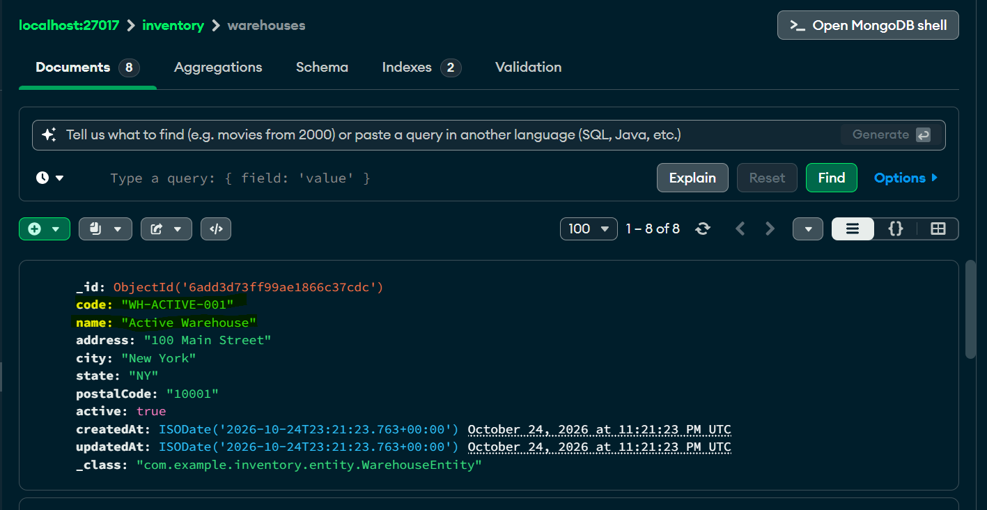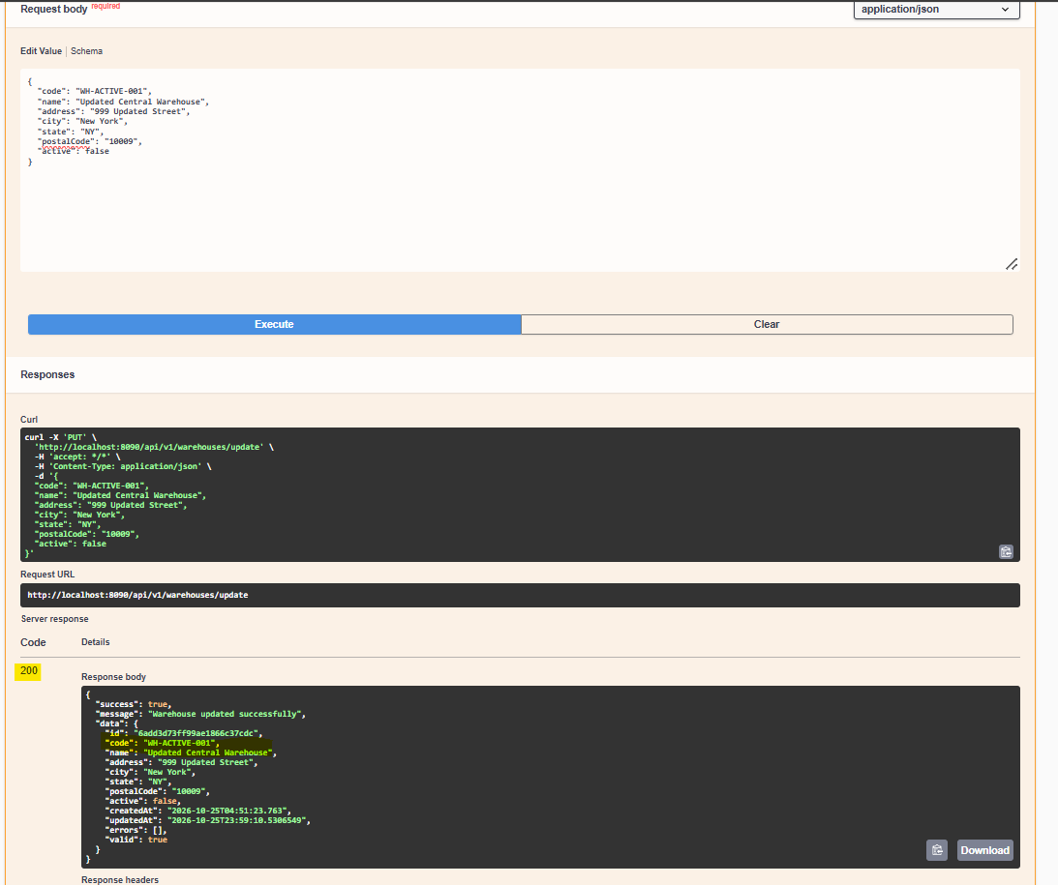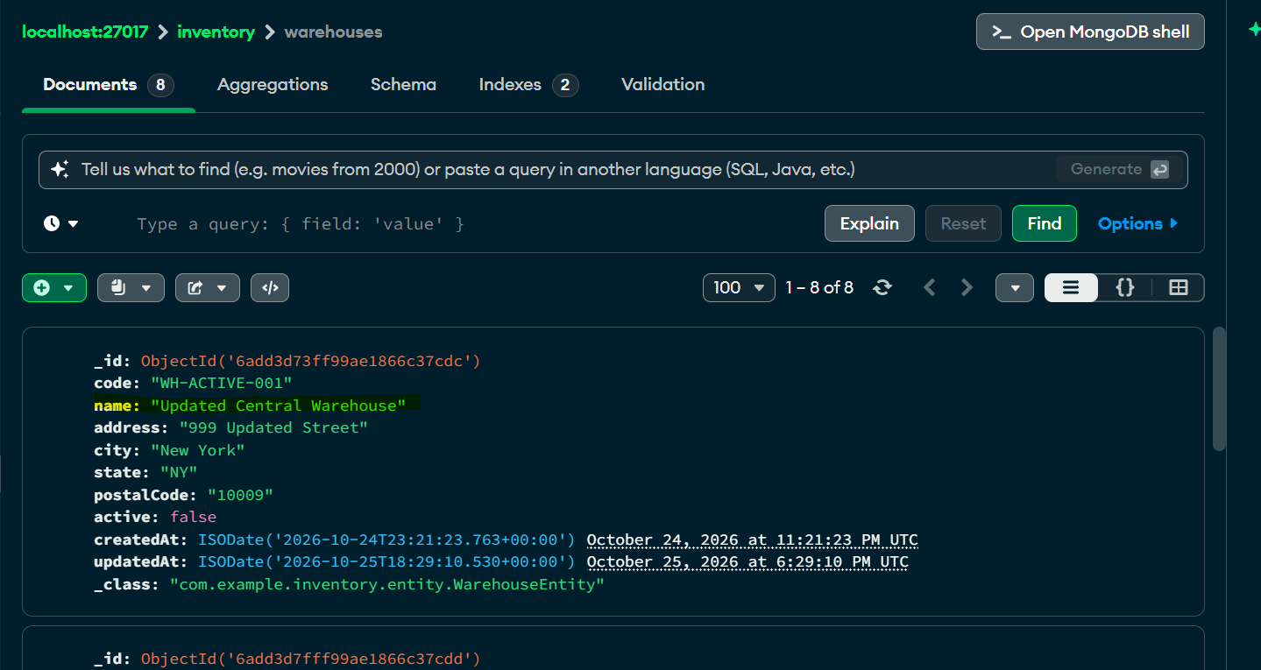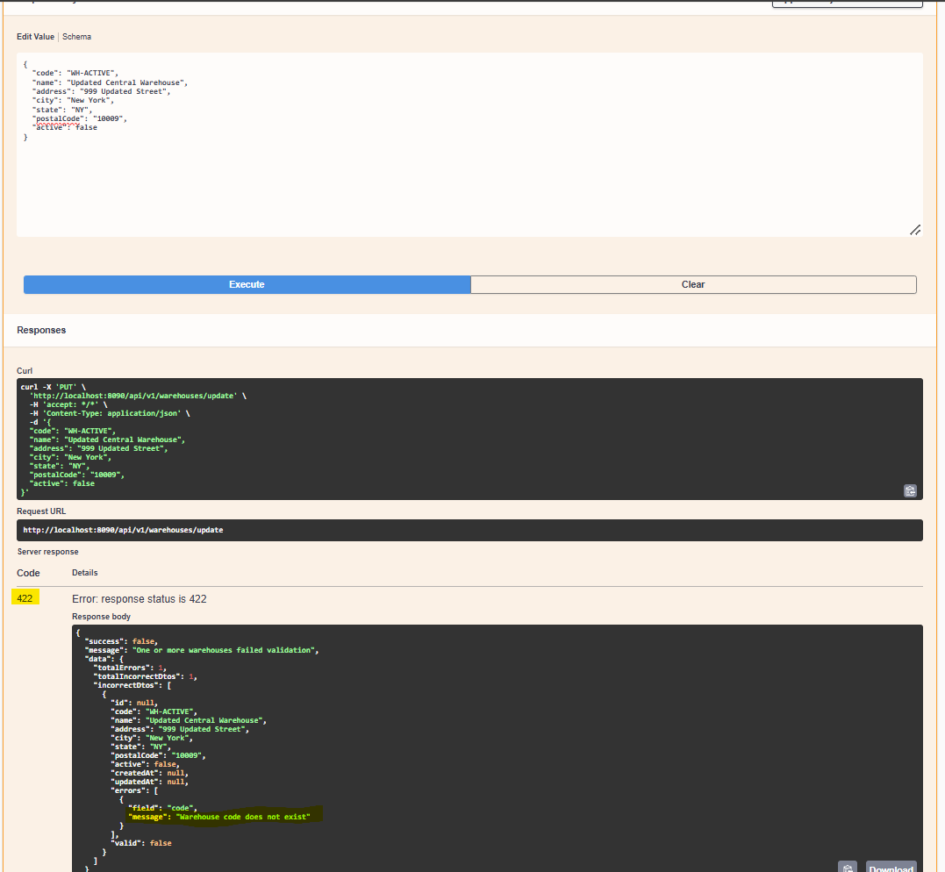
6.5 Create Multiple Warehouses
HTTP Method: POST
Endpoint: /api/v1/warehouses/create-multi
Success Status: 201 Created
Request Body
An array of WarehouseRequestDTO objects.
[
{
"code": "WH-001",
"name": "Central Warehouse",
"address": "100 Main Street",
"city": "Bengaluru",
"state": "Karnataka",
"postalCode": "560001",
"active": true
},
{
"code": "WH-002",
"name": "North Warehouse",
"address": "20 North Road",
"city": "Bengaluru",
"state": "Karnataka",
"postalCode": "560002",
"active": true
}
]
The response uses the message "Warehouses created successfully" and returns a list of WarehouseResponseDTO objects in data.
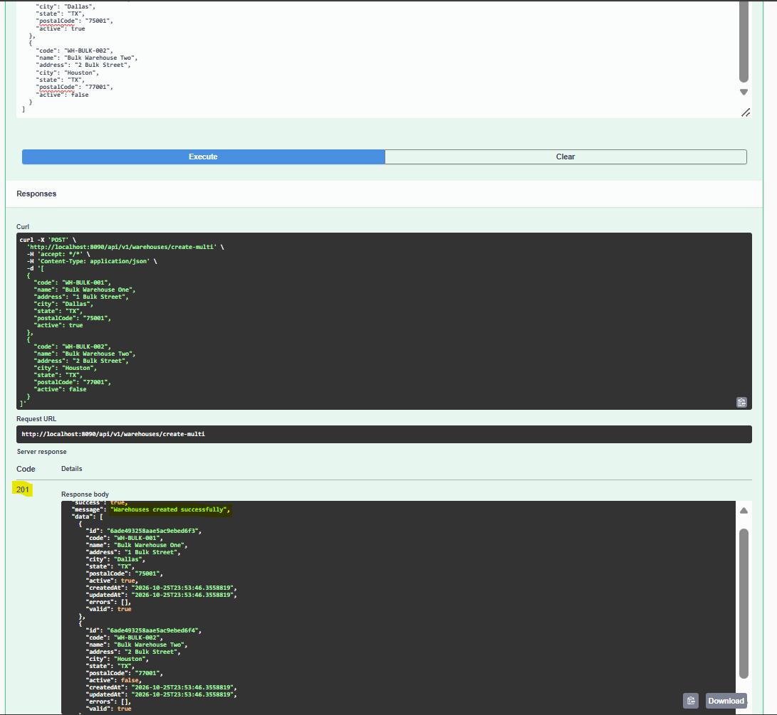
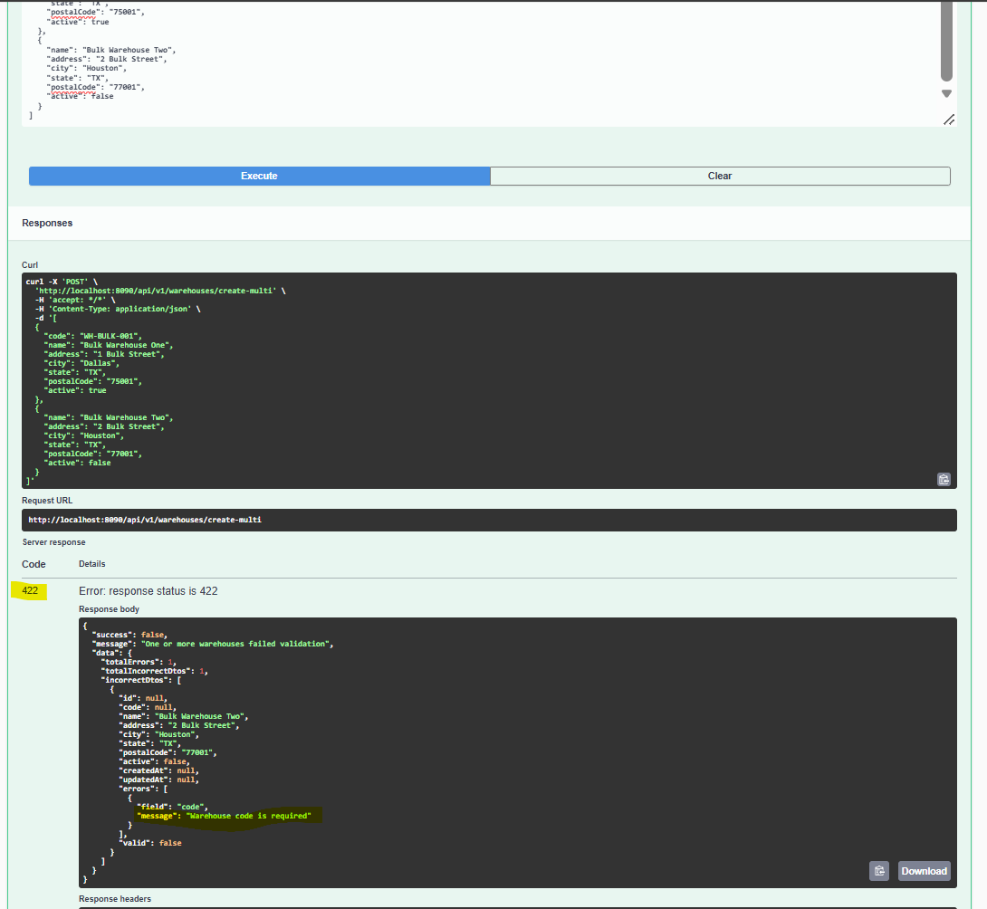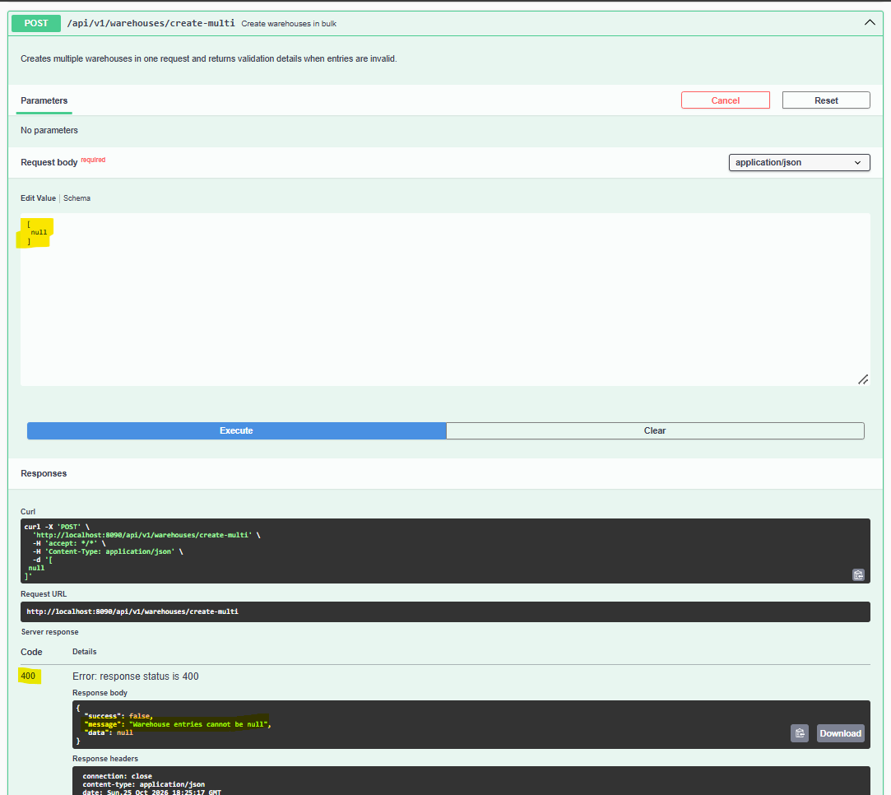
6.6 Update Multiple Warehouses
HTTP Method: PUT
Endpoint: /api/v1/warehouses/update-multi
Success Status: 200 OK
Request body: Array of WarehouseRequestDTO objects. Each warehouse ID must refer to an existing warehouse.
The response message is "Warehouses updated successfully".

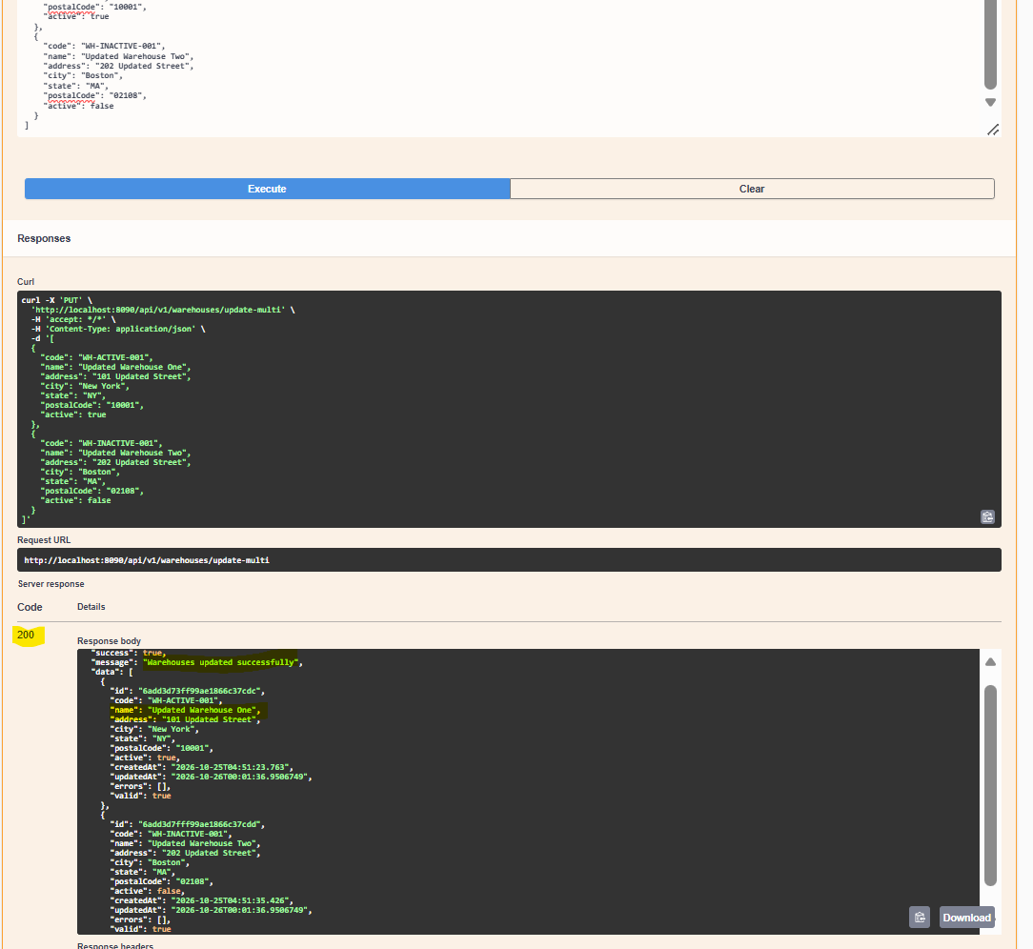
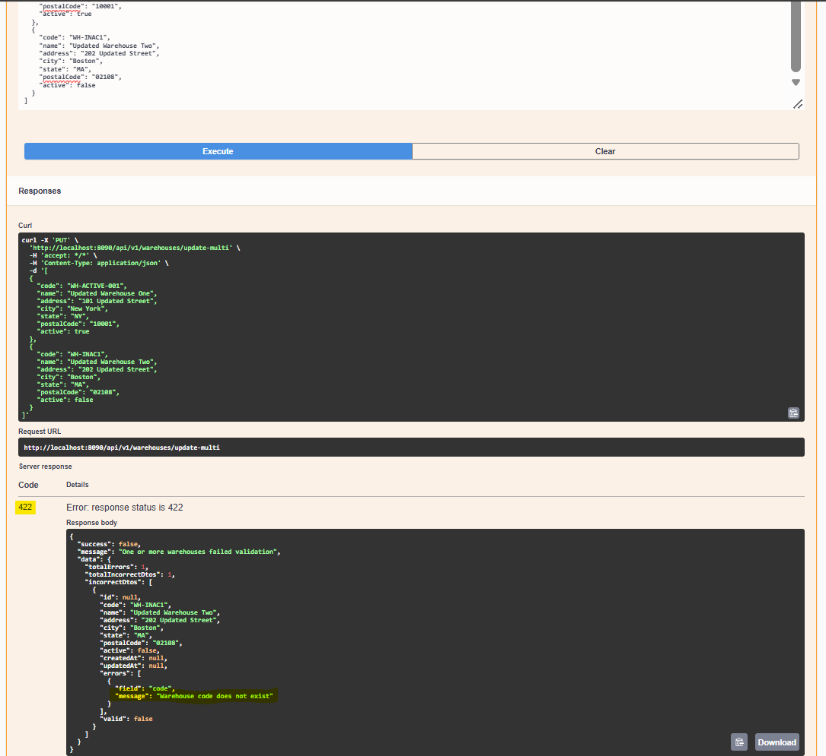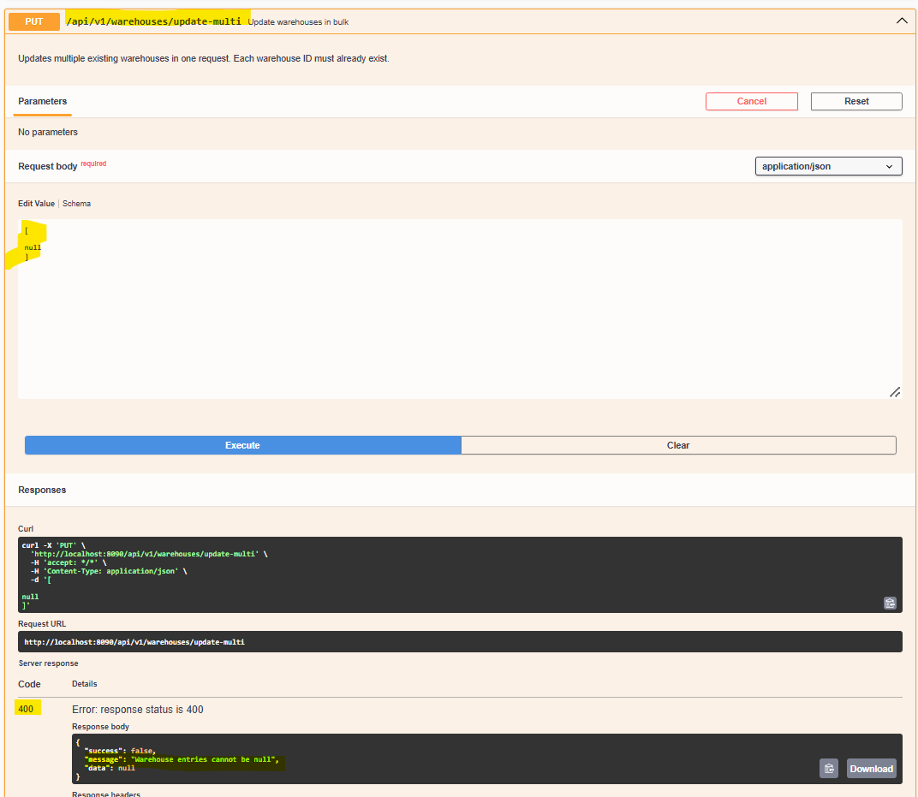
6.7 Delete Warehouse by ID
HTTP Method: DELETE
Endpoint: /api/v1/warehouses/{id}
Success Status: 200 OK
Example:
DELETE /api/v1/warehouses/wh001
Response:
{
"success": true,
"message": "Warehouse deleted successfully",
"data": null
}
The warehouse service determines how related inventory records are handled.
6.8 Delete All Warehouses
HTTP Method: DELETE
Endpoint: /api/v1/warehouses/delete-all
Success Status: 200 OK
Response:
{
"success": true,
"message": "All warehouses deleted successfully",
"data": null
}
6.9 Delete Warehouses by Filters
HTTP Method: DELETE
Endpoint: /api/v1/warehouses/delete-by-filters
Success Status: 200 OK
Request body: SearchRequestDTO<WarehouseField>.
Example:
{
"filters": [
{
"field": "city",
"operator": "EQUALS",
"value": "Bengaluru"
}
],
"page": 0,
"size": 20,
"sortBy": "name",
"sortDirection": "ASC"
}
Response:
{
"success": true,
"message": "Warehouses matching filters deleted successfully",
"data": null
}
The implementation deletes matching warehouses and related inventory records.
6.10 Import Warehouses from Excel
HTTP Method: POST
Endpoint: /api/v1/warehouses/import
Content-Type: multipart/form-data
Form Field: file
Success Status: 200 OK
Upload an .xlsx file in the file form field.
Rows containing an ID are treated as updates; rows without an ID are treated as creations. The response uses ImportResponseDTO with separate created and updated lists.
Example response structure:
{
"success": true,
"message": "Warehouses imported successfully",
"data": {
"created": [],
"updated": []
}
}
6.11 Advanced Warehouse Search
HTTP Method: POST
Endpoint: /api/v1/warehouses/advance-search
Success Status: 200 OK
Request body: SearchRequestDTO<WarehouseField>.
Supported warehouse fields:
ID, CODE, NAME, ADDRESS, CITY, STATE, POSTAL_CODE, ACTIVE.
Supported operators:
EQUALS, NOT_EQUALS, CONTAINS, STARTS_WITH, ENDS_WITH, GREATER_THAN, GREATER_THAN_OR_EQUAL, LESS_THAN, LESS_THAN_OR_EQUAL, IN, BETWEEN.
Example request:
{
"filters": [
{
"field": "city",
"operator": "EQUALS",
"value": "Bengaluru"
},
{
"field": "active",
"operator": "EQUALS",
"value": true
}
],
"page": 0,
"size": 10,
"sortBy": "name",
"sortDirection": "ASC"
}
Multiple filters use AND semantics.
6.12 Query-Parameter Warehouse Search
HTTP Method: GET
Endpoint: /api/v1/warehouses/search
Success Status: 200 OK
Supported query parameters:
- query
- code
- name
- address
- city
- state
- postalCode
- active
- codes
- names
- cities
- states
- page
- size
- sortBy
- sortDirection
Example request:
GET /api/v1/warehouses/search?query=Bengaluru&active=true&page=0&size=10&sortBy=name&sortDirection=ASC
The query parameter searches across code, name, address, city, state, and postal code. Other supplied filters use AND semantics. If no search criteria are supplied, the endpoint returns a paginated warehouse listing.
7. INVENTORY API DOCUMENTATION
7.1 Create Inventory
HTTP Method: POST
Endpoint: /api/v1/inventory/create
Success Status: 201 Created
Request DTO: InventoryRequestDTO
Fields:
- id
- productId
- warehouseId
- quantity
Validation:
- productId must not be blank.
- warehouseId must not be blank.
- quantity must not be null.
- quantity must be zero or greater.
Example Request
{
"productId": "prod001",
"warehouseId": "wh001",
"quantity": 100
}
Example Response
{
"success": true,
"message": "Inventory created successfully",
"data": {
"id": "inv001",
"productId": "prod001",
"warehouseId": "wh001",
"quantity": 100,
"createdAt": "2026-10-23T10:00:00",
"updatedAt": "2026-10-23T10:00:00",
"errors": [],
"valid": true
}
}
Processing Flow
- InventoryController receives the request.
- Bean validation checks productId, warehouseId, and quantity.
- InventoryService processes the operation.
- The service verifies the product and active warehouse according to its business rules.
- The service checks for an existing product–warehouse inventory record.
- The repository persists the inventory record.
- The controller returns the created record inside ApiResponseDTO.
Error Scenarios
- 400 Bad Request: Required request fields are missing or malformed.
- 404 Not Found: Referenced product or warehouse does not exist.
- 409 Conflict: Inventory already exists for the product and warehouse, or the warehouse is inactive.
- 422 Unprocessable Entity: Inventory validation fails.
- 503 Service Unavailable: Database access failure.
- 500 Internal Server Error: Unexpected application failure.
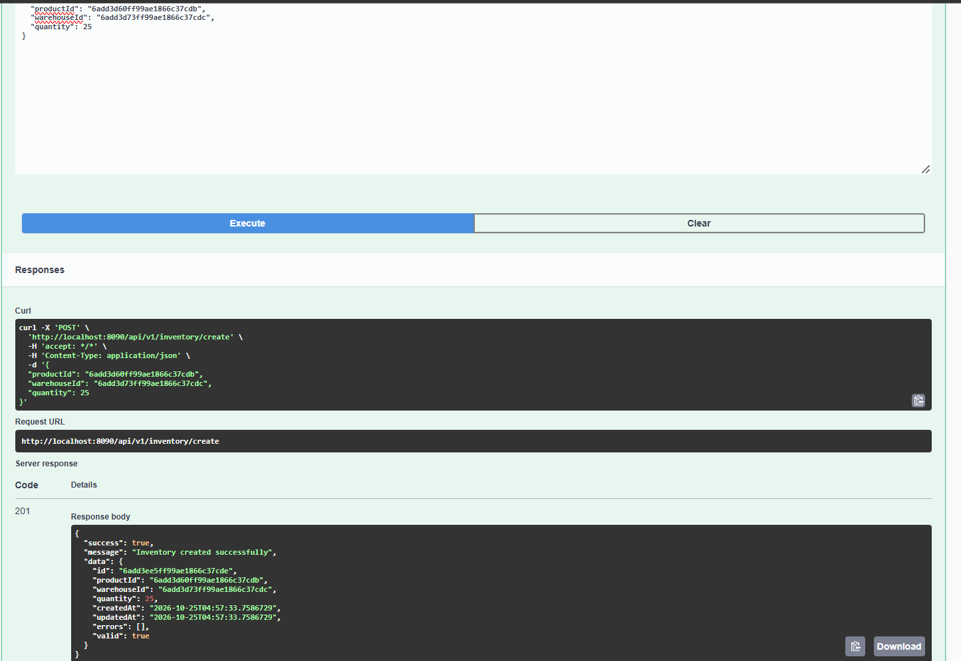
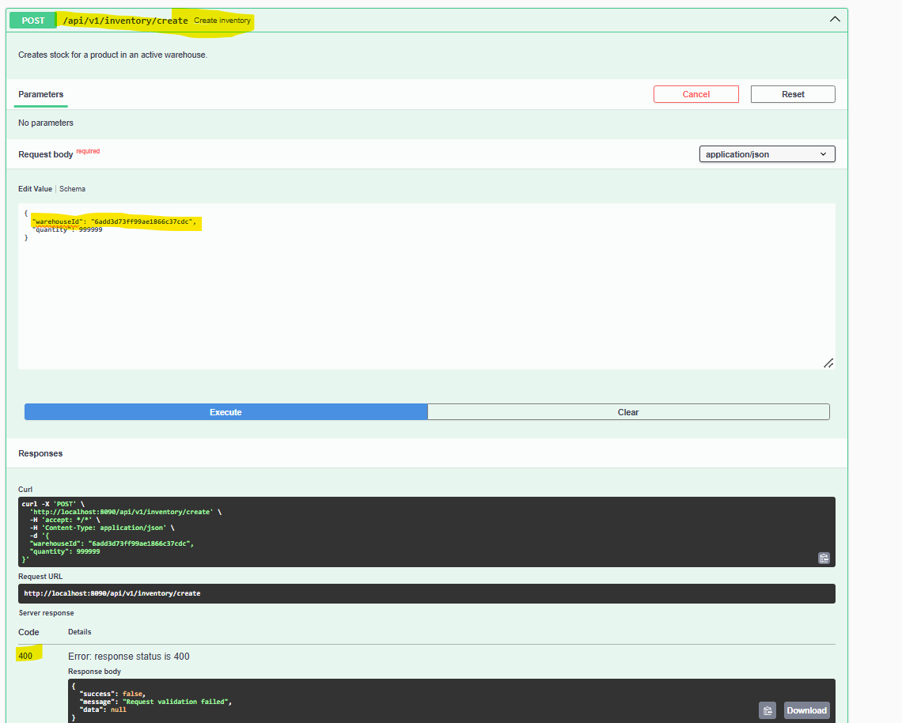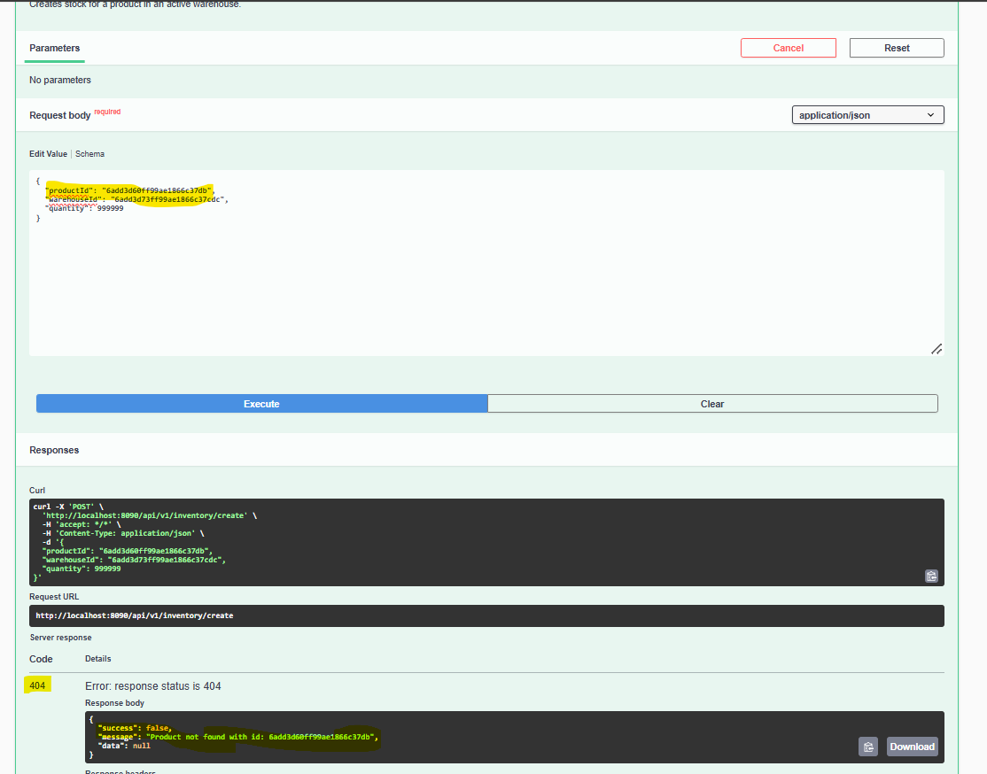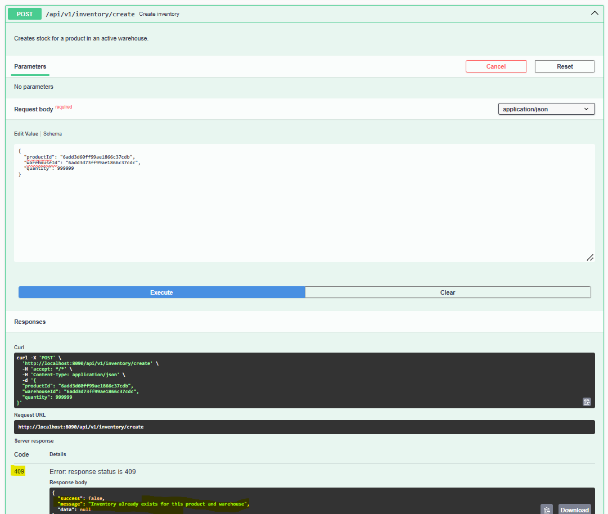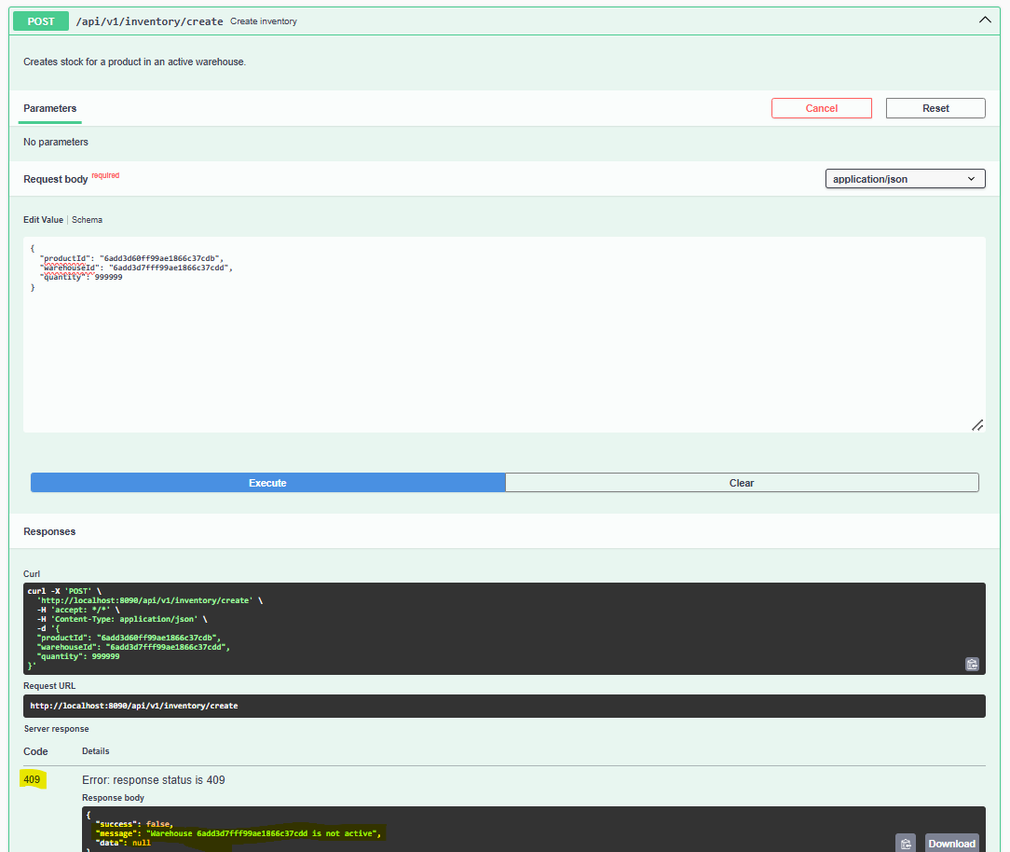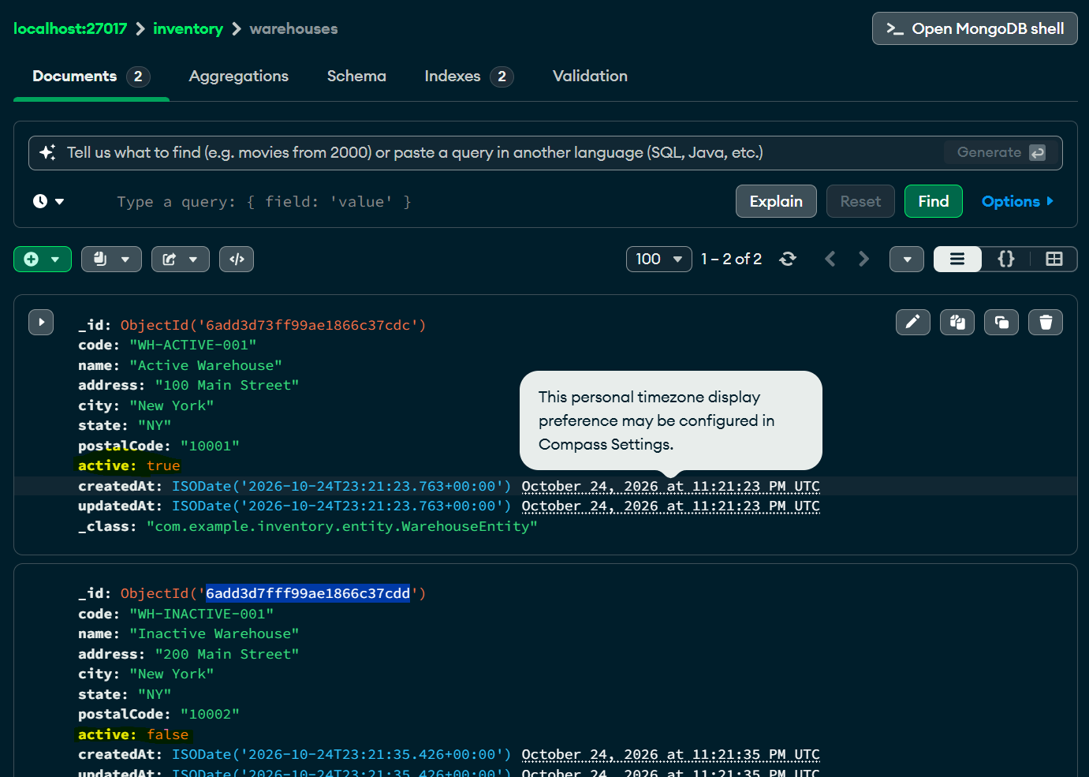
7.2 Create Multiple Inventory Records
HTTP Method: POST
Endpoint: /api/v1/inventory/create-multi
Success Status: 201 Created
Request Body
An array of InventoryRequestDTO objects.
[
{
"productId": "prod001",
"warehouseId": "wh001",
"quantity": 100
},
{
"productId": "prod002",
"warehouseId": "wh001",
"quantity": 50
}
]
Response Structure
{
"success": true,
"message": "Inventory records created successfully",
"data": [
{
"id": "inv001",
"productId": "prod001",
"warehouseId": "wh001",
"quantity": 100,
"createdAt": "2026-10-23T10:00:00",
"updatedAt": "2026-10-23T10:00:00",
"errors": [],
"valid": true
}
]
}
The example data array is abbreviated. The actual response depends on the records created by the service.
7.3 Update Multiple Inventory Records
HTTP Method: PUT
Endpoint: /api/v1/inventory/update-multi
Success Status: 200 OK
Request Body
Each item uses InventoryRequestDTO and must include the ID of the inventory record being updated.
[
{
"id": "inv001",
"productId": "prod001",
"warehouseId": "wh001",
"quantity": 125
}
]
Response
{
"success": true,
"message": "Inventory records updated successfully",
"data": [
{
"id": "inv001",
"productId": "prod001",
"warehouseId": "wh001",
"quantity": 125,
"createdAt": "2026-10-23T10:00:00",
"updatedAt": "2026-10-23T11:00:00",
"errors": [],
"valid": true
}
]
}
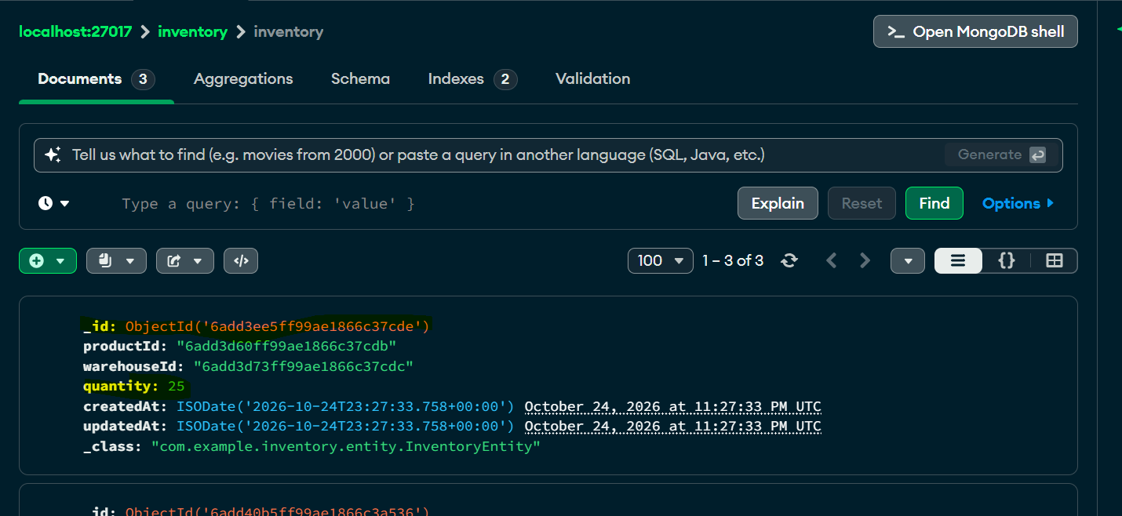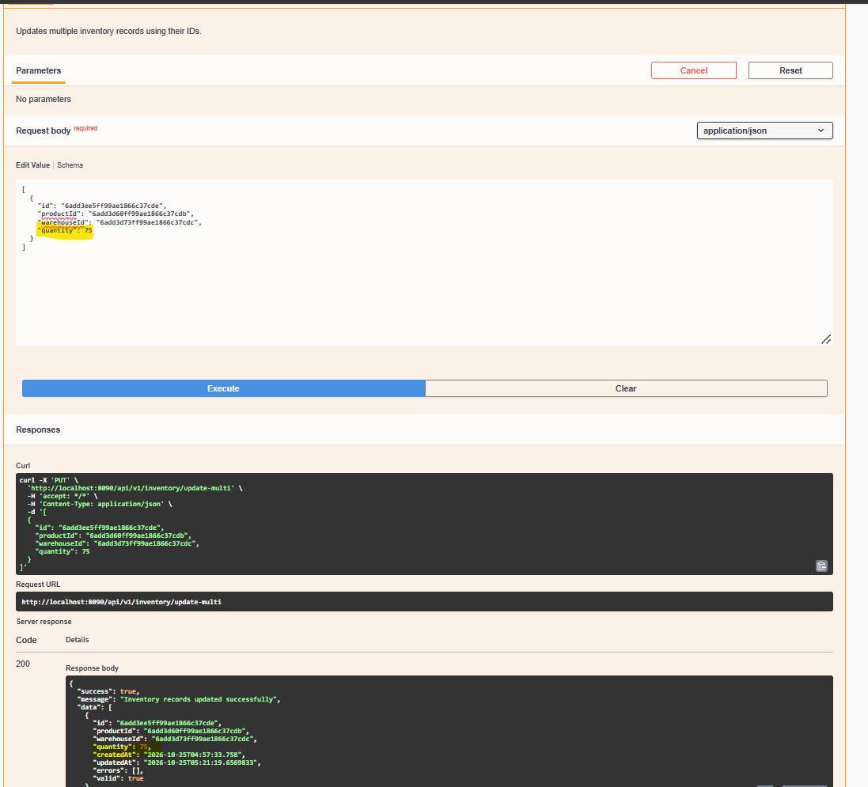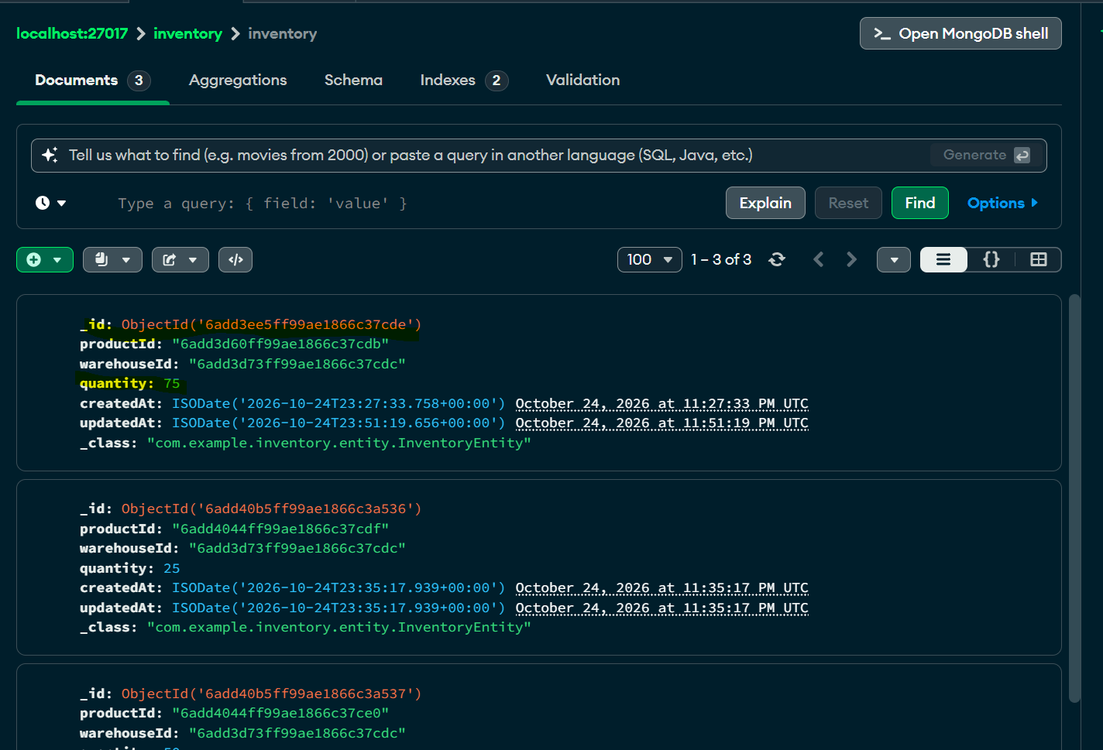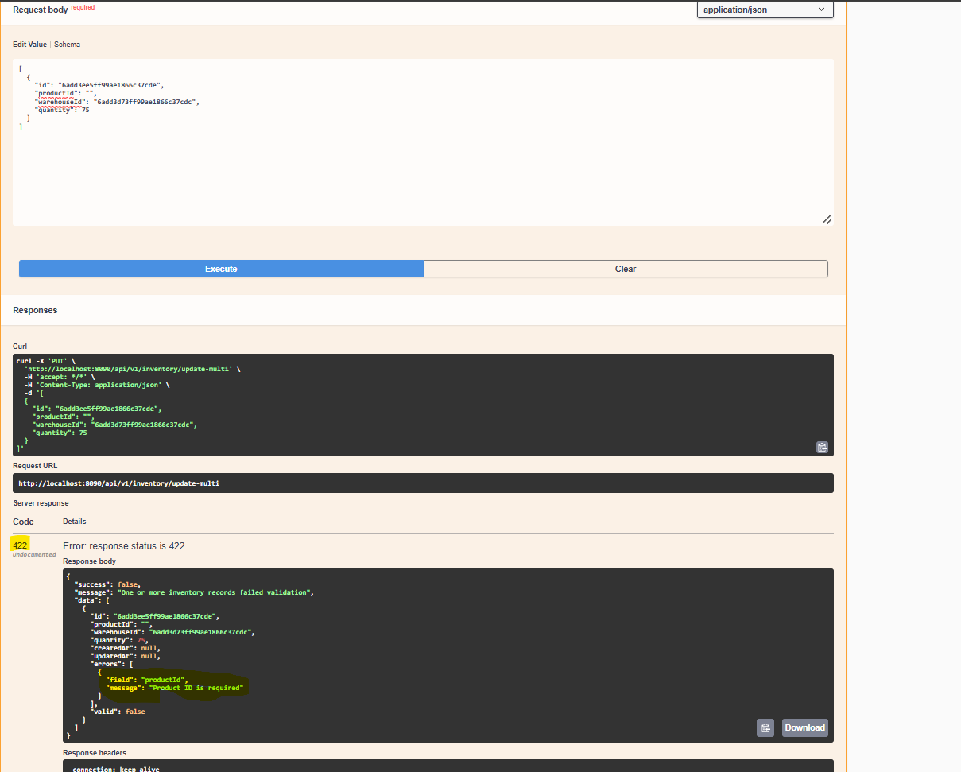
7.4 Get Inventory by ID
HTTP Method: GET
Endpoint: /api/v1/inventory/{inventoryId}
Success Status: 200 OK
Example request:
GET /api/v1/inventory/inv001
Response:
{
"success": true,
"message": "Inventory fetched successfully",
"data": {
"id": "inv001",
"productId": "prod001",
"warehouseId": "wh001",
"quantity": 100,
"createdAt": "2026-10-23T10:00:00",
"updatedAt": "2026-10-23T10:00:00",
"errors": [],
"valid": true
}
}
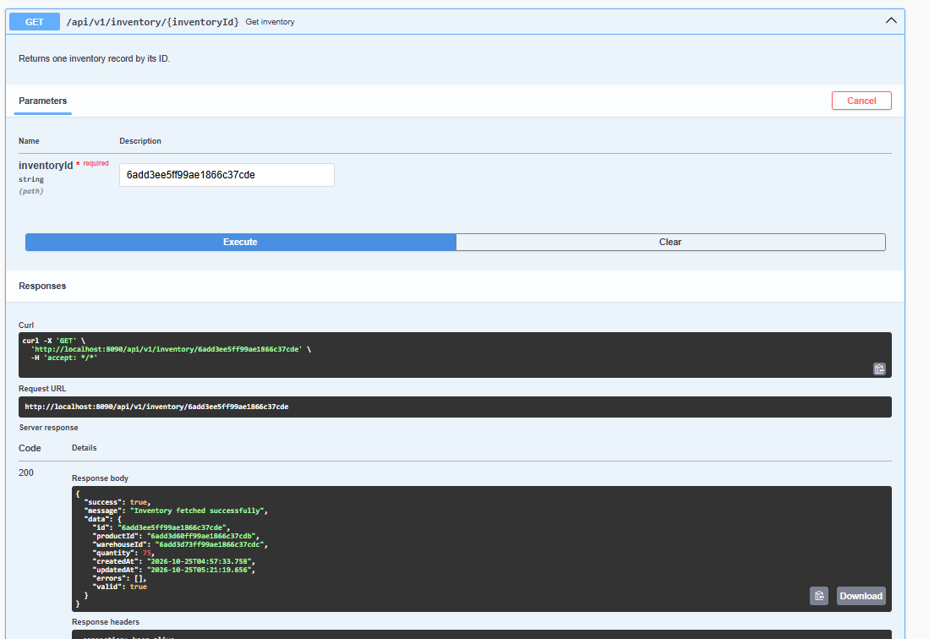
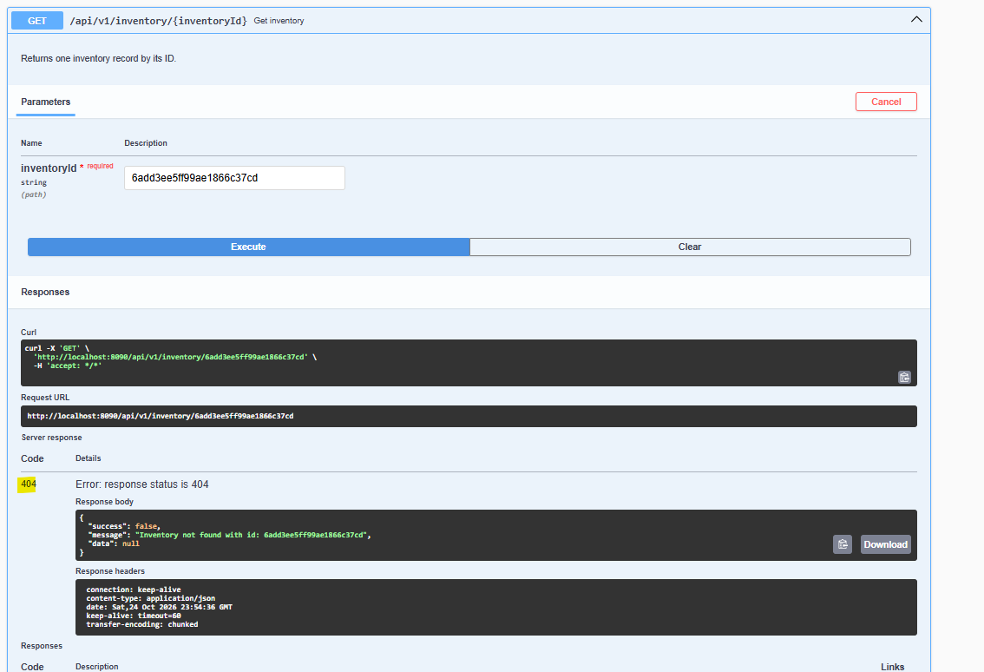
7.5 Get Product Stock Across Warehouses
HTTP Method: GET
Endpoint: /api/v1/inventory/products/{productId}
Success Status: 200 OK
This endpoint returns inventory records for the requested product and calculates the total stock across warehouses.
Example request:
GET /api/v1/inventory/products/prod001
Example response:
{
"success": true,
"message": "Product stock fetched successfully",
"data": {
"productId": "prod001",
"inventory": [
{
"id": "inv001",
"productId": "prod001",
"warehouseId": "wh001",
"quantity": 100,
"createdAt": "2026-10-23T10:00:00",
"updatedAt": "2026-10-23T10:00:00",
"errors": [],
"valid": true
},
{
"id": "inv002",
"productId": "prod001",
"warehouseId": "wh002",
"quantity": 50,
"createdAt": "2026-10-23T10:00:00",
"updatedAt": "2026-10-23T10:00:00",
"errors": [],
"valid": true
}
],
"totalStock": 150
}
}
Total stock calculation:
100 + 50 = 150 units.
The totalStock field is defined in ProductStockResponseDTO.
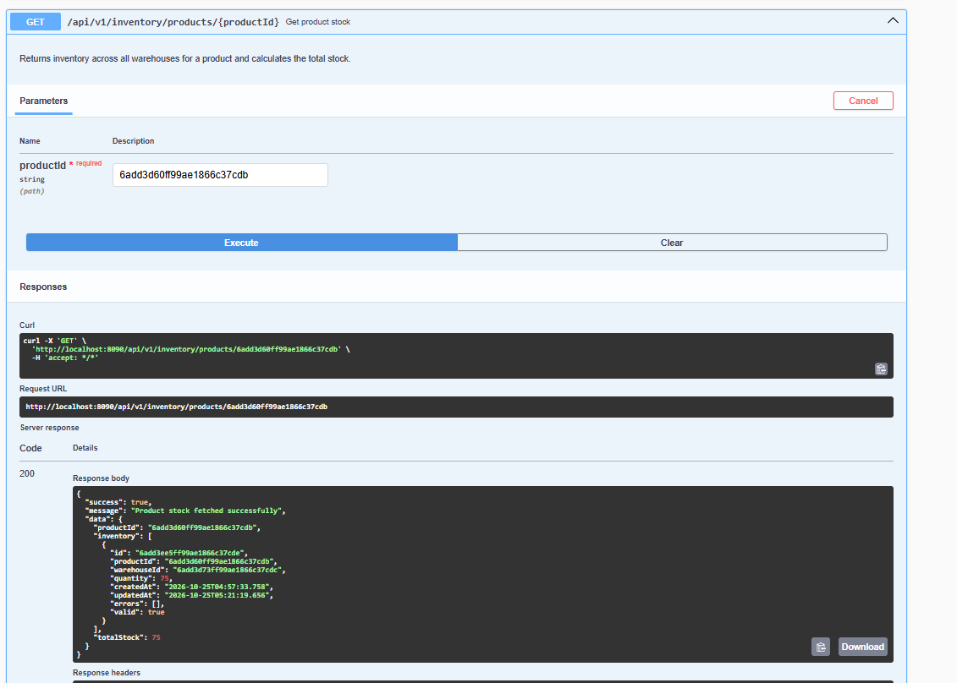
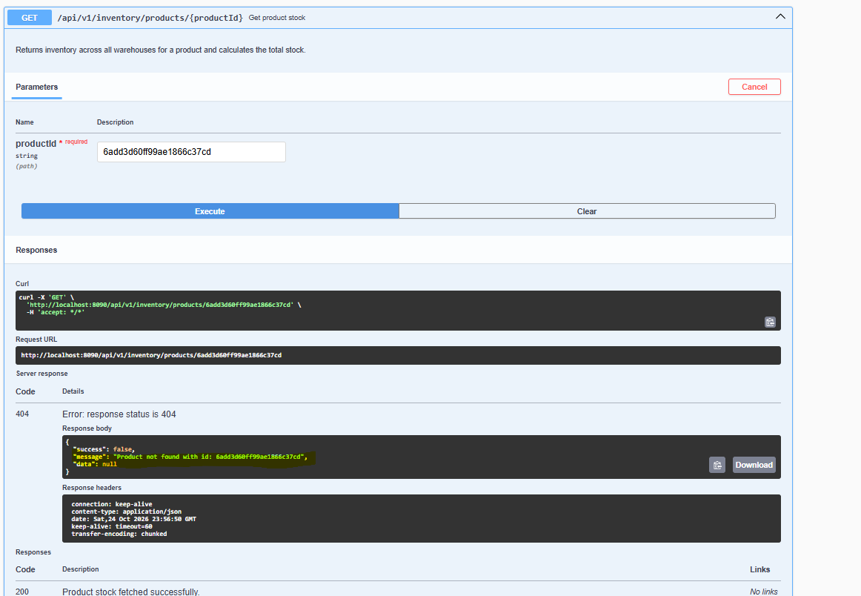

7.6 Get Inventory by Warehouse
HTTP Method: GET
Endpoint: /api/v1/inventory/warehouses/{warehouseId}
Success Status: 200 OK
Example request:
GET /api/v1/inventory/warehouses/wh001
Example response:
{
"success": true,
"message": "Warehouse inventory fetched successfully",
"data": [
{
"id": "inv001",
"productId": "prod001",
"warehouseId": "wh001",
"quantity": 100,
"createdAt": "2026-10-23T10:00:00",
"updatedAt": "2026-10-23T10:00:00",
"errors": [],
"valid": true
}
]
}
The endpoint returns the inventory records held at the specified warehouse.’
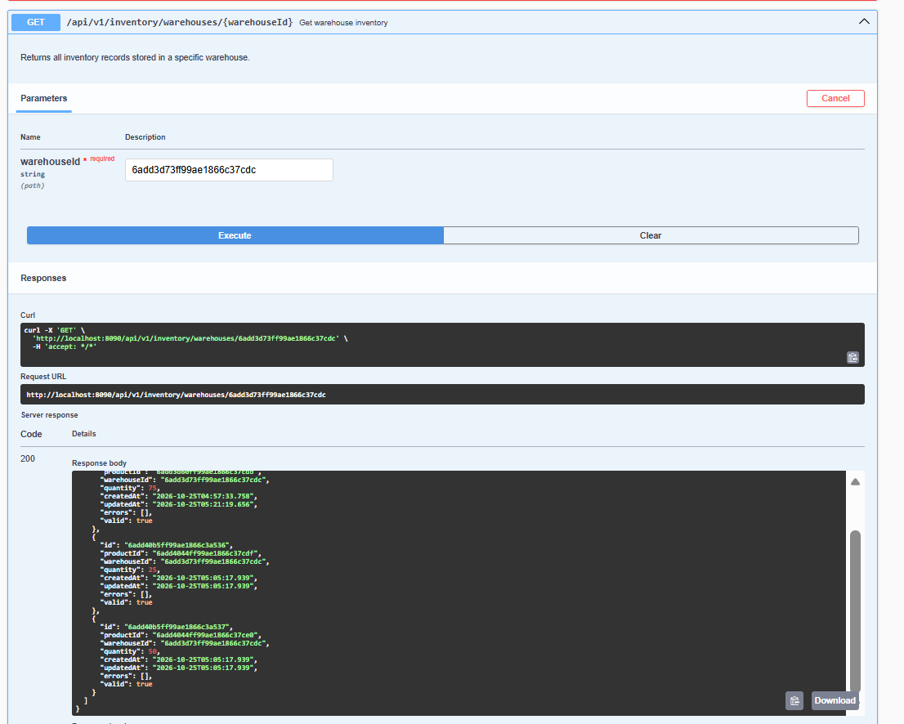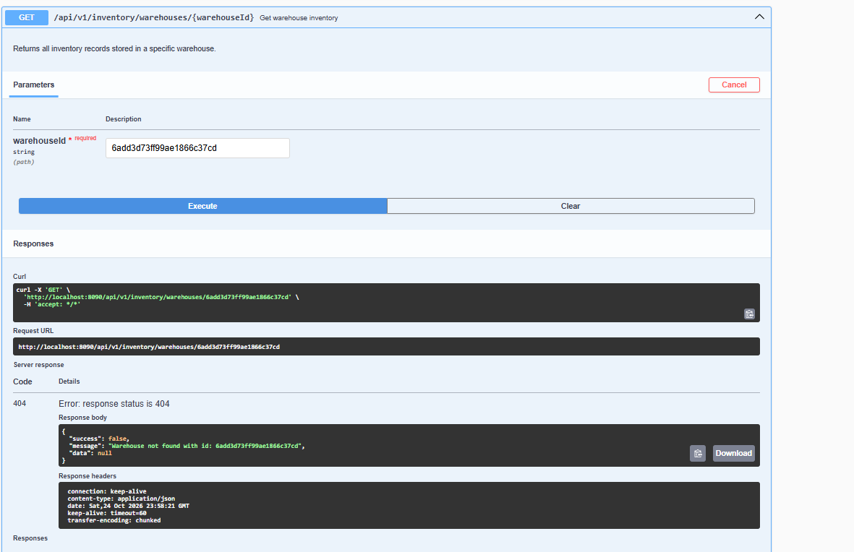
7.7 Set Exact Stock Quantity
HTTP Method: PUT
Endpoint: /api/v1/inventory/{inventoryId}/stock
Success Status: 200 OK
Request DTO: SetStockRequestDTO
Field:
- quantity: Required integer greater than or equal to zero.
Example Request
PUT /api/v1/inventory/inv001/stock
{
"quantity": 75
}
Example Response
{
"success": true,
"message": "Stock updated successfully",
"data": {
"id": "inv001",
"productId": "prod001",
"warehouseId": "wh001",
"quantity": 75,
"createdAt": "2026-10-23T10:00:00",
"updatedAt": "2026-10-23T11:00:00",
"errors": [],
"valid": true
}
}
Processing Flow
- Receive inventoryId and quantity.
- Validate the quantity.
- Retrieve the inventory record.
- Check warehouse status according to the service rules.
- Replace the existing quantity with the supplied quantity.
- Persist and return the updated inventory record.
The quantity is replaced, not incremented.
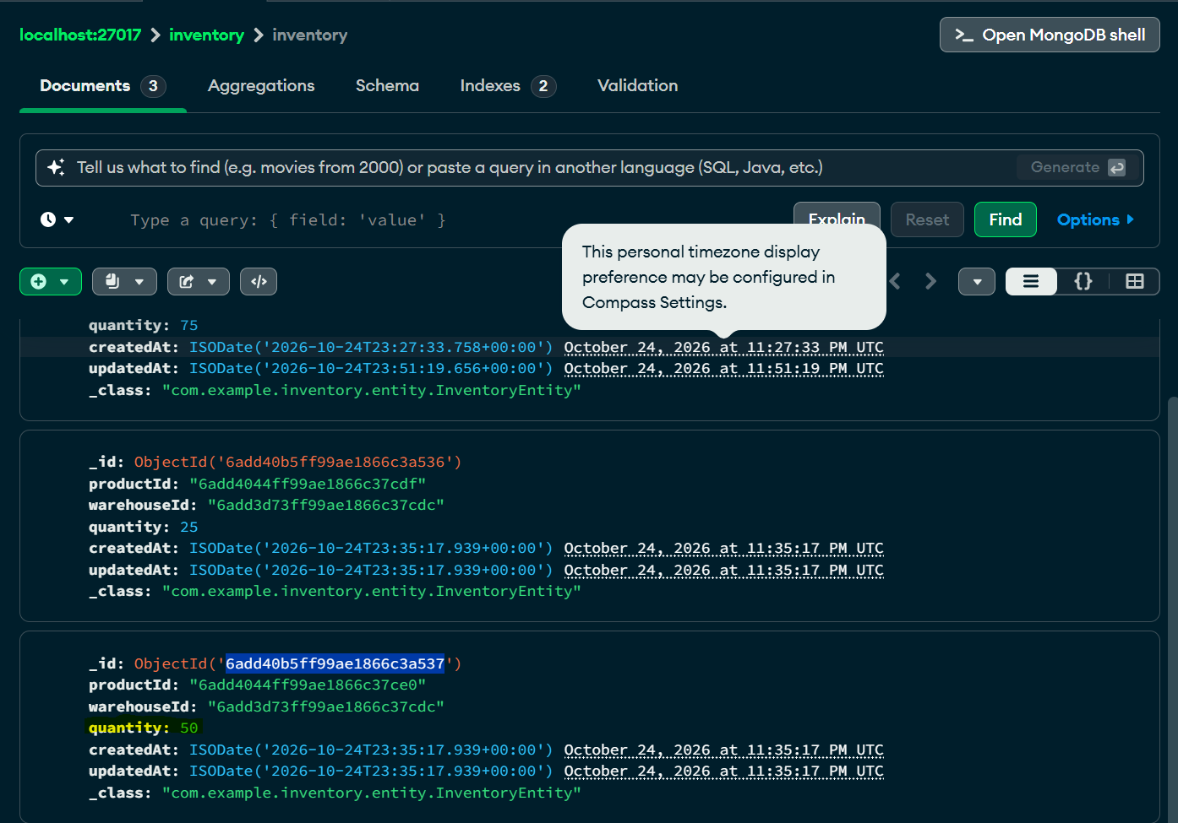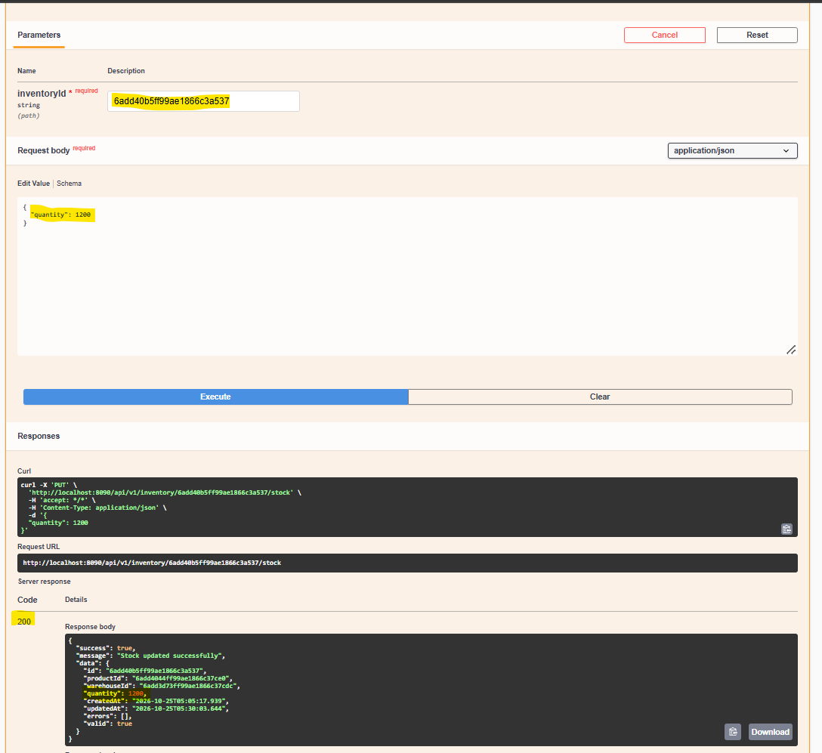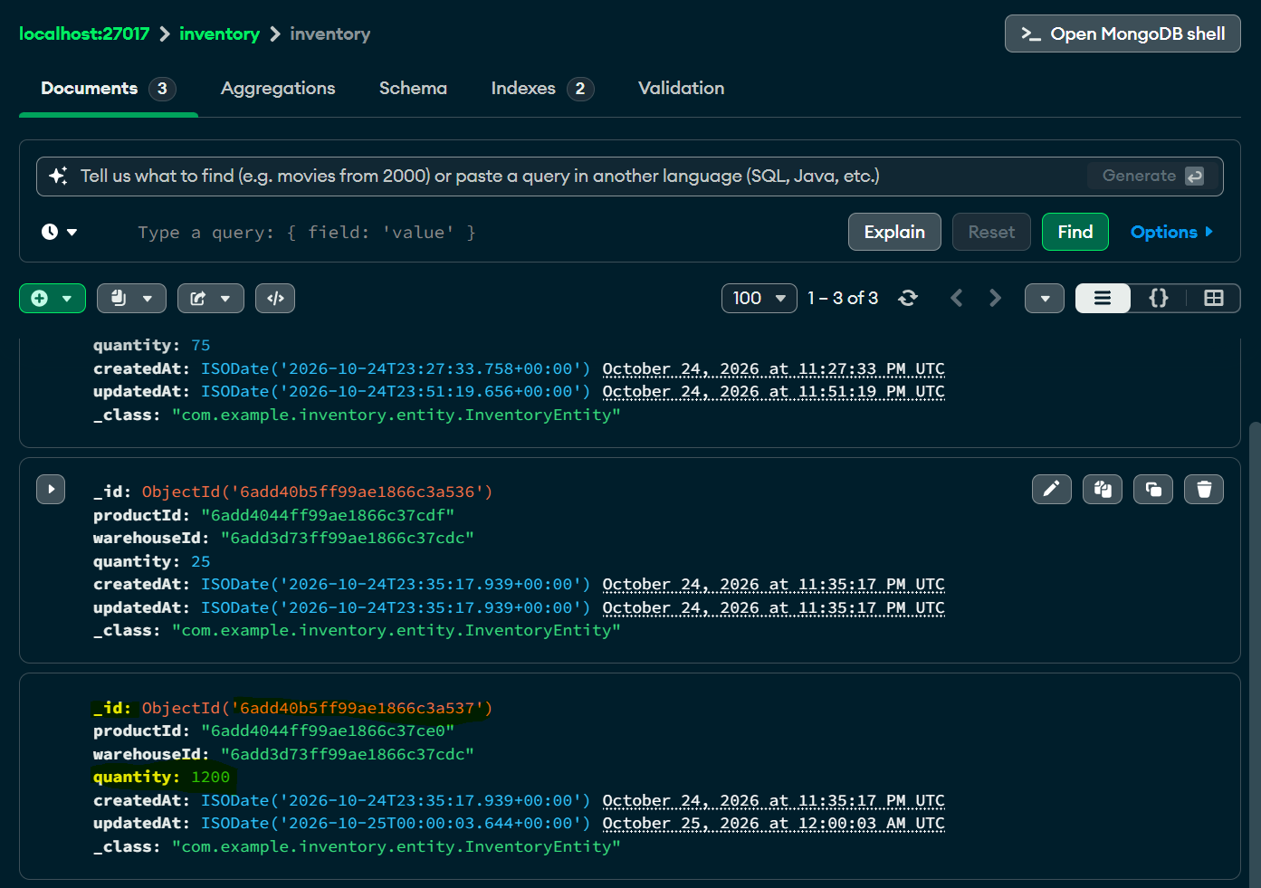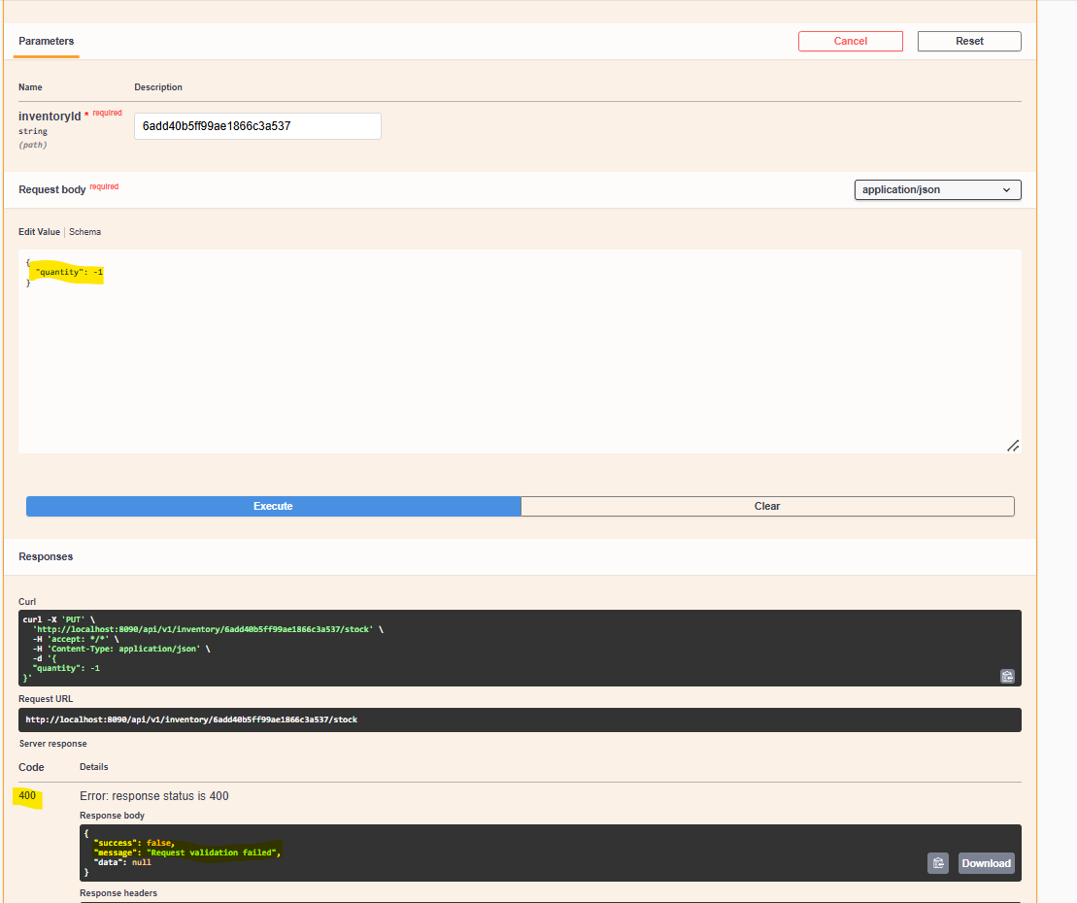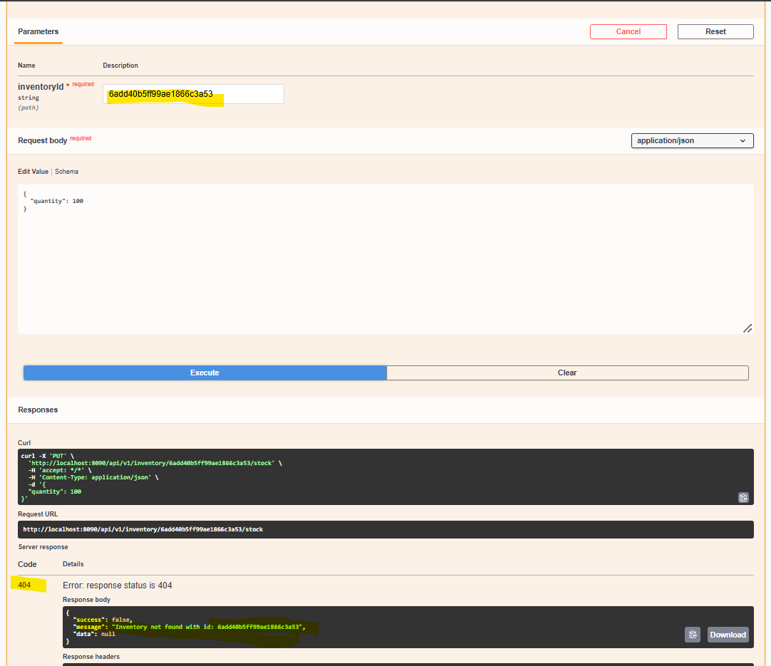
7.8 Increase Stock
HTTP Method: PATCH
Endpoint: /api/v1/inventory/{inventoryId}/stock/increase
Success Status: 200 OK
Request DTO: StockAdjustmentRequestDTO
Fields:
- quantity: Required positive integer.
- reason: Optional string.
Example Request
PATCH /api/v1/inventory/inv001/stock/increase
{
"quantity": 20,
"reason": "New stock received"
}
Example Response
{
"success": true,
"message": "Stock increased successfully",
"data": {
"id": "inv001",
"productId": "prod001",
"warehouseId": "wh001",
"quantity": 95,
"createdAt": "2026-10-23T10:00:00",
"updatedAt": "2026-10-23T11:00:00",
"errors": [],
"valid": true
}
}
Example calculation:
Previous quantity = 75
Adjustment = 20
New quantity = 75 + 20 = 95
The service requires the warehouse to be active for this operation.

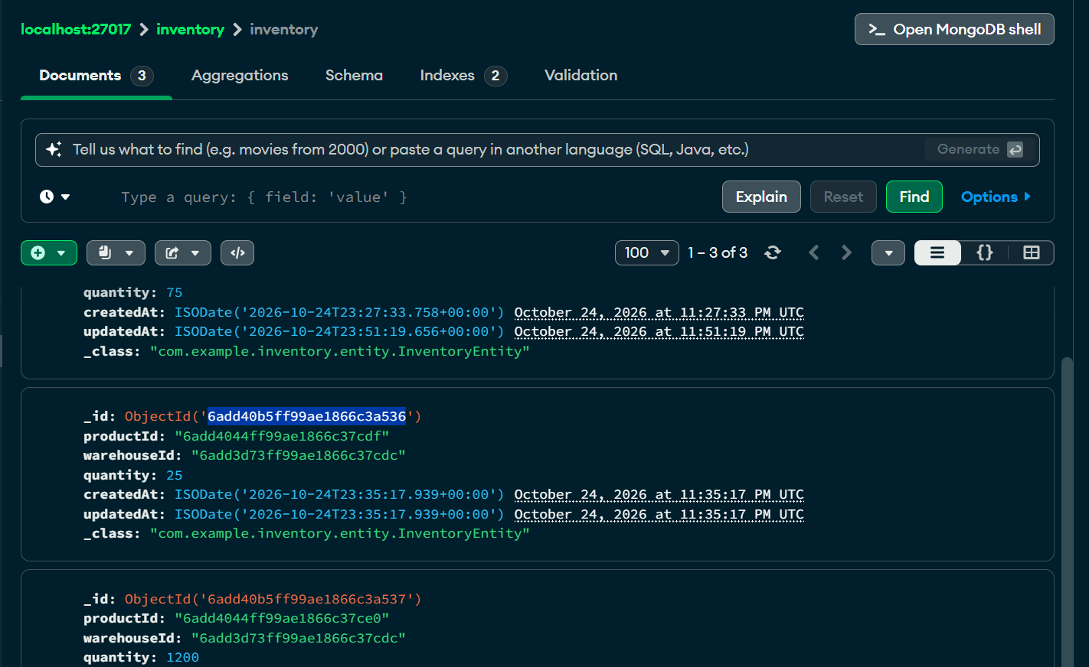
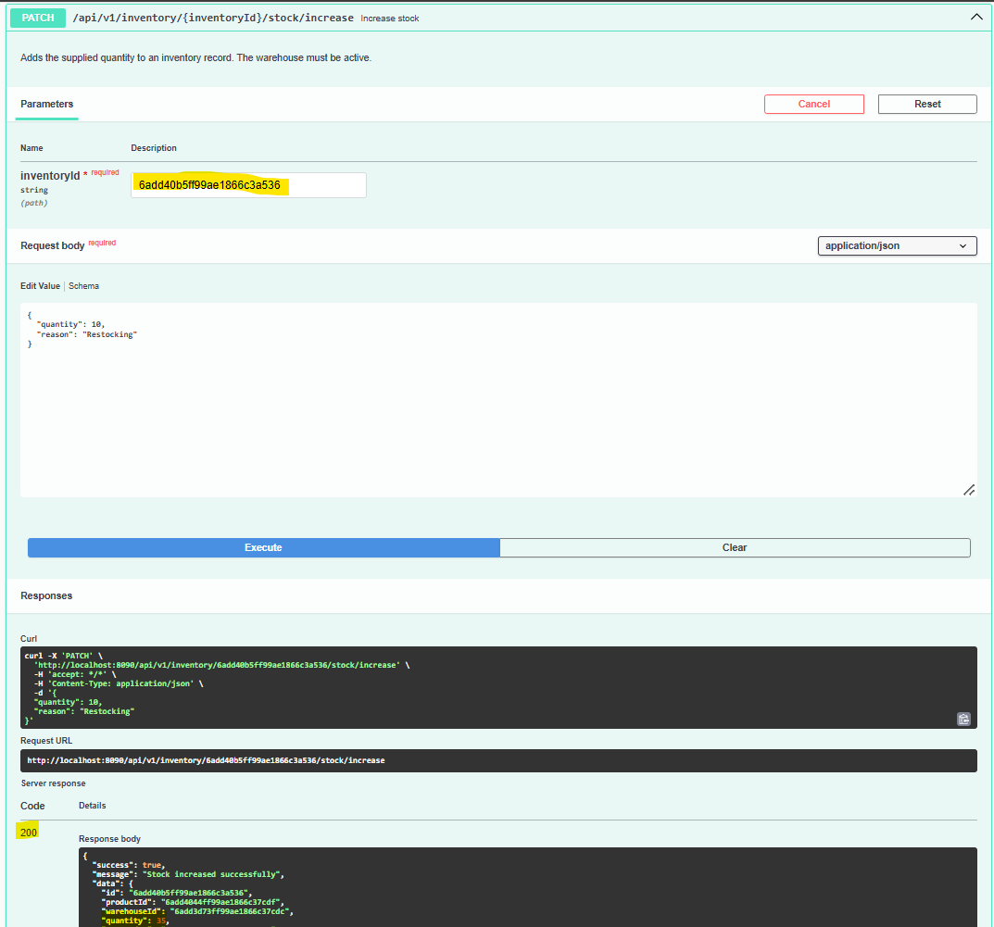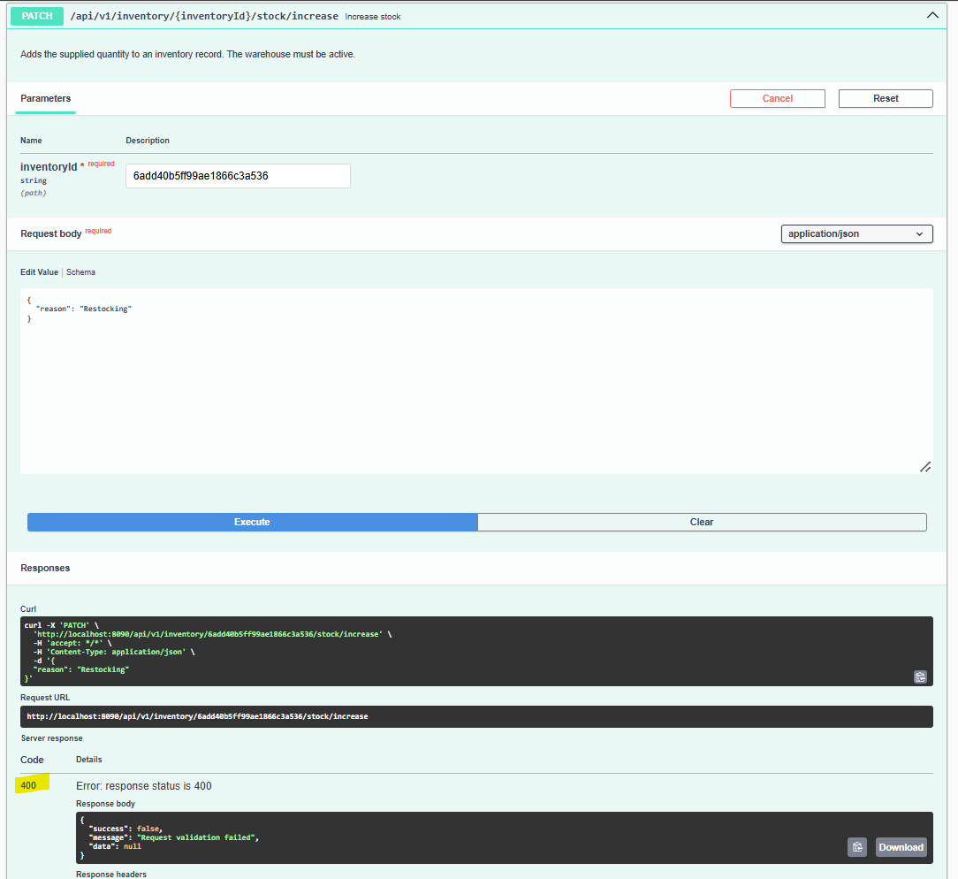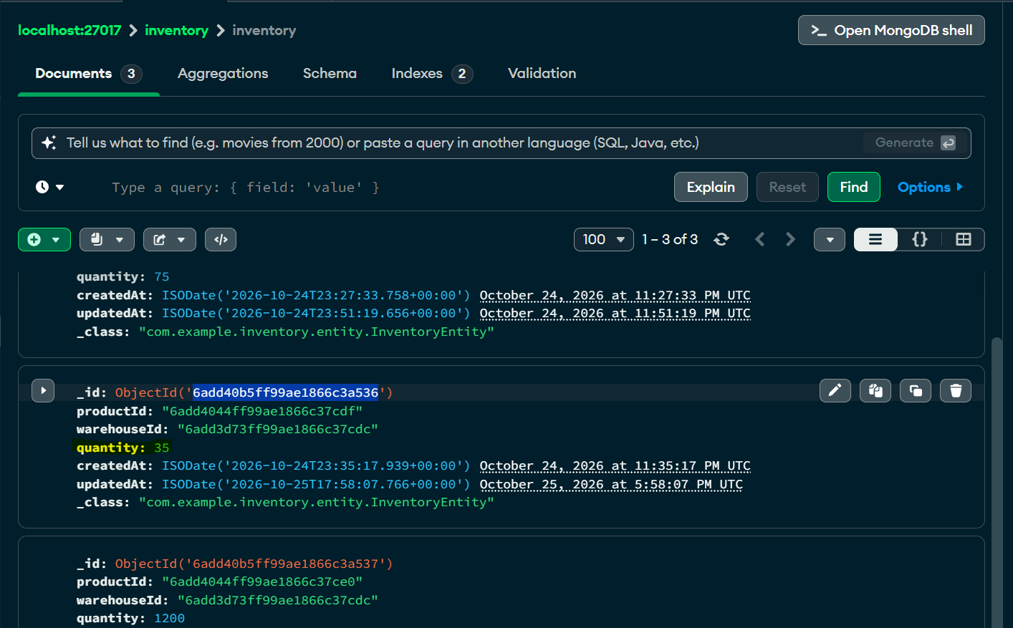
7.9 Decrease Stock
HTTP Method: PATCH
Endpoint: /api/v1/inventory/{inventoryId}/stock/decrease
Success Status: 200 OK
Example Request
PATCH /api/v1/inventory/inv001/stock/decrease
{
"quantity": 15,
"reason": "Damaged stock"
}
Example Response
{
"success": true,
"message": "Stock decreased successfully",
"data": {
"id": "inv001",
"productId": "prod001",
"warehouseId": "wh001",
"quantity": 80,
"createdAt": "2026-10-23T10:00:00",
"updatedAt": "2026-10-23T11:00:00",
"errors": [],
"valid": true
}
}
Example calculation:
Previous quantity = 95
Adjustment = 15
New quantity = 95 - 15 = 80
The service performs the stock decrease atomically and rejects the operation if it would produce negative stock.
Insufficient Stock Response
HTTP Status: 409 Conflict
{
"success": false,
"message": "Insufficient stock for the requested operation",
"data": null
}
The exact message is supplied by the exception raised by the service.
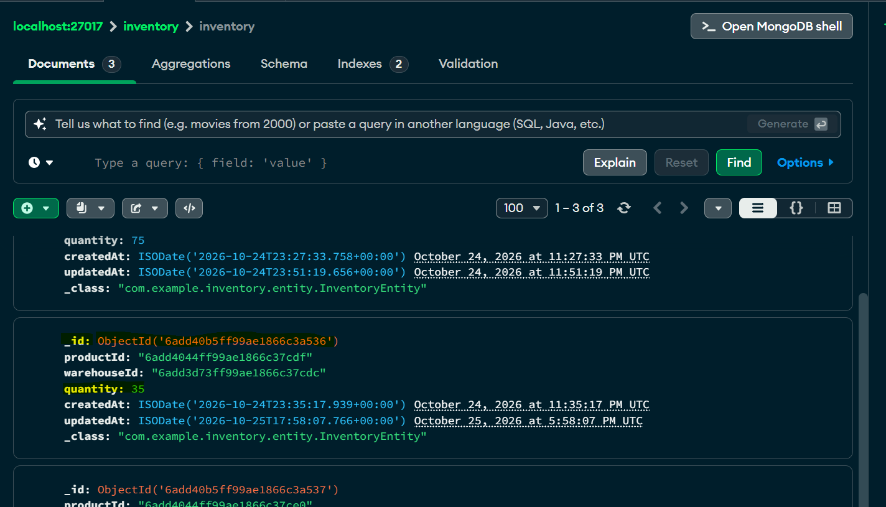
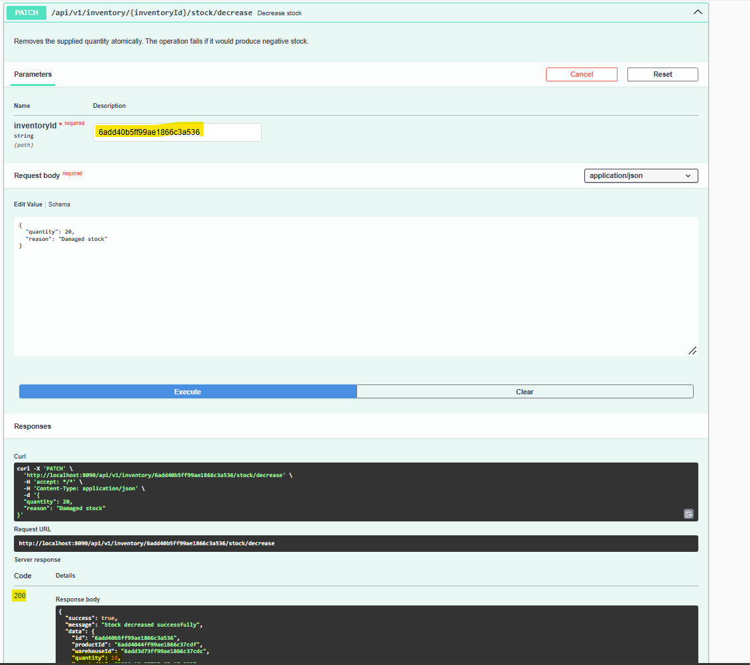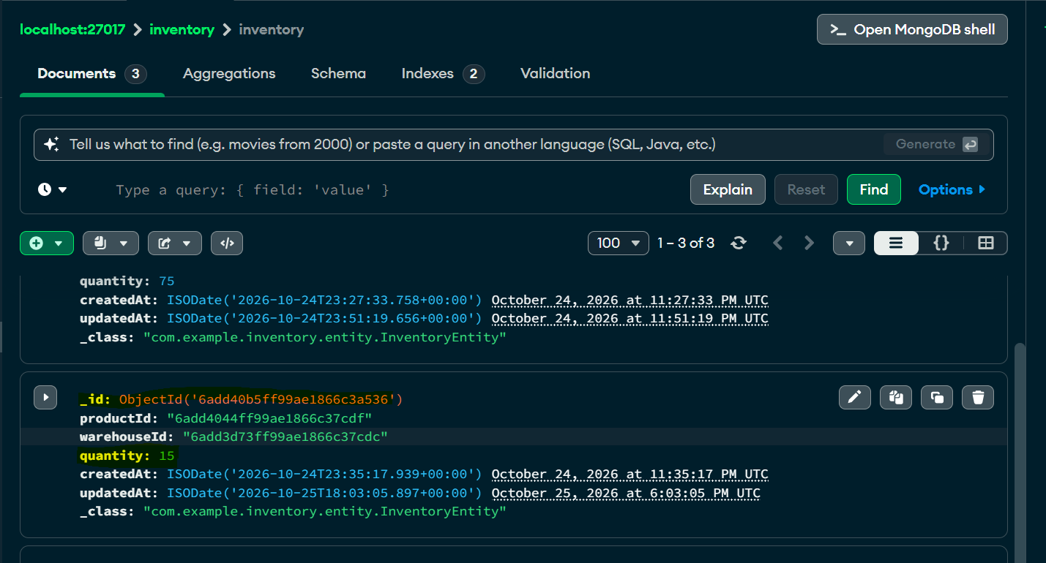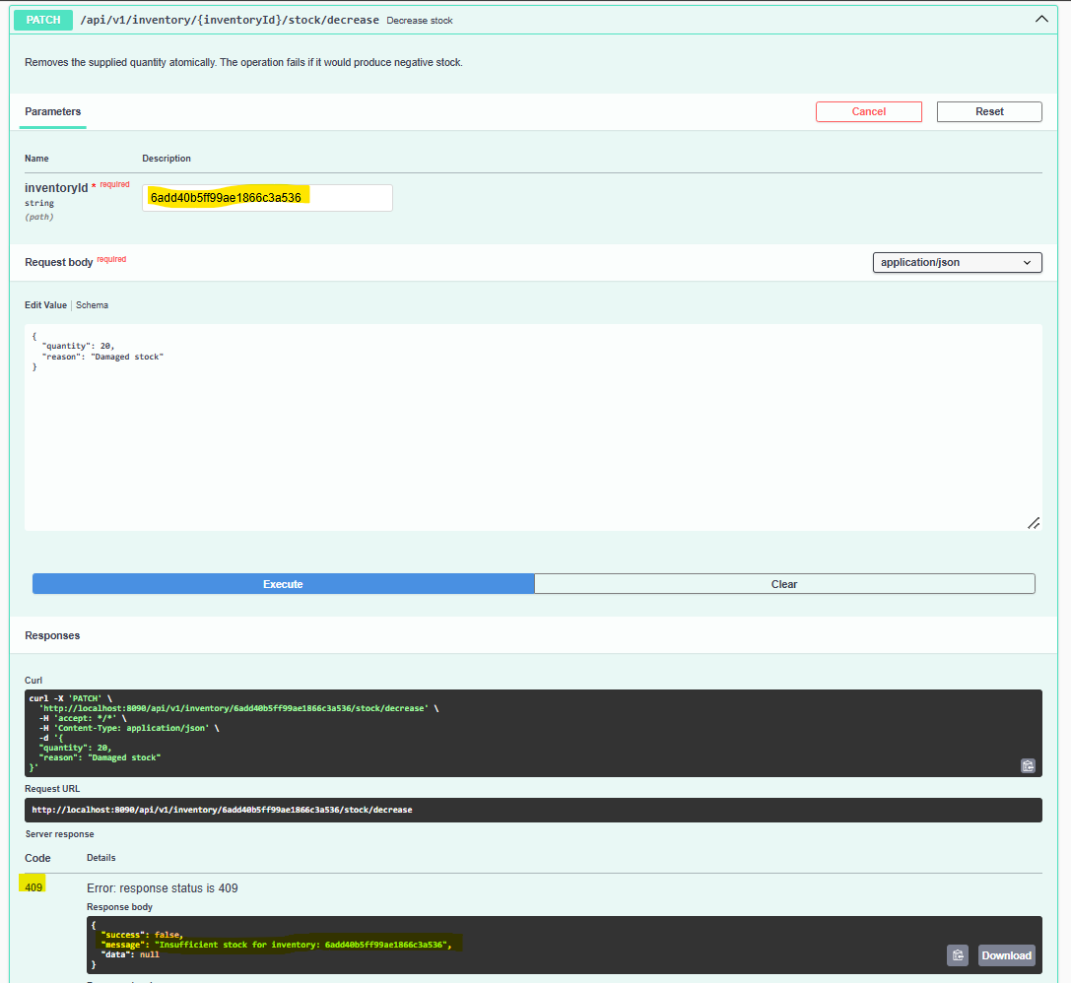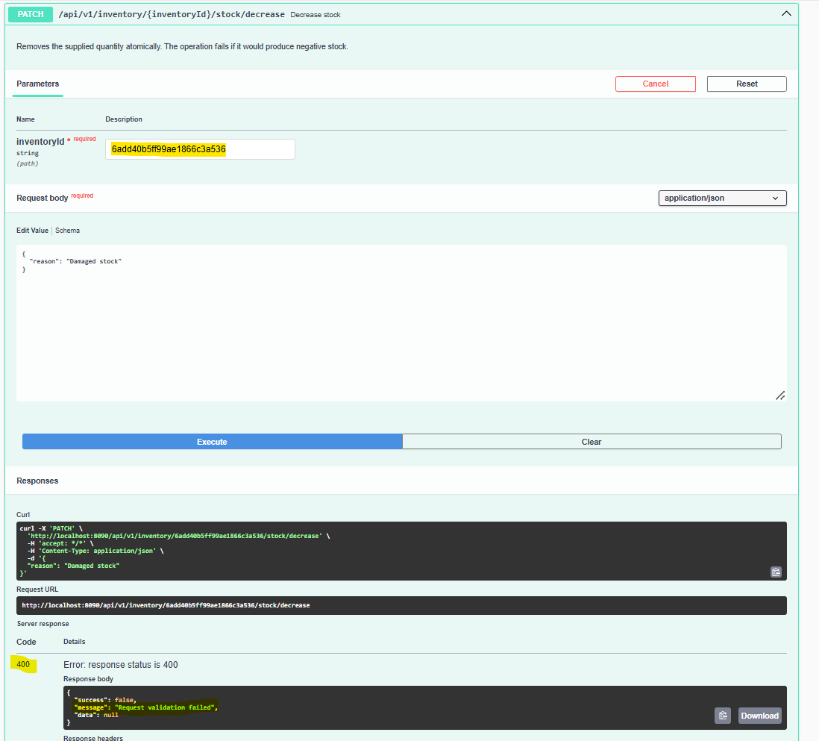
7.10 Retrieve Low-Stock Inventory
HTTP Method: GET
Endpoint: /api/v1/inventory/low-stock
Success Status: 200 OK
Query Parameters
Parameter | Required | Description
threshold | Yes | Quantity threshold
warehouseId | No | Optional warehouse filter
The endpoint returns records whose quantity is less than or equal to the threshold.
Example Request
GET /api/v1/inventory/low-stock?threshold=5
To restrict the search to a warehouse:
GET /api/v1/inventory/low-stock?threshold=5&warehouseId=wh001
Example Response
{
"success": true,
"message": "Low-stock inventory fetched successfully",
"data": [
{
"id": "inv003",
"productId": "prod003",
"warehouseId": "wh001",
"quantity": 3,
"createdAt": "2026-10-23T10:00:00",
"updatedAt": "2026-10-23T10:00:00",
"errors": [],
"valid": true
},
{
"id": "inv004",
"productId": "prod004",
"warehouseId": "wh001",
"quantity": 5,
"createdAt": "2026-10-23T10:00:00",
"updatedAt": "2026-10-23T10:00:00",
"errors": [],
"valid": true
}
]
}
The example records satisfy the condition quantity <= 5.
Error Scenarios
- 400 Bad Request: Missing or invalid threshold.
- 404 Not Found: The optional warehouse filter references a warehouse that cannot be found.
- 503 Service Unavailable: Inventory data is temporarily unavailable.
- 500 Internal Server Error: Unexpected failure.
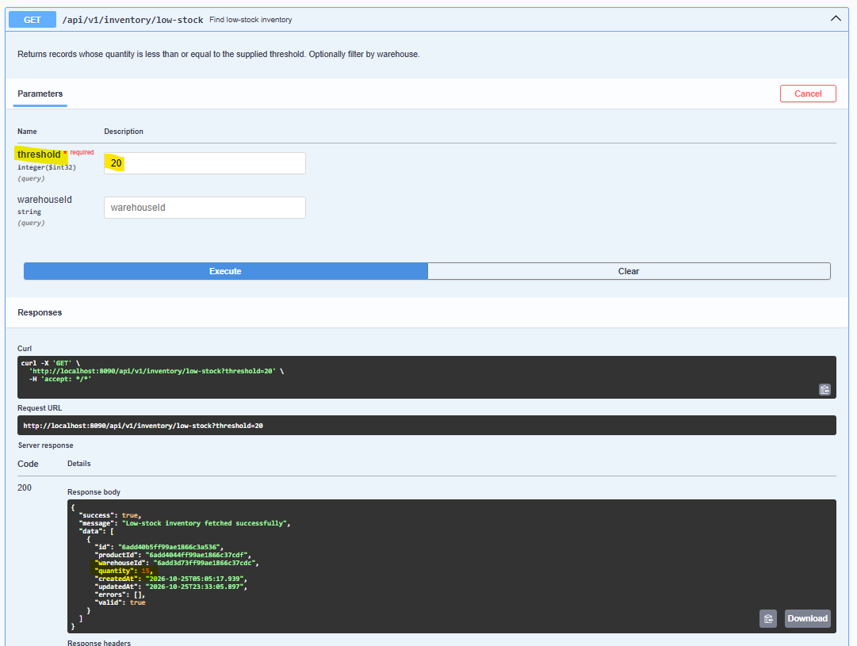
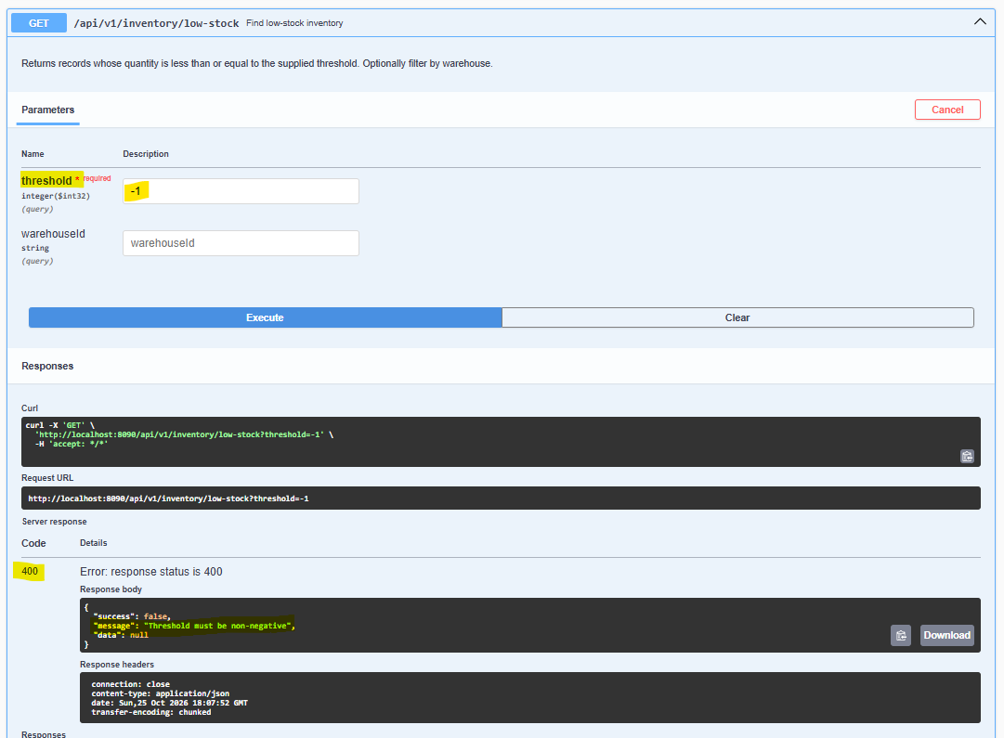
7.11 Delete Inventory
HTTP Method: DELETE
Endpoint: /api/v1/inventory/{inventoryId}
Success Status: 204 No Content
Example request:
DELETE /api/v1/inventory/inv001
Successful response:
HTTP/1.1 204 No Content
The response has no body.
The inventory record is deleted without deleting its associated product or warehouse.

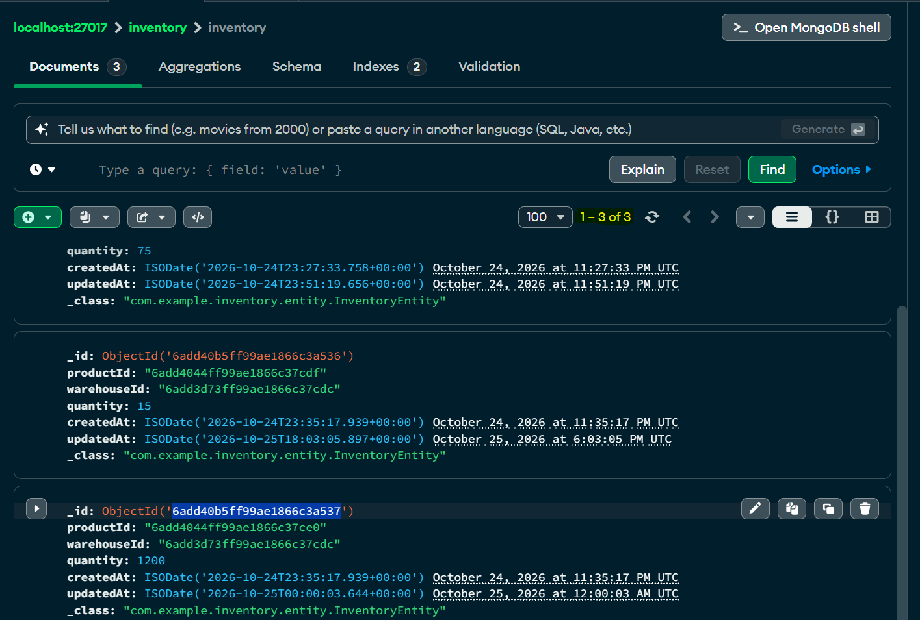
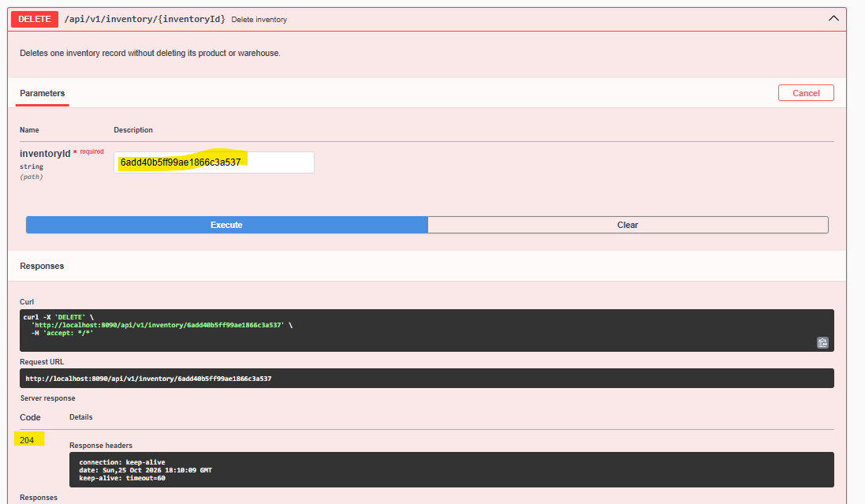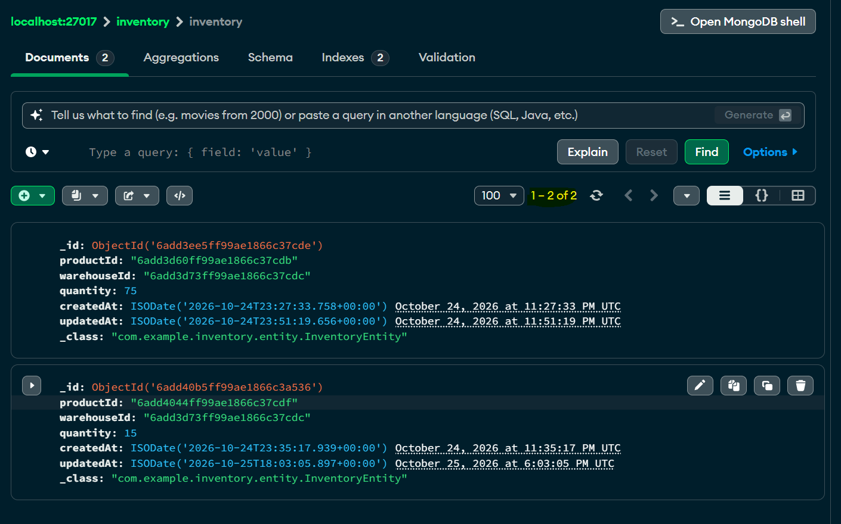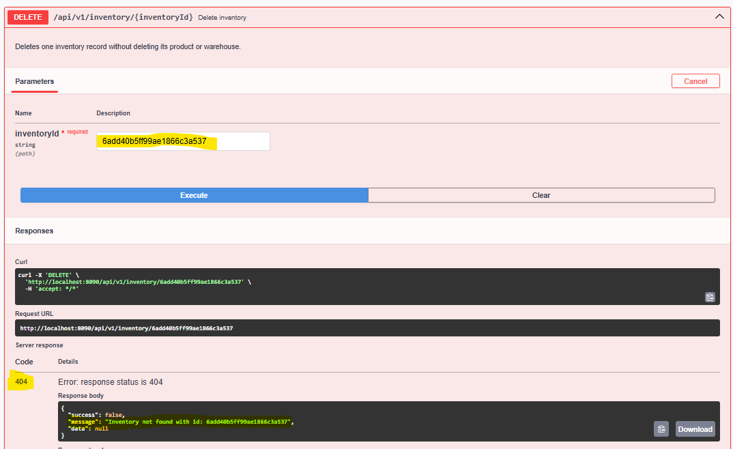
8. COMMON ERROR RESPONSE FORMAT
The global exception handler returns the following standard format for most handled errors:
{
"success": false,
"message": "Error description",
"data": null
}
Examples of handled errors include:
8.1 Bad Request
HTTP Status: 400 Bad Request
{
"success": false,
"message": "Request is malformed or contains invalid parameters",
"data": null
}
This response is used for malformed JSON and missing required request parameters.
For Bean Validation failures, the handler returns:
{
"success": false,
"message": "Request validation failed",
"data": null
}
8.2 Not Found
HTTP Status: 404 Not Found
{
"success": false,
"message": "Product not found for the supplied ID",
"data": null
}
The message depends on the specific exception raised.
8.3 Conflict
HTTP Status: 409 Conflict
{
"success": false,
"message": "A product with the same SKU already exists",
"data": null
}
The global duplicate-key handler returns this message for a MongoDB duplicate-key exception.
Inventory conflicts and insufficient-stock exceptions also map to HTTP 409, with the exception message.
8.4 Service Unavailable
HTTP Status: 503 Service Unavailable
{
"success": false,
"message": "Product data is temporarily unavailable",
"data": null
}
The global handler uses this response for data-access exceptions.
8.5 Unexpected Server Error
HTTP Status: 500 Internal Server Error
{
"success": false,
"message": "An unexpected error occurred",
"data": null
}
The global exception handler avoids returning internal exception details in this response.
8.6 Product and Warehouse Validation Errors
Product and warehouse validation failures return HTTP 422 with a ValidationErrorResponseDTO inside data.
Example structure:
{
"success": false,
"message": "Product validation failed",
"data": {
"totalErrors": 1,
"totalIncorrectDtos": 1,
"incorrectDtos": [
{
"sku": "SKU-1001",
"title": "",
"errors": [
{
"field": "title",
"message": "Title is required"
}
],
"valid": false
}
]
}
}
This is an illustrative structure. The exact validation message depends on ErrorMessage formatting, and the incorrectDtos item contains the corresponding response DTO fields.
Inventory validation failures also return HTTP 422, but the handler places a list of InventoryResponseDTO objects directly in data.
9. END-TO-END INVENTORY FLOW
The normal workflow for maintaining product stock is:
Step 1: Create a product using POST /api/v1/products/create.
Step 2: Create an active warehouse using POST /api/v1/warehouses/create.
Step 3: Create an inventory record using POST /api/v1/inventory/create.
Step 4: Increase or decrease stock using the inventory ID.
Step 5: Retrieve the updated inventory using GET /api/v1/inventory/{inventoryId}.
Step 6: Retrieve consolidated stock using GET /api/v1/inventory/products/{productId}.
Step 7: Check low-stock inventory using GET /api/v1/inventory/low-stock?threshold=5.
Example Stock Lifecycle
Operation | Quantity Change | Final Quantity
Create inventory | Initial 100 | 100
Increase stock | +20 | 120
Decrease stock | -15 | 105
Retrieve inventory | No change | 105
All operations in this example target the same inventory record.
10. REQUEST PROCESSING ARCHITECTURE
The application follows this general flow:
Client
|
v
Controller
|
v
Request validation and parameter handling
|
v
Service interface
|
v
Service implementation and business rules
|
v
Repository
|
v
MongoDB
|
v
DTO mapping
|
v
Standard API response
|
v
Client
The exception-handling flow is:
Controller or service throws an exception
|
v
GlobalExceptionHandler
|
v
Map exception to HTTP status and response DTO
|
v
Return error response to client
312. CONCLUSION
The Product Inventory Management System exposes APIs for product catalogue management, warehouse management, advanced search, bulk operations, Excel imports, and inventory tracking.
The inventory APIs support creating and updating stock records, setting exact quantities, increasing or decreasing stock, calculating total stock across warehouses, and retrieving low-stock records.
The common response envelope provides consistent success and error messaging, while the global exception handler maps application errors to appropriate HTTP status codes.
This API documentation is based on the controller mappings and DTOs in the supplied source archive. The sample identifiers, dates, and business data are illustrative. For formal acceptance testing, run the application and compare captured responses with the examples in this document.

